Design Day Booklet Team Page

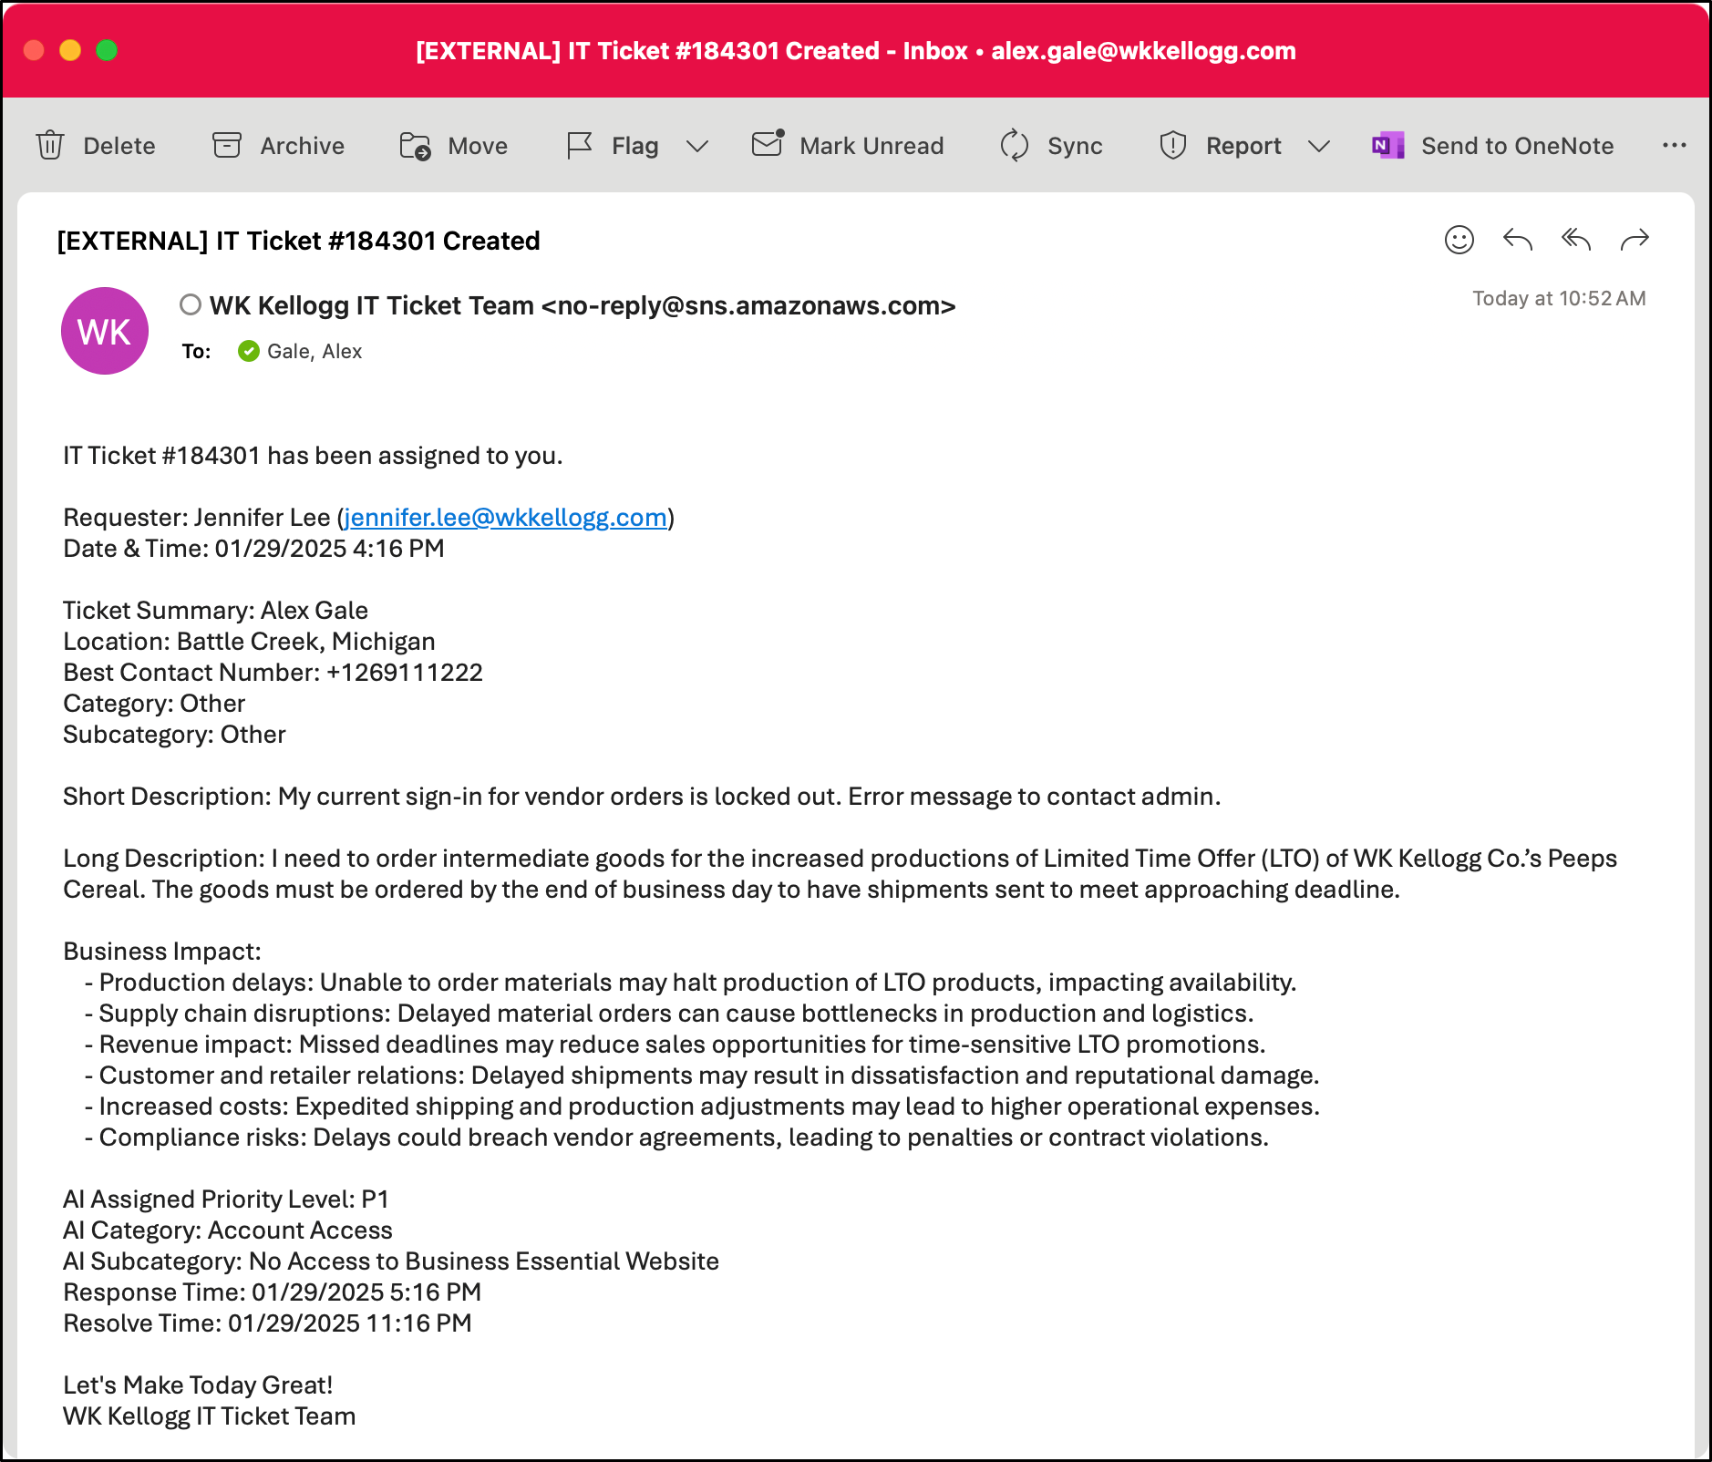

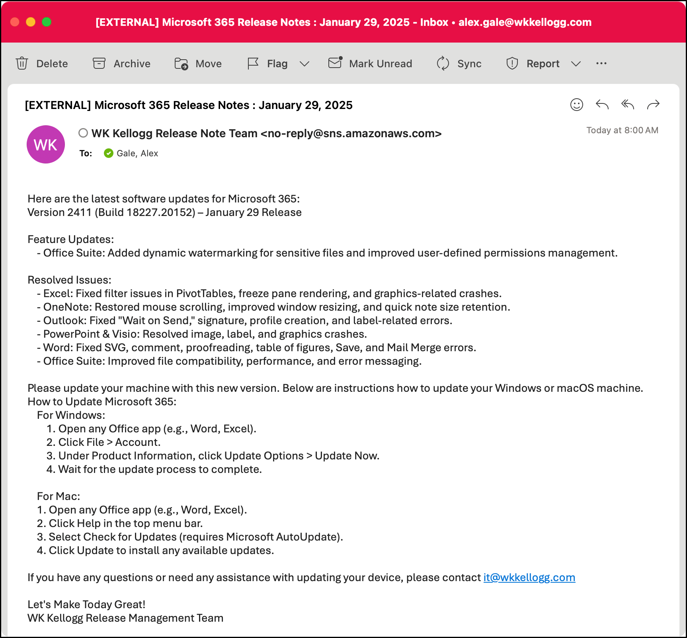

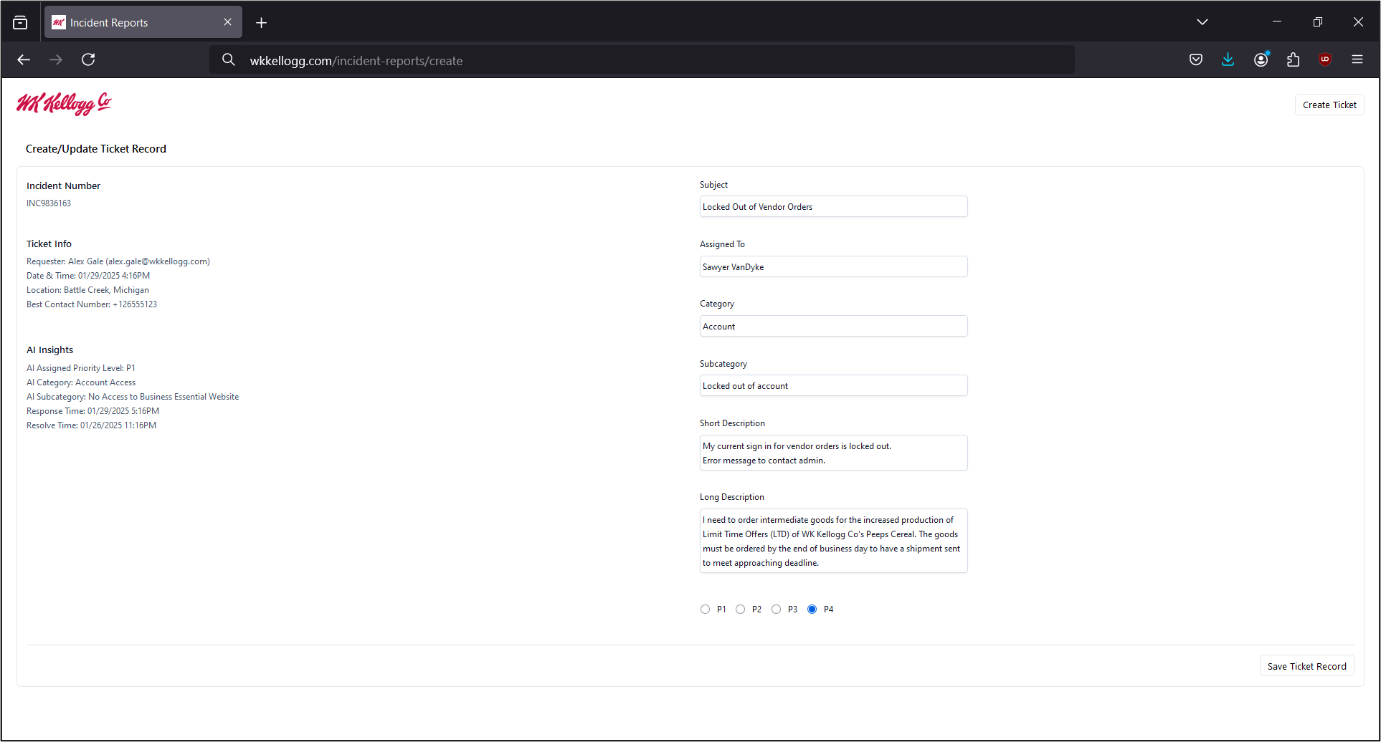

PAGE N + 31

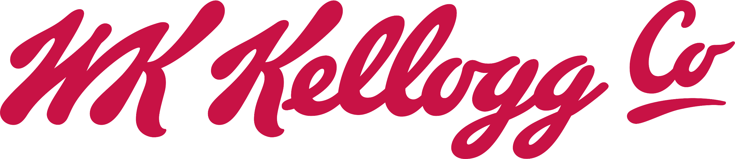

WK Kellogg Co

Project Sponsors

Shwet Bhasin

Battle Creek, Michigan

Federico Conde

Battle Creek, Michigan

Alex Jantz

Grand Rapids, Michigan

Brian Krygsman

Grand Rapids, Michigan

Naveen Paul

Battle Creek, Michigan

Bill Rex

Battle Creek, Michigan

Aaron Smith

Battle Creek, Michigan

Ganesan Vasudevan

Battle Creek, Michigan

Adolfo Vazquez

Battle Creek, Michigan

Michigan State University

Team Members (left to right)

Alex Gale

Naperville, Illinois

Shuja Husain

Nagpur, Michigan

Sawyer Vandyke

Wyoming, Michigan

Jennifer Lee

Troy, Michigan

Gavin Heiner

Plymouth, Michigan

Ryan Lind

Woodhaven, Michigan



WK Kellogg Co, one of the world’s leading food companies, is renowned for its iconic breakfast cereals. Based in Battle Creek, Michigan, the company has expanded its presence worldwide, delivering unfaltering quality and sustainability for over 100 years.

When a WK Kellogg Co employee requires technical support, they create an incident report through a third-party service desk web application. Each incident report needs to be manually processed by a member of WK Kellogg Co’s IT team to determine the relative priority and proper responding team.

The WK Kellogg Co enterprise architecture team is responsible for tracking new releases of third-party software used by the company. It is time-consuming for them to determine whether a given release is relevant to the company’s application landscape.

Our Intelligent Ticketing and Release Management system saves valuable developer time by leveraging large language models to automatically determine the priority of an incident report based on its potential impact to the business and route the report to the proper responding team.

The system also routinely checks vendor websites for updates and summarizes important changes that might affect the company’s application landscape. Our web application serves as a portal for WK Kellogg Co employees to open new incident reports and enables members of WK Kellogg Co’s IT team to audit the company’s extensive incident report history.

Our software expedites the incident report ingestion and release note analysis processes automatically, saving time and keeping WK Kellogg Co’s technologies up to date.

Our system uses Amazon Web Services to improve the sustainability of the technology footprint at WK Kellogg Co. Our web application is built using React and Tailwind for the front end and Node.js for the back end.

3200/3300 Hallway | Third Floor, Computer Science and Engineering 8:00 a.m. – Noon | CSE498

WK Kellogg Co

Intelligent Ticketing and Release Management