Design Day Booklet Team Page

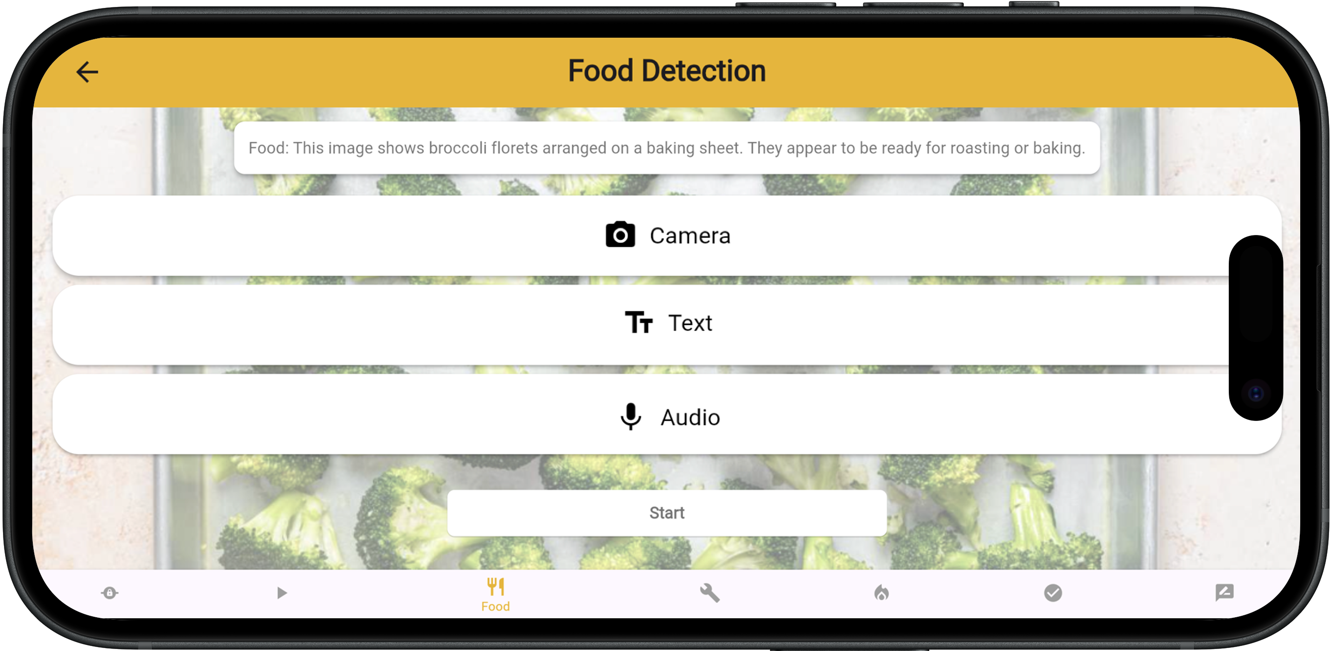

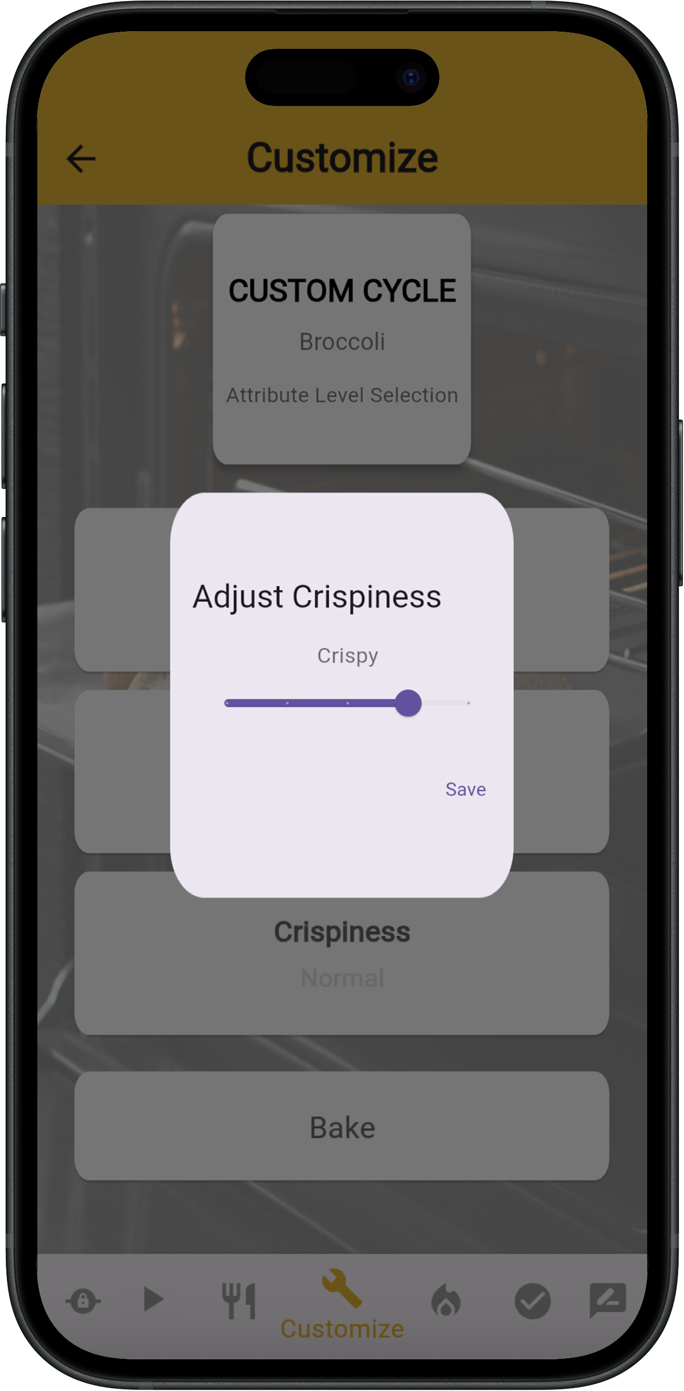

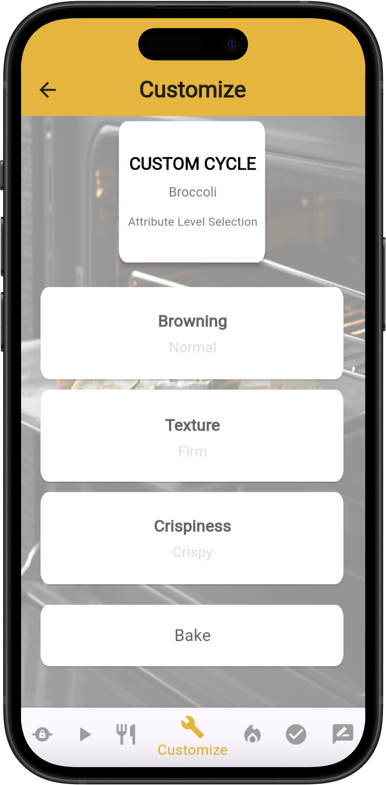

PAGE N + 30



Whirlpool

Project Sponsors

Esther Faronbi

Benton Harbor, Michigan

Alessandro Gigante

Cassinetta, Italy

Elizabeth (Liz) Kacpura

Benton Harbor, Michigan

Jackie Li

Benton Harbor, Michigan

Michigan State University

Team Members (left to right)

David Wasilewski

Grand Rapids, Michigan

Lauren Funk

Troy, Michigan

Darayus Daboo

Ann Arbor, Michigan

Pavel Shevchenko

Okemos, Michigan

Aaron Ngo

East Lansing, Michigan

Frank Puglise

Romeo, Michigan

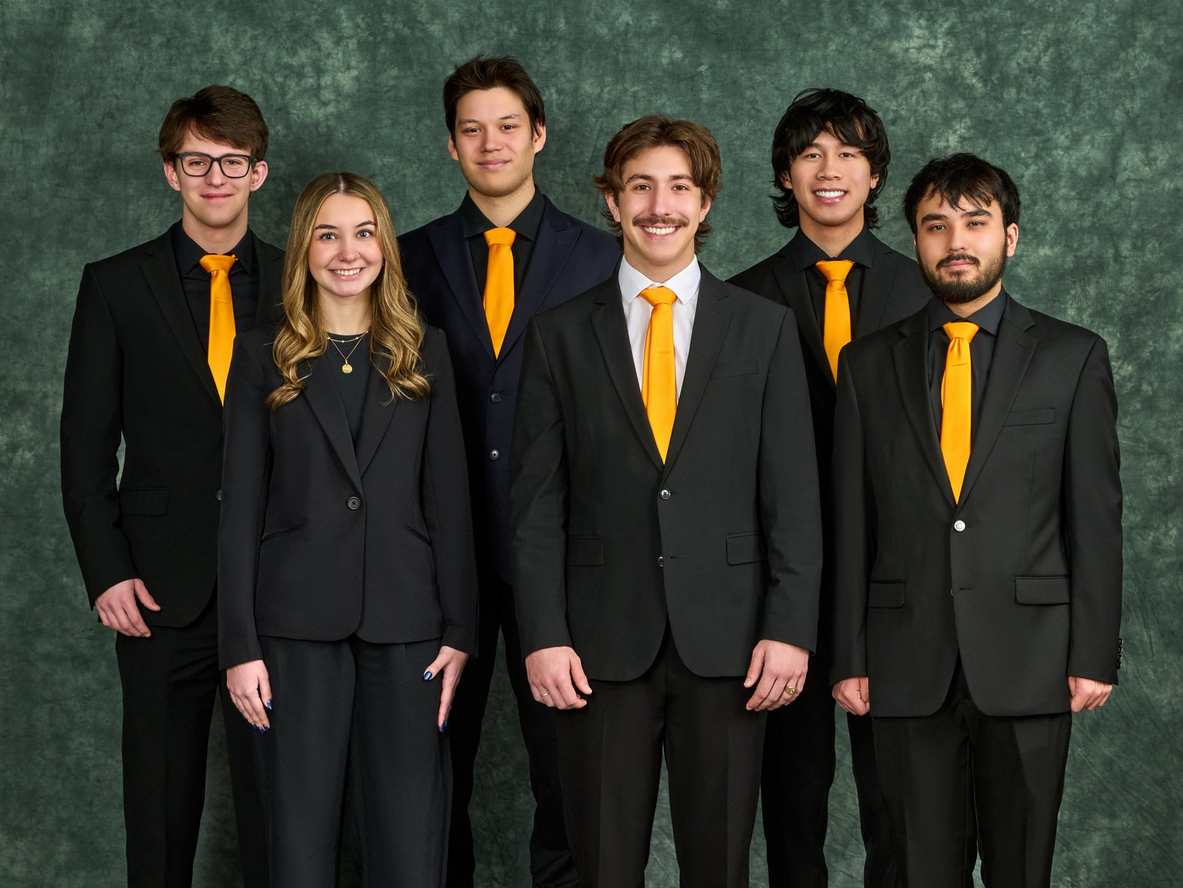

Whirlpool Corporation, headquartered in Benton Harbor, Michigan, is a global home appliance manufacturer with approximately $17 billion in annual sales, 40 manufacturing and research centers, and 44,000 employees. Whirlpool’s mission is to improve satisfaction and engagement with their home appliances.

Kitchen appliances have evolved notably over the last decade. With appliances having new features, and many food options to choose from when cooking, it can be overwhelming for individuals to determine the best way to cook their food. It requires previous knowledge, trial and error, or expansive time spent on research.

Our AI-Powdered Precision Cooking with TasteLogic curates a more enjoyable user experience with Whirlpool appliances by utilizing an on-product system and a mobile app that simplifies the cooking process when using an oven.

Users begin the process by using the mobile app to identify the food they intend to cook. This is done through a manual search, verbal speech or camera detection by taking a picture of the food.

From there, the software analyzes and suggests cooking settings for the food based on attributes that the user has approved in the past. If the user does not have previous history with the current food item, the system enables them to choose their desired cooking settings based on food type specific attributes. These attributes may include browning, texture and crispiness. After cooking, the user then provides feedback to the system based on the settings used. From this feedback, the system learns and suggests the desired settings for that food in the future.

Our mobile application is built with Dart to provide a modern and simple user interface. The application is supported by a Firebase server, with API calls facilitated by OpenAI. Flutter framework is utilized to connect the front end to the back end. The oven interface utilizes Java.

CSE498 | 8:00 a.m. – Noon Computer Science and Engineering, Third Floor | 3200/3300 Hallway

Whirlpool Corporation

AI-Powered Precision Cooking with TasteLogic