Design Day Booklet Team Page

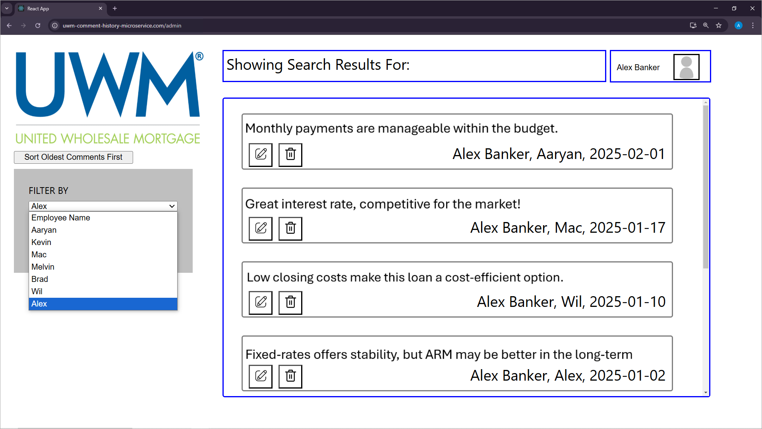

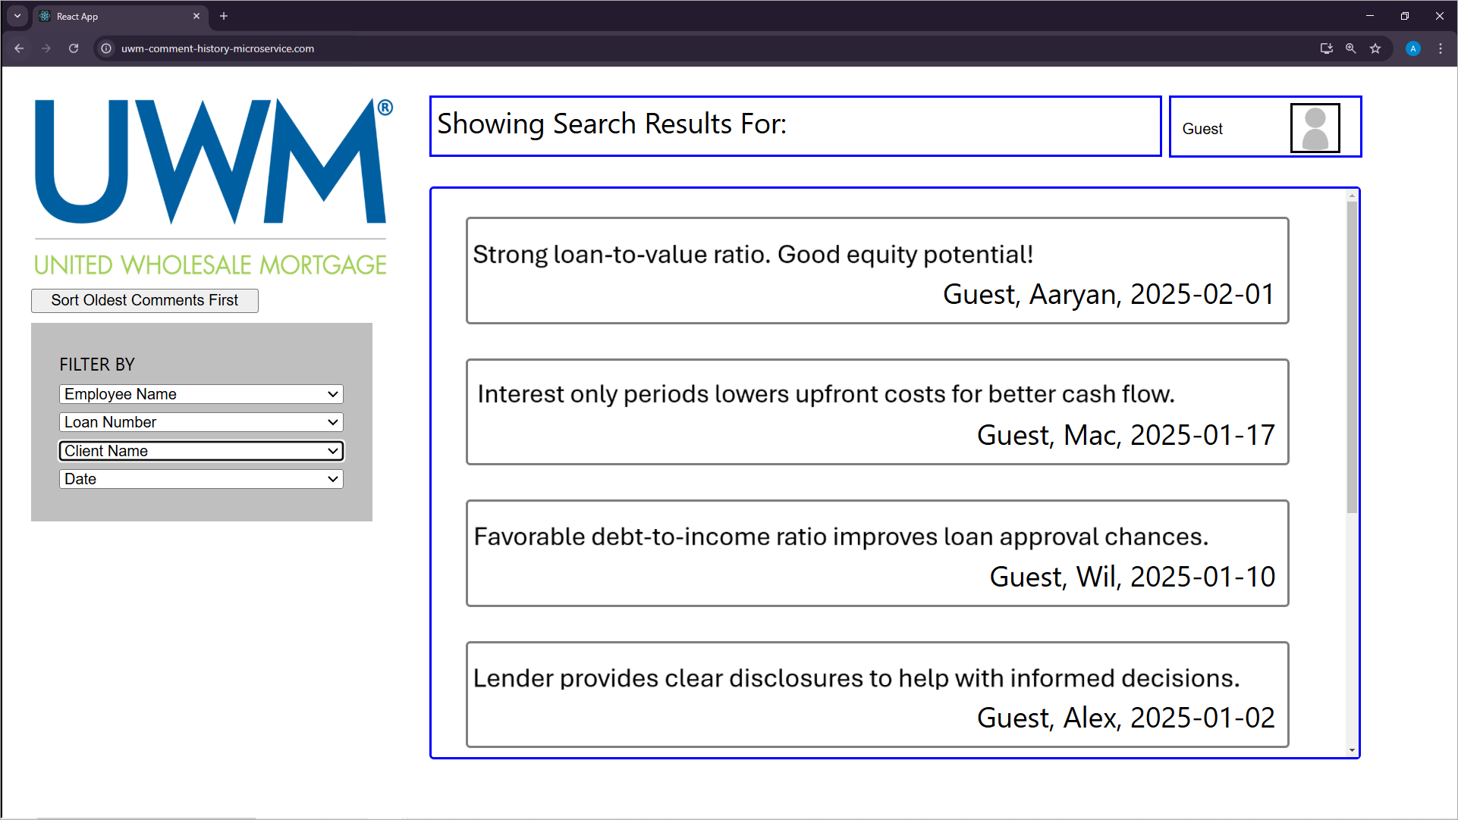

PAGE N + 28



UWM

Project Sponsors

Jillian Mantua

Pontiac, Michigan

Andrew Pirkola

Pontiac, Michigan

Jenni Sproul

Pontiac, Michigan

Michigan State University

Team Members (left to right)

Aaryan Walia

Canton, Michigan

Mac Dailey

Grosse Ile, Michigan

William Arnold

Shanghai, Puxi, China

Melvin Thomas

Farmington Hills, Michigan

Brad Deaner

Memphis, Michigan

Alex Banker

Fairfax, Virginia

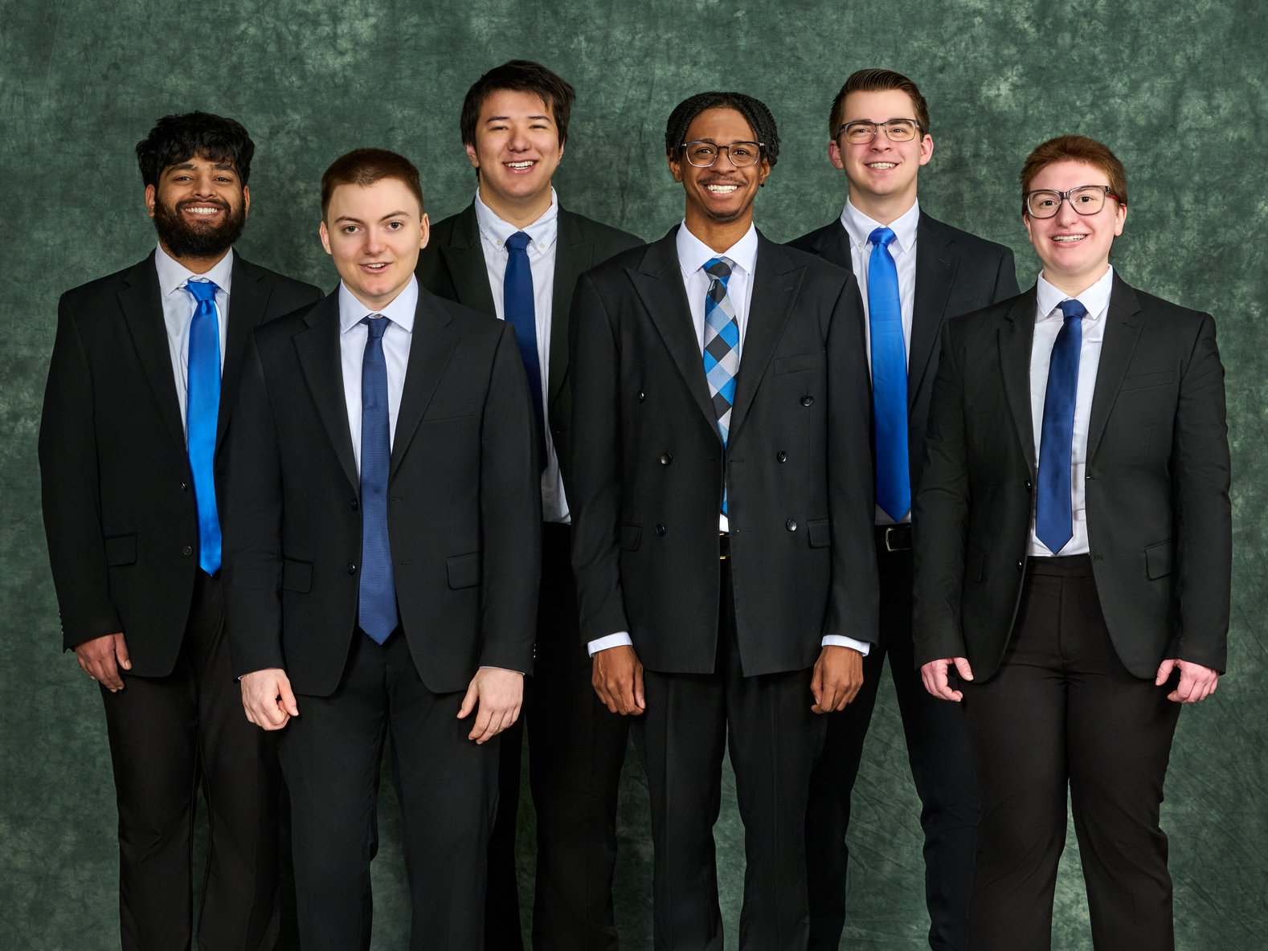

Headquartered in Pontiac, Michigan, United Wholesale Mortgage provides mortgage products and services to mortgage brokers all over the country. They are the nation’s largest wholesale mortgage broker due to their innovation, efficiency and commitment to excellence.

Because of the scale of their operations and the number of brokers they cater to, UWM houses a vast amount of data. Finding pertinent transaction information, like comments, becomes tiresome and cumbersome, as they must sift through all other relevant data to find just the comment history.

Our Centralized Comment History Microservice fixes this issue by hosting all transaction comments on a separate database, which enables a faster and more streamlined retrieval.

Users filter the comment history they want to find by specifying relevant information pertaining to the transaction, whether it is the loan number, the client or employee name, or the date.

Once the history is found, our software quickly shows the user the comments of that transaction, alongside the time of that comment and who wrote it. Comments are sorted in newest or oldest order. Users can also see edit histories of the comments.

Finally, relevant employee data pertaining to the transaction, including the name of the commenter, is seamlessly shown accompanying the comments.

Our system aggregates comment data into a single platform, speeding up transaction review and increasing productivity.

Our microservice is written in C#, using React as our front end and SQL to contain the comment data. We utilize UWM’s proprietary architecture and code to write an efficient and comprehensive software. We also use ASP.NET Core to connect the UI to the database.

CSE498 | 8:00 a.m. – Noon Computer Science and Engineering, Third Floor | 3200/3300 Hallway

UWM

Centralized Comment History Microservice