Design Day Booklet Team Page

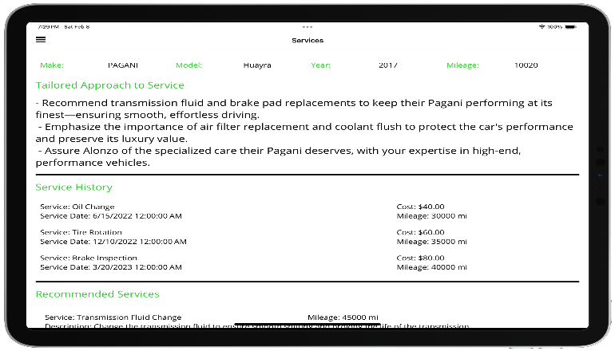

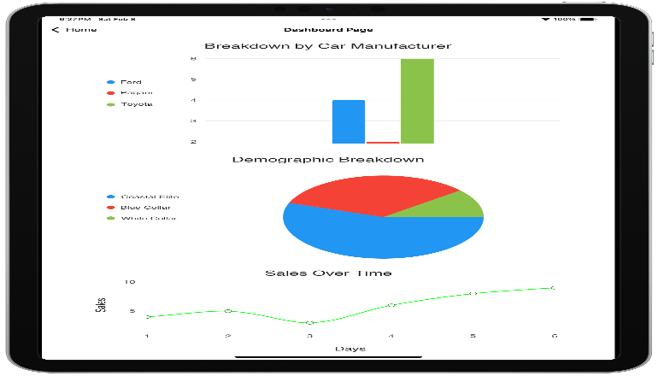

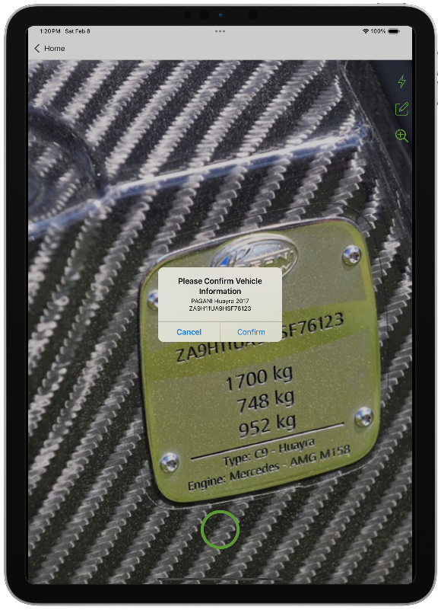

PAGE N + 27



Urban Science

Project Sponsors

Pratap Chennamoulu

Detroit, Michigan

Pierre Gilbert

Long Beach, California

Julian Gombos

Detroit, Michigan

Majd Nashwati

Detroit, Michigan

Michigan State University

Team Members (left to right)

Travis Wright

Lansing, Michigan

Owen Miller

Livonia, Michigan

John Harris

Ann Arbor, Michigan

Omar Osman

Lansing, Michigan

Josh VanBynen

Pinckney, Michigan

Srujan Patil

Novi, Michigan

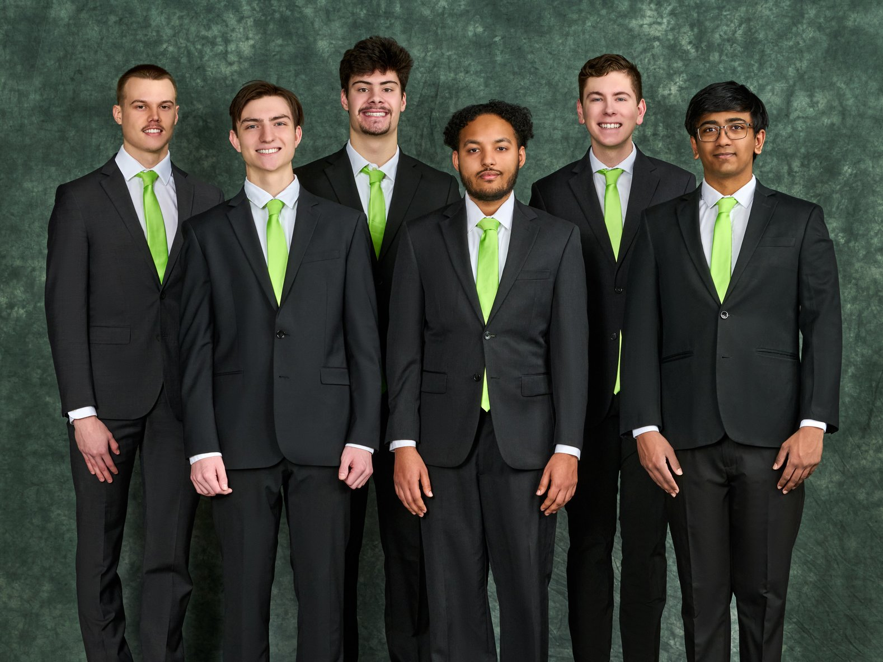

Urban Science is a leading global data-driven consulting firm based in Detroit, Michigan, specializing in providing insights and solutions for the automotive industry. Founded in 1977, the company has leveraged data and business science to help clients increase market share, improve profitability, and enhance customer satisfaction.

Due to technical knowledge gaps and varying levels of sales expertise, service advisors often face challenges when trying to connect with customers. This disconnect can result in missed sales opportunities, inconsistent service recommendations, and an unpleasant customer experience. With recent advancements in artificial intelligence (AI), Urban Science can create innovative solutions that enhance customer interactions and drive business growth.

The Automotive Service Advisor AI Assistant is a mobile application that closes the experience gap between advisors. Our tool identifies and recommends services to customers, while delivering clear and insightful sales strategies to dealerships based on individual customer personalities.

Our software captures a vehicle’s identification number and mileage, immediately displaying the customer’s information and service history, along with key relevant insights.

Our system then crafts a personalized sales strategy for the advisor informed by the customer’s past visits and generates service recommendations tailored to their current vehicle’s mileage.

Utilizing our recommendation software and generated media, dealerships easily extract insights, resulting in a refined and optimized sales experience.

Our application is built with C# featuring a .NET MAUI front end and a .NET Core web API back end. Azure AI Services, along with Synthesia, are used to generate personalized media.

3200/3300 Hallway | Third Floor, Computer Science and Engineering 8:00 a.m. – Noon | CSE498

Urban Science

Automotive Service Advisor AI Assistant