Design Day Booklet Team Page

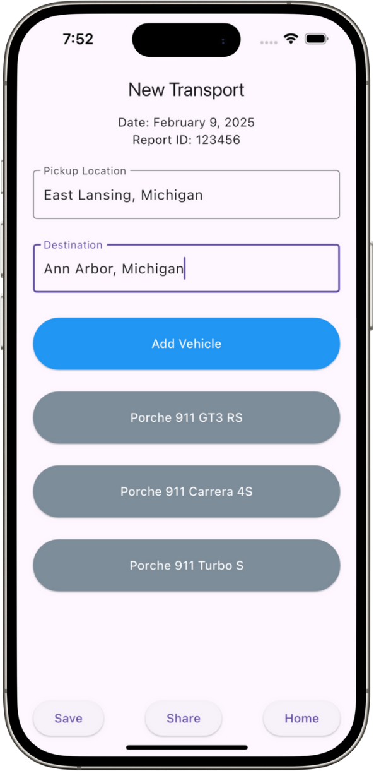

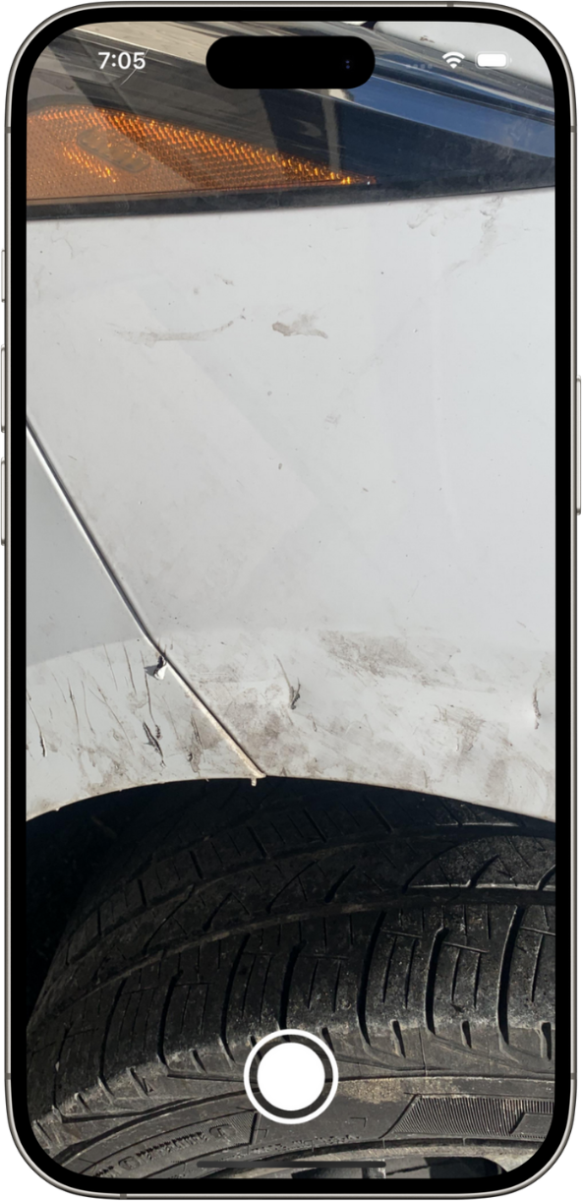

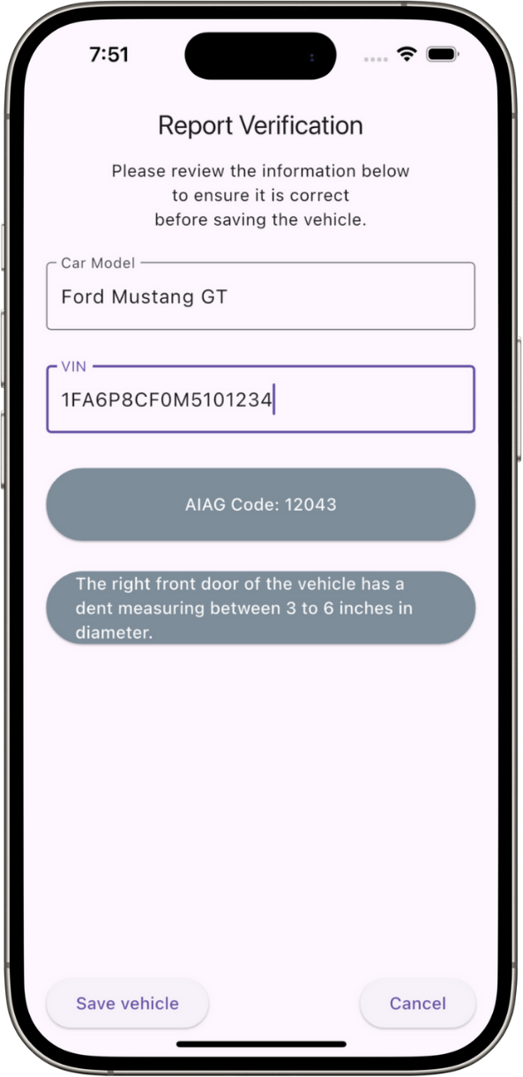

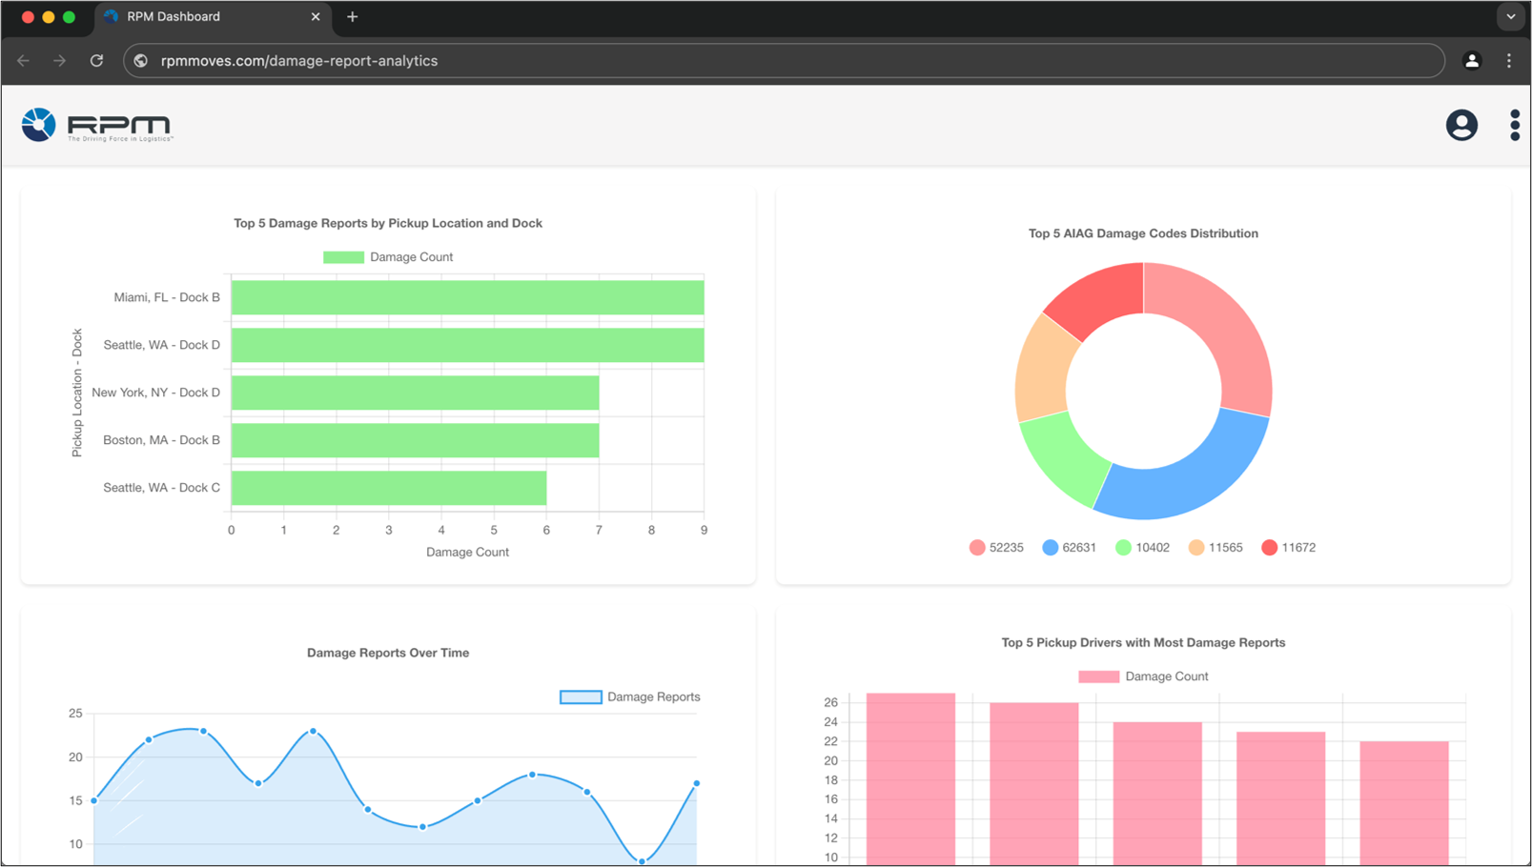

PAGE N + 23



RPM

Project Sponsors

Rick Grubb

Birmingham, Michigan

Synica Melton

Birmingham, Michigan

Michigan State University

Team Members (left to right)

Alfredo Sanchez Perez

Caracas, Miranda, Venezuela

Dheeraj Thota

Vijayawada, Andhra Pradesh, India

Gavin Bourdon

Livonia, Michigan

Flower Akaliza

Nairobi, Nairobi County, Kenya

Hayden Rance

Troy, Michigan

Troy Williams

Detroit, Michigan

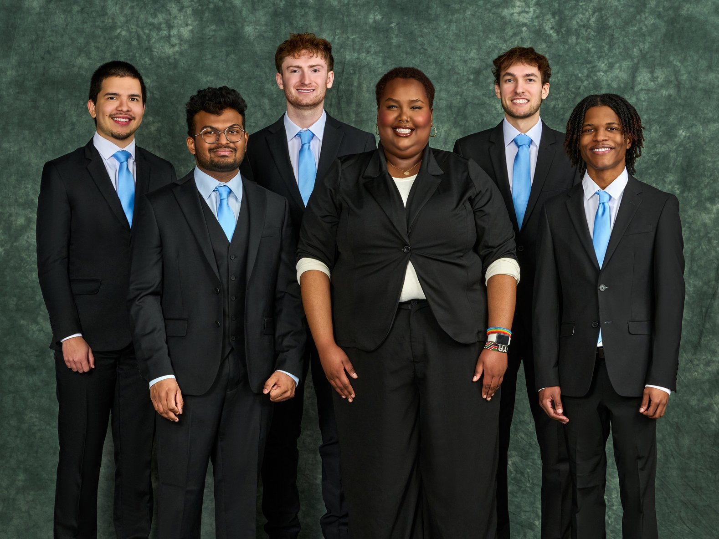

RPM is an international logistics and supply chain company based in Birmingham, Michigan. RPM specializes in freight transportation and vehicle logistics across North America and Europe. As a non-asset-based logistics company, RPM invests heavily in modern technologies and automation solutions.

RPM connects business clients with truck drivers to complete vehicle deliveries. Before transportation, truck drivers must manually log damages on each individual vehicle. This is a time-sensitive process and, when done incorrectly, can lead to costly disputes.

Our Automated Damage Logging for Truck Drivers provides drivers with a mobile app that automatically logs and classifies damages to a vehicle using photos of it. When a driver recognizes damage, they capture a photo of the vehicle and input its model and VIN. Our AI models analyze the images, identify the matching AIAG damage codes, and populate the report with a description of the damage that drivers edit before submitting. This reduces the time and effort needed for the logging process.

Our software also includes a companion web interface through which RPM’s operational teams view damage reports, track user metrics, and visualize analytics. The dashboard provides real-time insights into damage trends, vehicle conditions, and reporting frequency, helping RPM optimize operations and reduce disputes. Reports from the mobile app are seamlessly transmitted to the web platform, ensuring efficient logging and retrieval.

Our mobile app is developed using Flutter, while the web interface utilizes React. A FastAPI back end, containerized with Docker and hosted on Azure, ensures scalability. Damage reports and user data are stored in a PostgreSQL database, and TensorFlow Lite enables real-time, on-device damage classification without requiring an internet connection.

3200/3300 Hallway | Third Floor, Computer Science and Engineering 8:00 a.m. – Noon | CSE498

RPM

Automated Damage Logging for Truck Drivers