Design Day Booklet Team Page

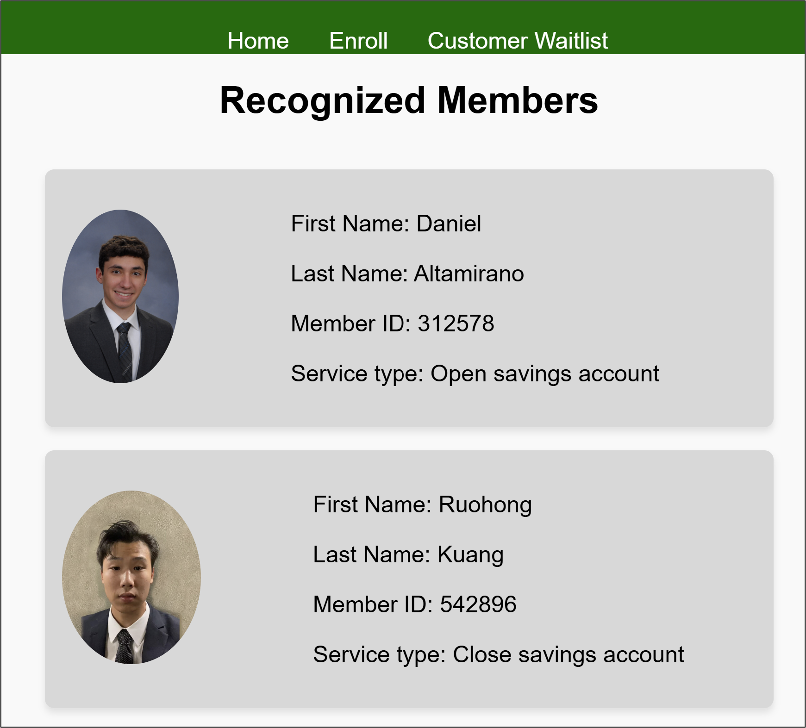

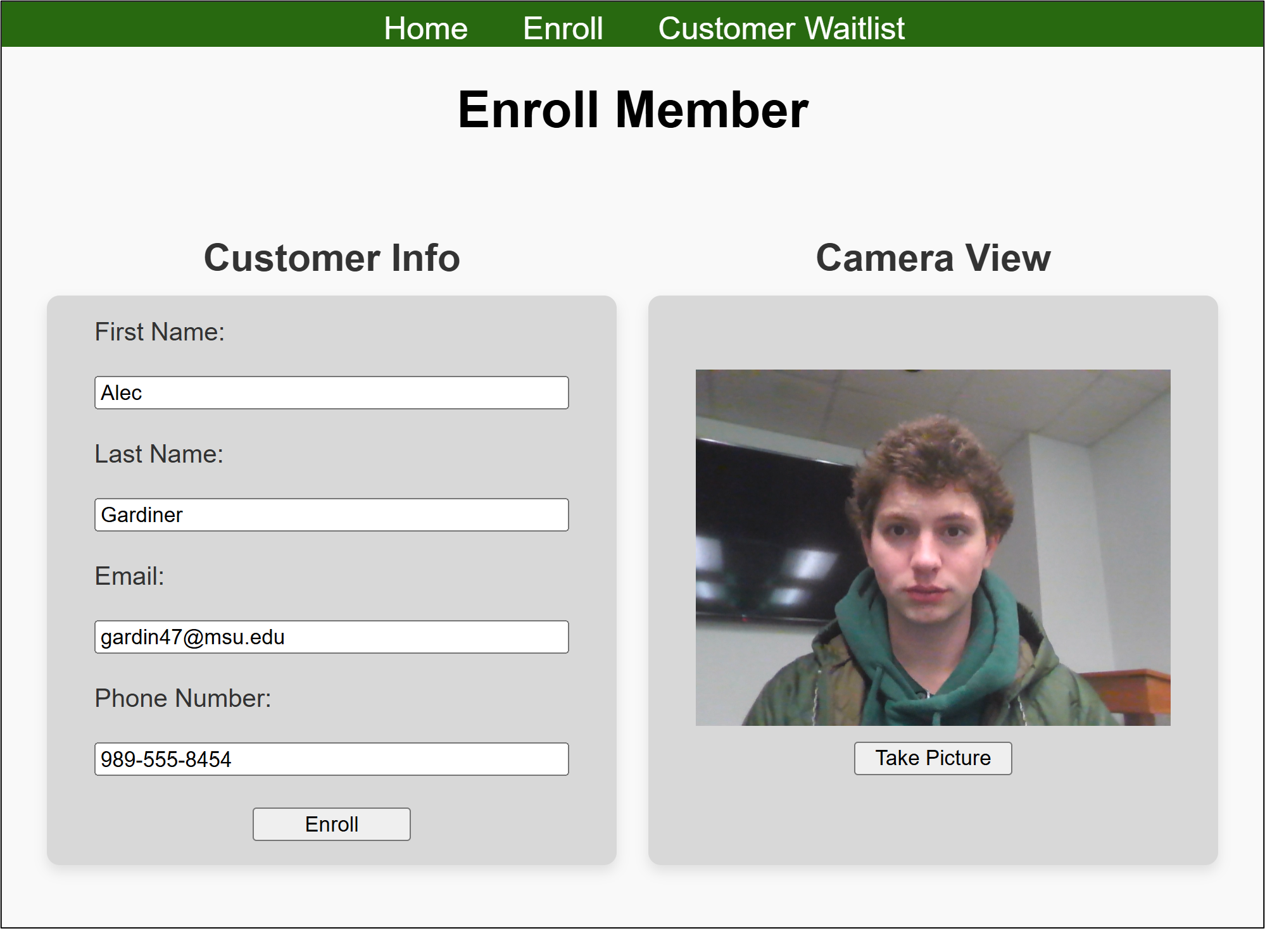

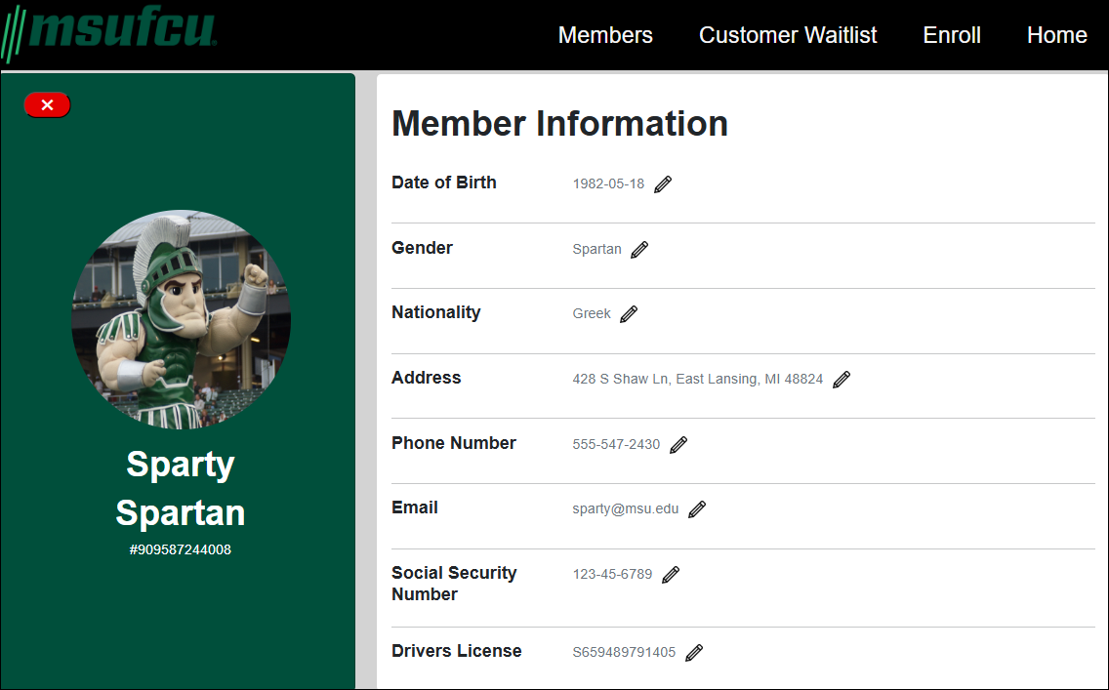

PAGE N + 21



MSUFCU

Project Sponsors

Alex de Almeida

East Lansing, Michigan

April Clobes

East Lansing, Michigan

Filip Danielewicz

East Lansing, Michigan

May Isrow

East Lansing, Michigan

Ben Maxim

East Lansing, Michigan

Meredith Nicholoff

East Lansing, Michigan

Michigan State University

Team Members (left to right)

Alec Gardiner

Grayling, Michigan

Spencer Russell

Livonia, Michigan

Ryan Fitzgerald

Oakland Township, Michigan

Reyna McConville

El Dorado Hills, California

Ruohong Kuang

Hengyang, Hunan, China

Daniel Altamirano

St. Louis, Missouri

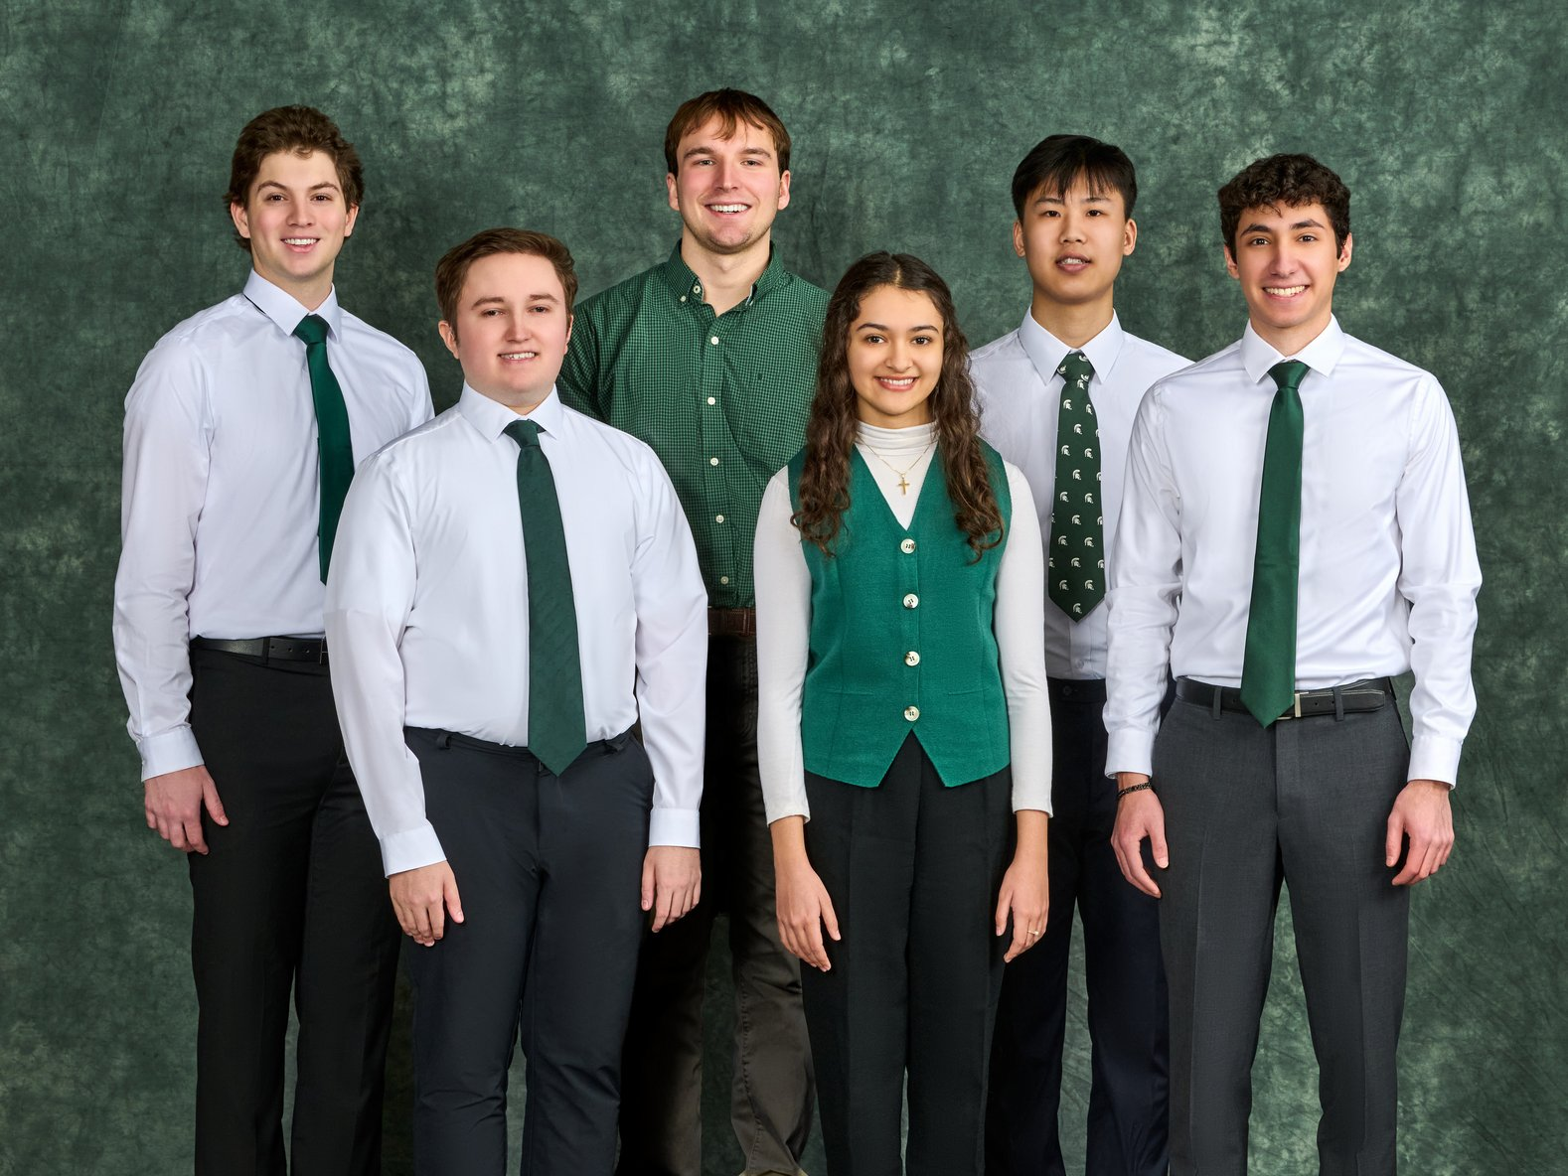

Established in 1937, MSU Federal Credit Union (MSUFCU) has been serving Michigan State University and the greater Lansing area for over 88 years. With over 24 branch locations statewide and 367,000 members, MSUFCU strives to help its local communities thrive and achieve financial freedom.

When visiting a branch, MSUFCU currently provides a standard check-in process that requires a member to input their name and wait for a teller to assist them. This process can be lengthy and contribute to customer dissatisfaction. MSUFCU is looking to provide a more seamless experience where the branch recognizes members upon arrival.

Our Logged-In Branch Experience streamlines the in-person banking experience by using the organization’s security cameras to identify members as they enter the building. Once a member is identified, MSUFCU staff can easily pull up relevant data and prepare to help the member.

Members are enrolled in the system by entering their name and a reference photo, which is stored securely in our system’s database. When anyone enters the building, facial recognition compares their face to those stored in our database.

When our system detects a face, the teller receives a notification on their computer. If a member is recognized, the teller then quickly accesses their account information and prepares to assist the member. Conversely, the teller also has the option to ignore the notification if they won’t be assisting the member or if the person detected is not an enrolled member. This process enables MSUFCU members to skip the sign-in process and fulfill their banking needs quickly and easily.

Our Logged-In Branch Experience utilizes a front end built with HTML, CSS, and JavaScript with a Python back end. Information is stored and updated using a MySQL database.

3200/3300 Hallway | Third Floor, Computer Science and Engineering 8:00 a.m. – Noon | CSE498

MSU Federal Credit Union

Logged-In Branch Experience