Design Day Booklet Team Page

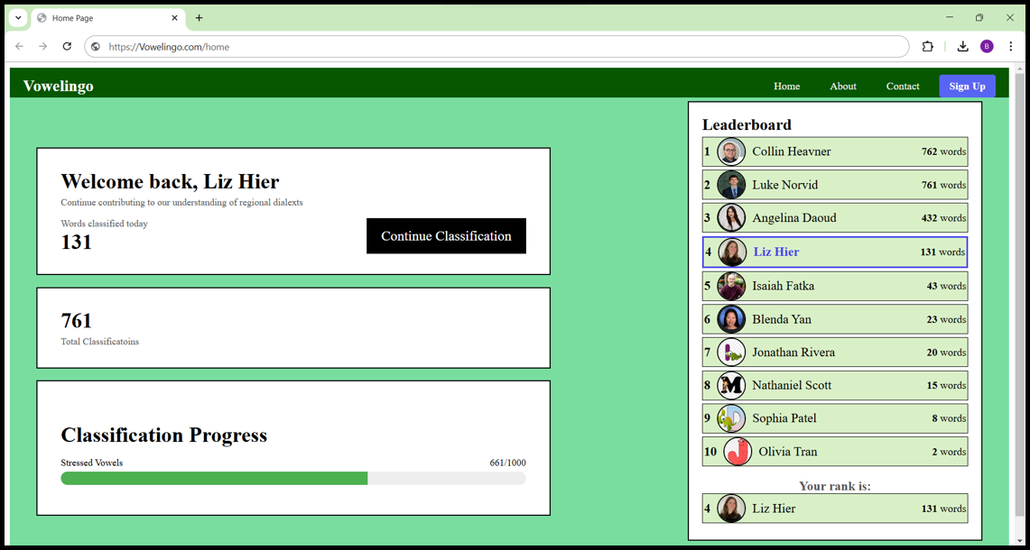

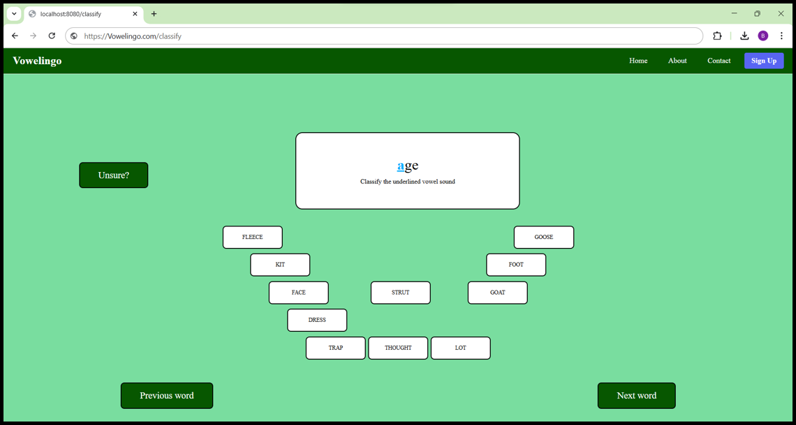

PAGE N + 20



Michigan State University Linguistics

Project Sponsors

Monica Nesbitt

Bloomington, Indiana

Betsy Sneller

East Lansing, Michigan

Joey Stanley

Provo, Utah

Michigan State University

Team Members (left to right)

Luke Norvid

Glen Ellyn, Illinois

Blenda Yan

Rochester Hills, Michigan

Collin Heavner

Dorr, Michigan

Angelina Daoud

Macomb, Michigan

Isaiah Fatka

Wixom, Michigan

Elizabeth Hier

Plymouth, Michigan

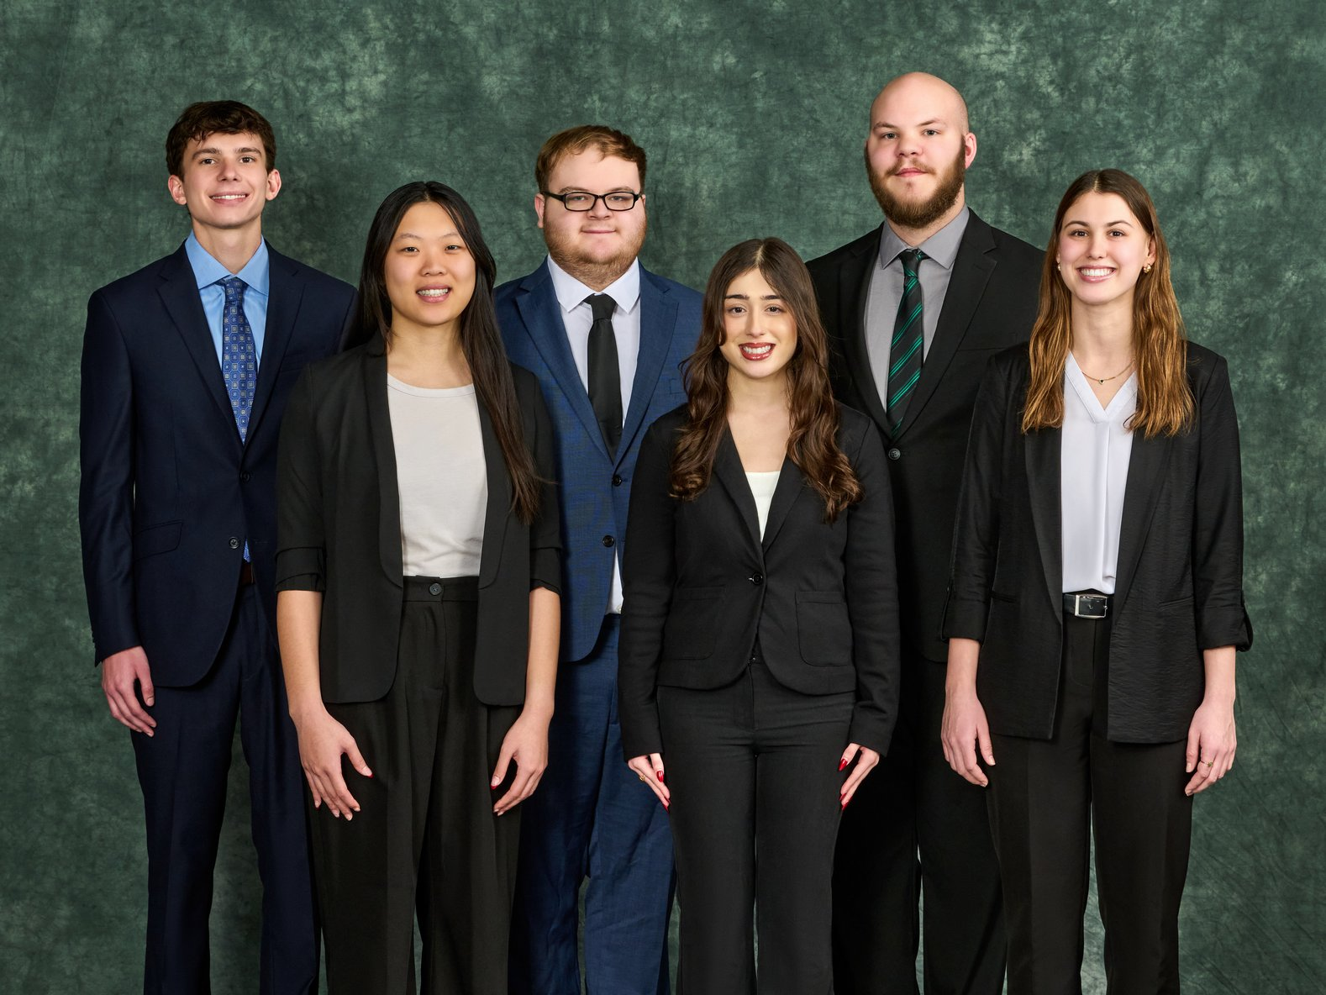

The Michigan State University Linguistics Department provides theoretical foundation in the science of language sounds, structures, and meanings, with a focus on language variation.

One variation in language is dialect evolution. While dialect boundaries in North America have remained relatively unchanged, the ways in which people pronounce words continue to evolve.

Traditional dialect atlases rely on methods that limit their accuracy and scope, and traditional linguistics research relies on limited data points to study these shifts.

Our Crowd-Sourcing Intuitions of Vowel Classifications system reimagines linguistic data collection by introducing a web application that enables real-time vowel classification. Linguists classify thousands of words efficiently, contributing to a more comprehensive and dynamic understanding of dialect evolution.

The web application streamlines the process of vowel classification. Users begin with a pre-test to determine their dialectal distinctions. During classification, a word appears in a central display box with the targeted vowel highlighted for identification. Below the word, classification buttons displaying available lexical sets for selection are arranged into a trapezoidal shape familiar to linguists.

As users engage with the platform, their progress is displayed on a dashboard with a point system to motivate consistent participation. Researchers download classification data to conduct their own data analysis.

Our vowel classification system reveals modern dialectal trends and propels linguistics research forward.

The front end is built with React.js and structured with HTML, CSS and JavaScript to handle various data. The back end is powered by Flask which handles API requests and communication with the database.

CSE498 | 8:00 a.m. – Noon Computer Science and Engineering, Third Floor | 3200/3300 Hallway

Michigan State University

Crowd-Sourcing Intuitions of Vowel Classifications