Design Day Booklet Team Page

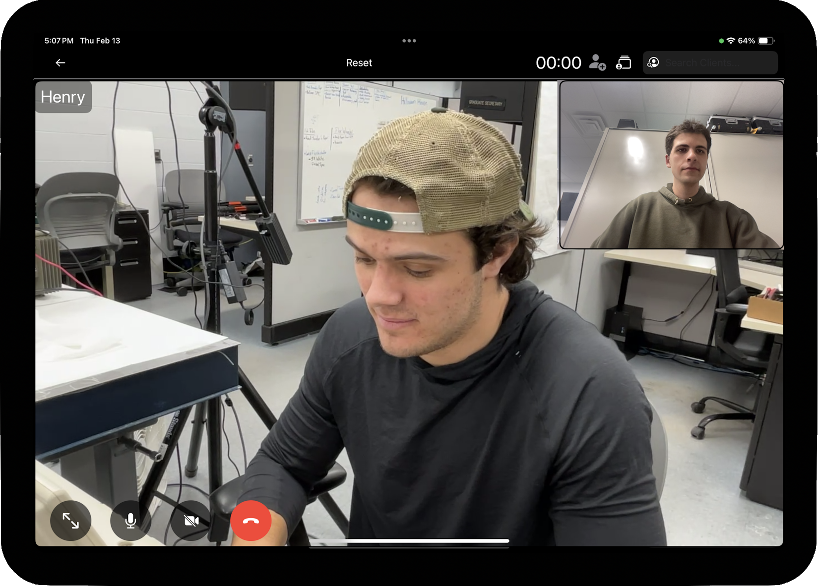

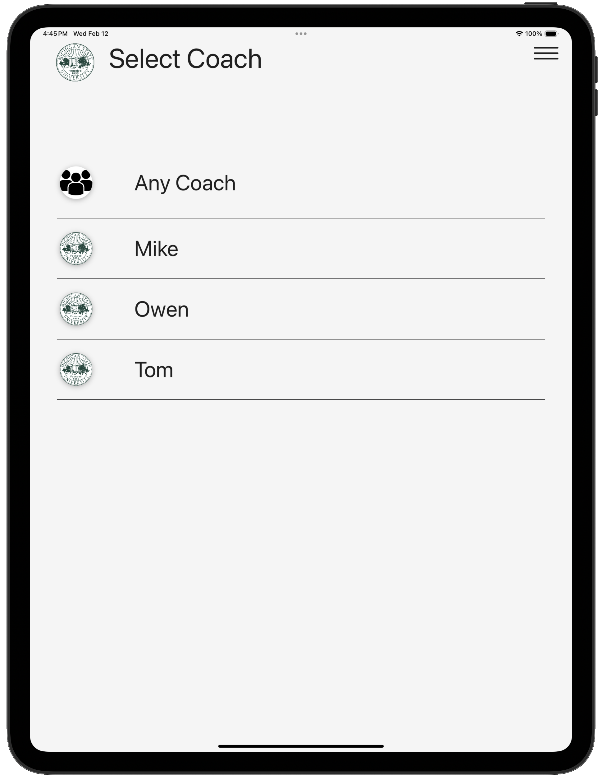

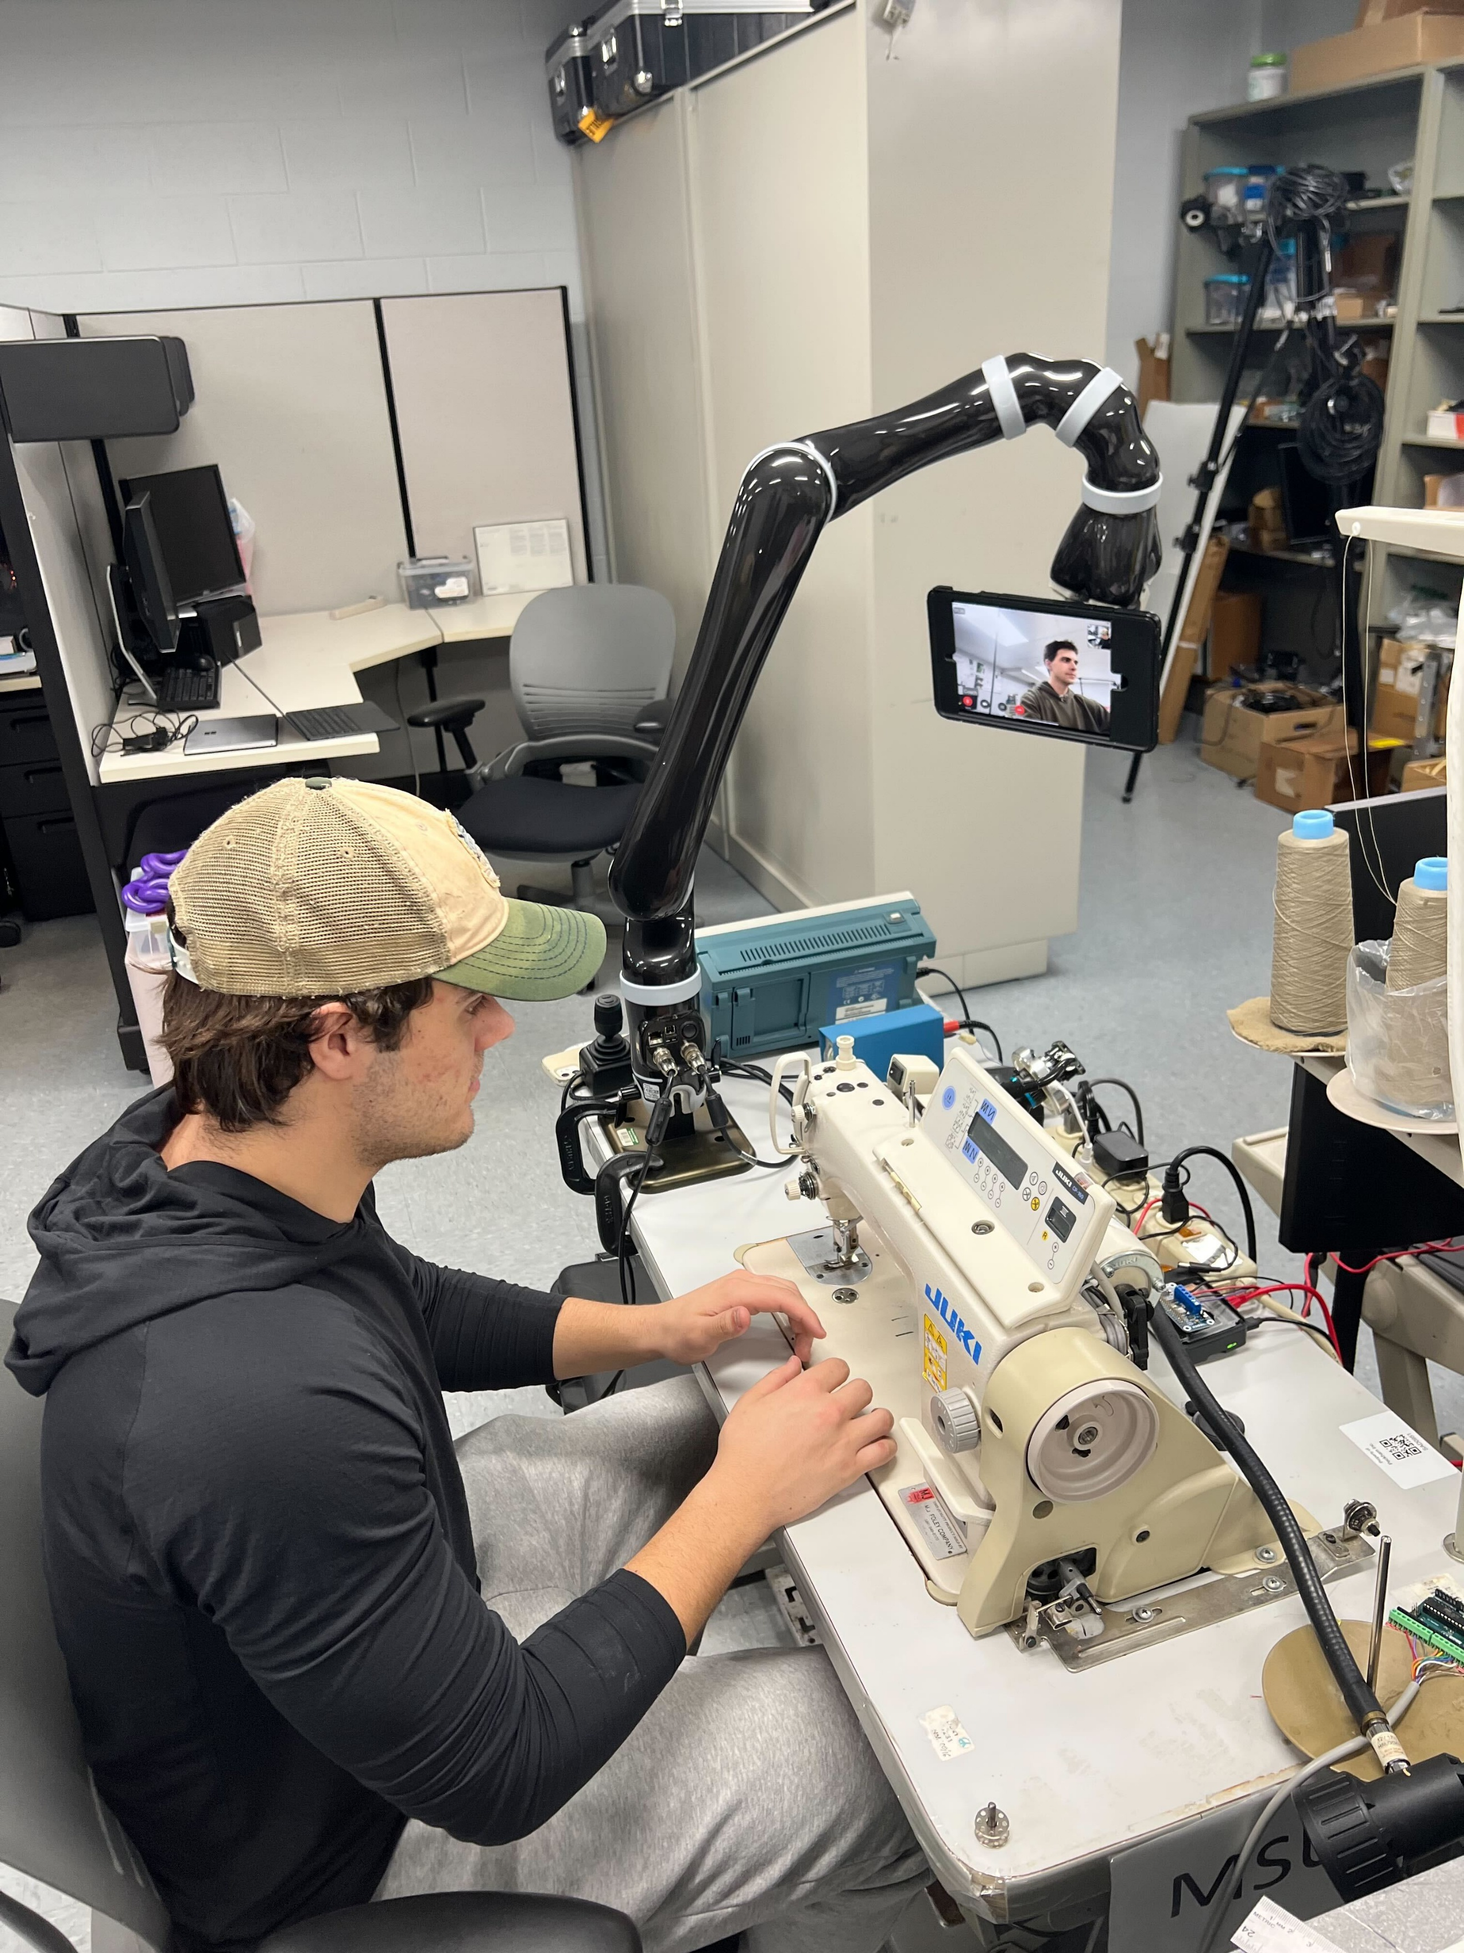

PAGE N + 18



Michigan State University CSE RJC

Project Sponsors

Ashrut Aryal

East Lansing, Michigan

Hung Jen Kuo

East Lansing, Michigan

Ranjan Mukherjee

East Lansing, Michigan

Charles Owen

East Lansing, Michigan

Michigan State University

Team Members (left to right)

John Nowinski

Blacksburg, Virginia

Gera Berhanu

Seattle, Washington

Nicolas Clark

Livonia, Michigan

Hail Lim

Seoul, Seoul, South Korea

Sean Finkel

Northbrook, Illinois

Cole Lanzinger

Toledo, Ohio

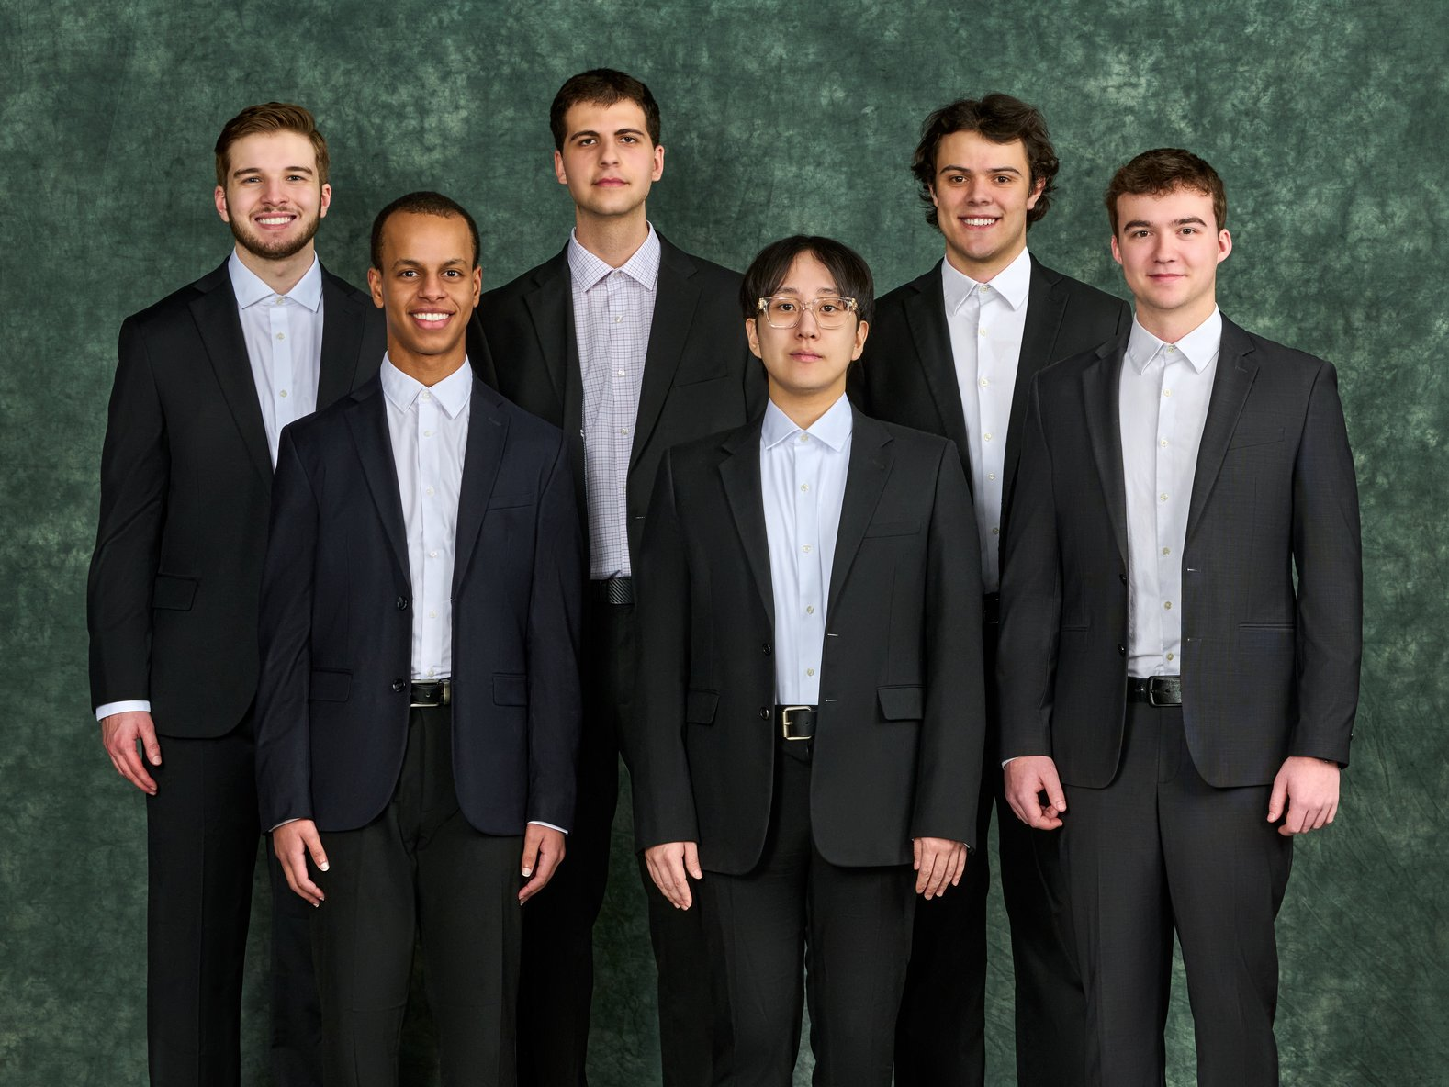

The department of Computer Science and Engineering (CSE) is the largest academic unit in the College of Engineering at Michigan State University (MSU). The department hosts 20 laboratories, each equipped with cutting-edge technologies that facilitate research in a wide spectrum of topics. MSU CSE boasts an array of industry-leading research in collaboration with departments such as robotics, special education, psychology, and more.

Research professionals from various fields are collaborating with the CSE department to develop an industry-leading system for workplace training. Job coaching is a valuable resource for employees with disabilities to thrive in a workplace. In-person job training requires a coach to be on-site. Virtual job coaching enables a job coach to reach multiple clients without the limitation of physical presence.

Our Robotic Job Coaching system alleviates many of the challenges with in-person job coaching. Using our system, coaches connect with any of their clients virtually through a teleconference call. Clients request assistance from a coach and enter a queue.

The client devices are mounted on a robotic arm and coaches remotely manipulate the robotic arm, enabling coaches to view the complete work area remotely. The coach is able to gain a full understanding of any problems that the employee may be experiencing, thereby facilitating better coaching.

Our system combines the effectiveness of in-person job coaching with the flexibility of virtual coaching to offer an effective and innovative solution for job coaches.

The front end of the Robotic Job Coaching system is built in Java for Android and Swift for iOS. Our back end is hosted on a docker container running a Python Flask application with a Gunicorn server client. The robot is controlled over UDP using ROS noetic and the ROSbridge package.

CSE498 | 8:00 a.m. – Noon Computer Science and Engineering, Third Floor | 3200/3300 Hallway

Michigan State University

Robotic Job Coaching 2.0