Design Day Booklet Team Page

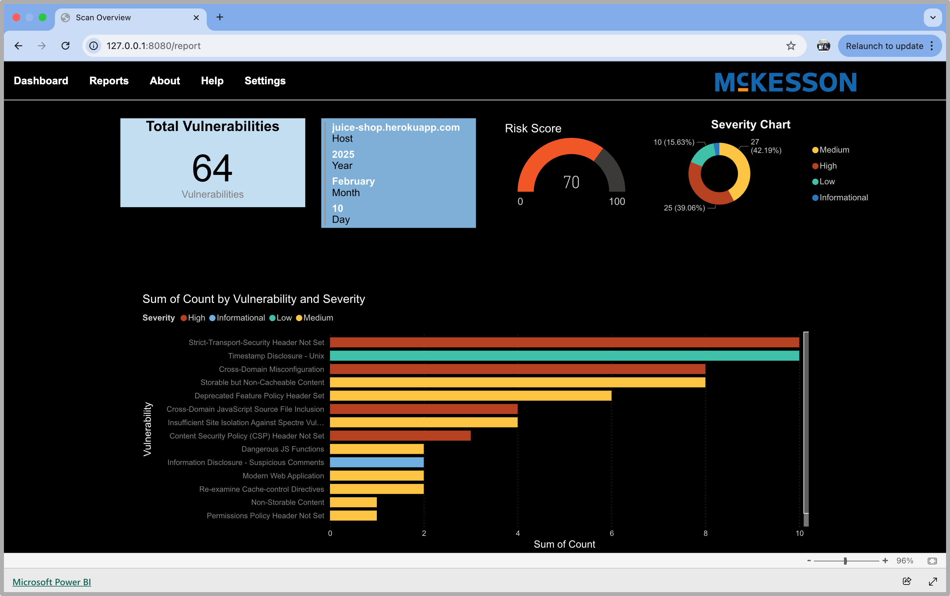

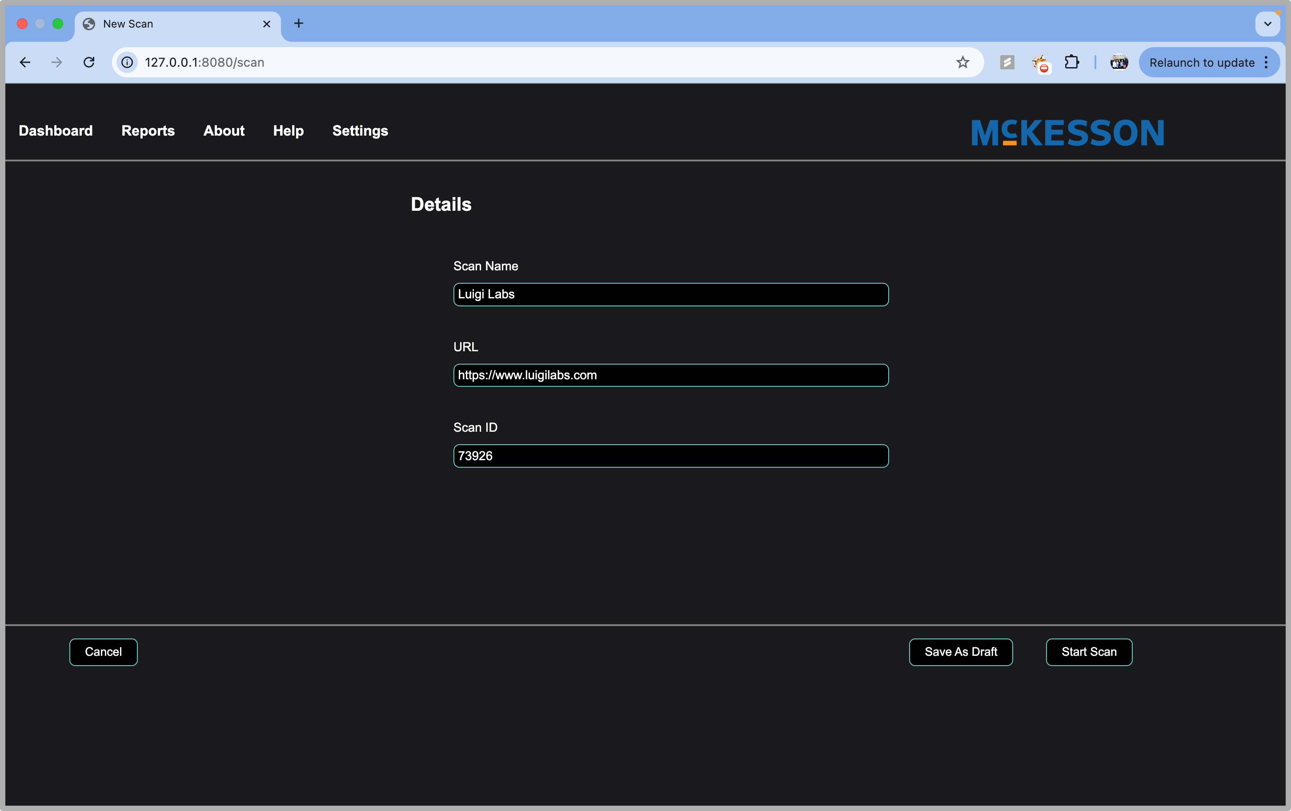

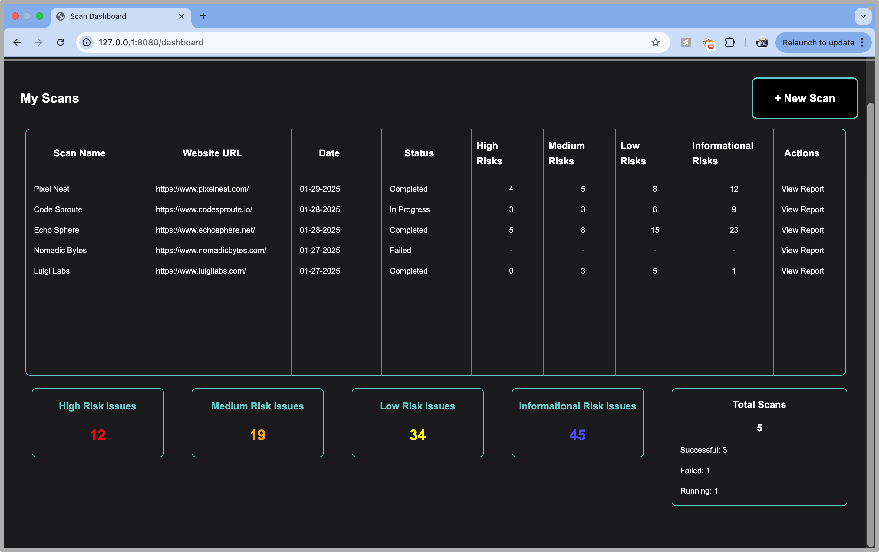

PAGE N + 16



McKesson

Project Sponsors

Kosti Cami

Irving, Texas

Antony Mathew

Detroit, Michigan

Spencer Searle

Detroit, Michigan

Michigan State University

Team Members (left to right)

Nicholas Felarca

Shelby Township, Michigan

Demetrius Wilson

West Bloomfield, Michigan

Brady Johnson

Rockford, Michigan

Ananya Chittineni

Vijayawada, Andhra Pradesh, India

John Bannon

Northville, Michigan

Chris Nguyen

Madison Heights, Michigan



McKesson is a Fortune 10 healthcare company that streamlines pharmaceutical delivery and patient care across the globe. McKesson strives to improve patient outcomes by seamlessly integrating technology into pharmaceutical services worldwide.

Healthcare environments depend on strong cybersecurity measures to protect sensitive patient data and prevent disruptions in critical hospital operations and pharmaceutical supply chains. Even a single vulnerability in a web application might serve as an entry point for cyber threats, putting patient privacy and healthcare infrastructure at risk. Identifying these weaknesses before they can be exploited is crucial in maintaining a secure digital environment.

Our Vulnerability Scan and Detect tool provides a proactive approach to cybersecurity by analyzing web applications for potential security flaws. After a user simply enters a URL, our system conducts a thorough scan, detecting vulnerabilities that could be leveraged in cyberattacks.

Once the scan is complete, a detailed report is generated, highlighting identified risks along with actionable recommendations to mitigate them. Risk statistics are visualized with easy-to-read charts, enabling users to understand risks at a glance. All reports are stored in a secure database which is linked to the web application for a seamless view of scan history.

This system enables healthcare organizations to address security gaps efficiently, reducing the likelihood of data breaches, system outages, or unauthorized access to critical information.

The application is built using a Flask-based back end to manage scan requests and process results. The front end is built with HTML, CSS, and JavaScript to provide an intuitive user experience for entering URLs and reviewing reports. The scanning process utilizes industry-standard security testing frameworks to provide accurate and comprehensive vulnerability detection.

CSE498 | 8:00 a.m. – Noon Computer Science and Engineering, Third Floor | 3200/3300 Hallway

McKesson

Vulnerability Scan and Detect