Design Day Booklet Team Page

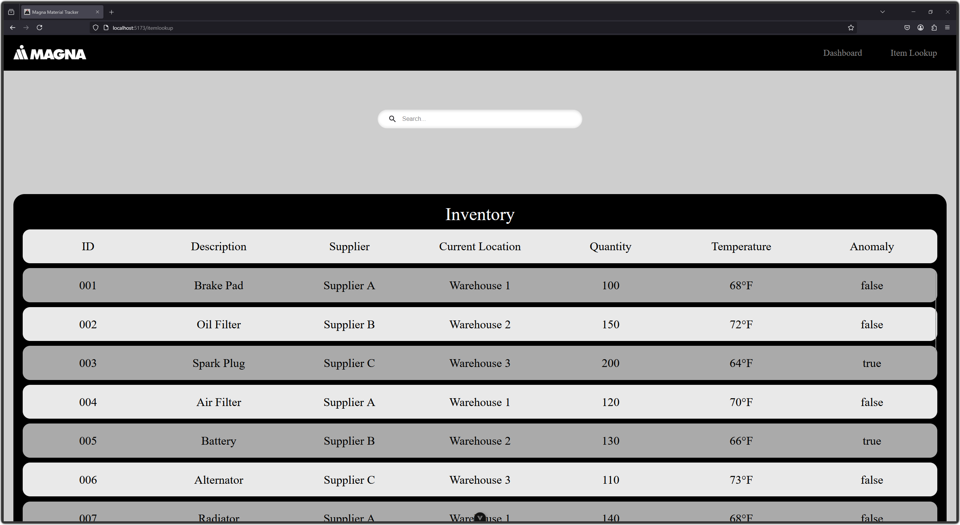

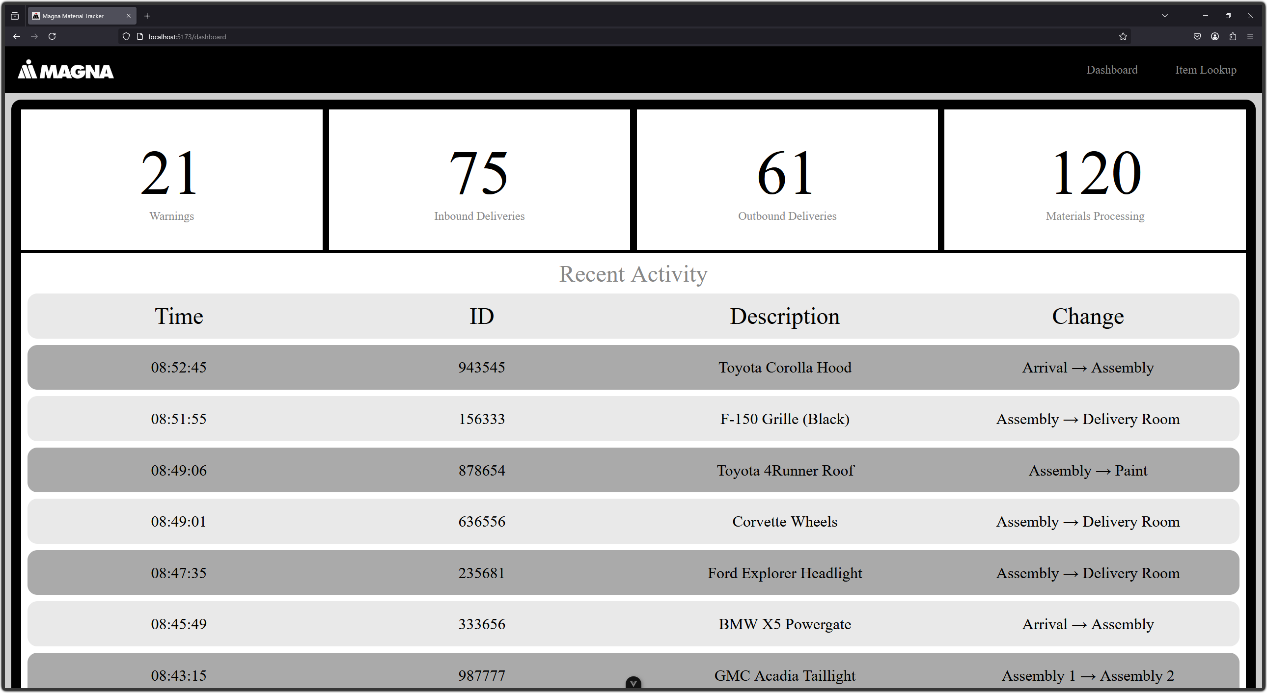

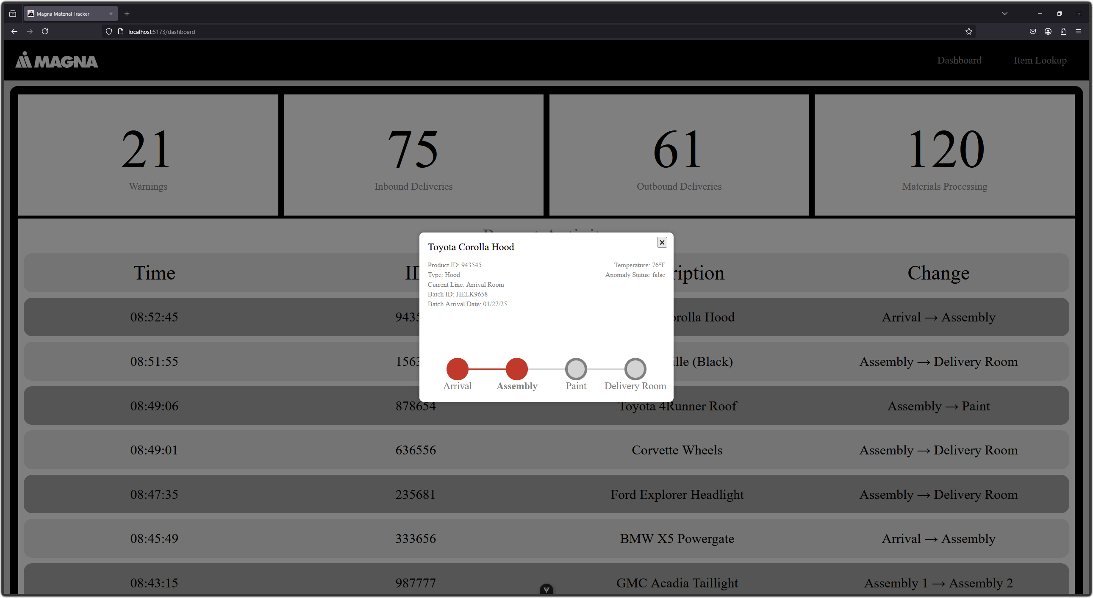

PAGE N + 15



Magna

Project Sponsors

Jim Quesenberry

Troy, Michigan

Raidu Rayasam

Boston, Massachusetts

Chantal Ruggaber

Troy, Michigan

Sundar Selvaraj

Boston, Massachusetts

Michigan State University

Team Members (left to right)

Kaustubh Siriki

Troy, Michigan

Charlie Cicchella

Bloomfield Hills, Michigan

Eli Gudeman

Grayslake, Illinois

Dung Nguyen

Warren, Michigan

Tim Bodholt

Las Vegas, Nevada

Allen Shi

Rochester, Michigan



Magna, founded in 1957 as a small tool and die shop, has evolved into a global automotive technology and manufacturing powerhouse. They are a key player in the automotive industry, supplying components and systems to major vehicle manufacturers worldwide, and shaping the future of mobility solutions.

In order to stay ahead of the competition, Magna needs to keep track of all of its goods and materials throughout the manufacturing process. Unfortunately, with so many factories and products, this can be very difficult. Manufacturers need a more efficient way to track and identify materials that make up their products.

Our Manufacturing Tracking System solves this problem for Magna by creating a digital record of materials as they pass through the manufacturing process. Our web app interface provides key information about material details and movement history.

Users gain real-time insight on the most recent material movements in the factory as well as the ability to find what materials make up a product. Our system displays factory sensor data in real time, enabling operators to detect manufacturing problems early, reducing waste and improving production.

Our software is built on blockchain technology, ensuring that every record is permanent and cannot be altered. The blockchain also enables users to view the entire history of a product as it navigates through Magna’s supply chain. Operators visualize these chains of events using our web app.

By combining real-time monitoring with secure digital records, our software improves efficiency and reduces costly errors.

Our system runs on Hyperledger for blockchain security with a Node.js back end to efficiently handle large volumes of real-time data from IoT sensors and material tracking logs. The front end uses Vue.js for a smooth UI interface that enables operators to view updates instantly as the material moves through production.

3200/3300 Hallway | Third Floor, Computer Science and Engineering 8:00 a.m. – Noon | CSE498

Magna

Manufacturing Tracking System