Design Day Booklet Team Page

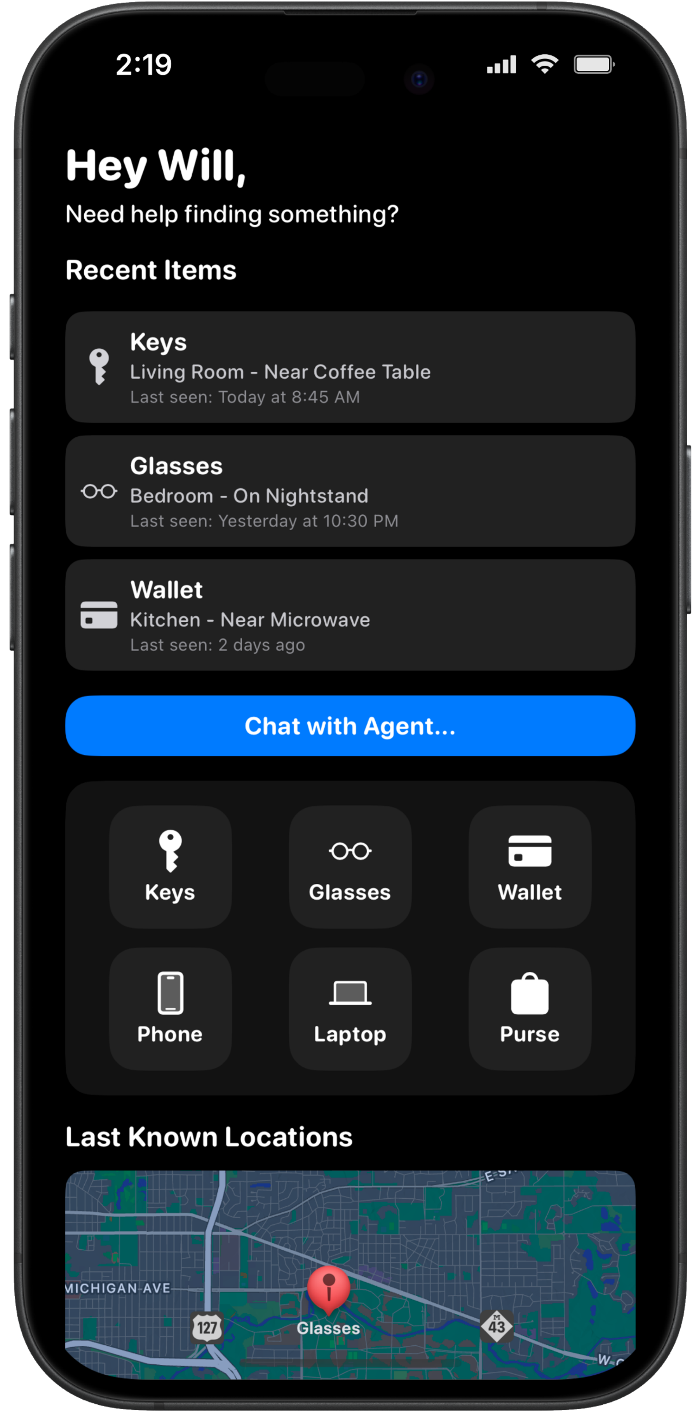

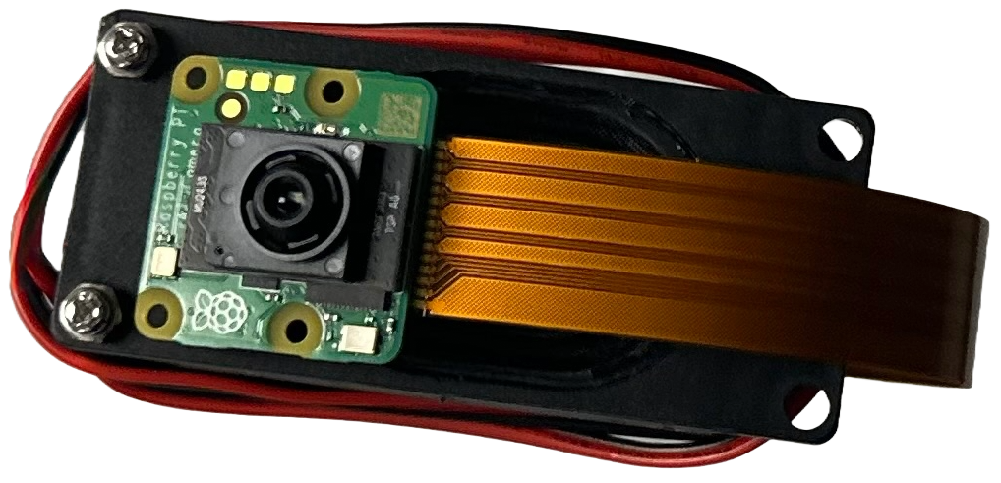

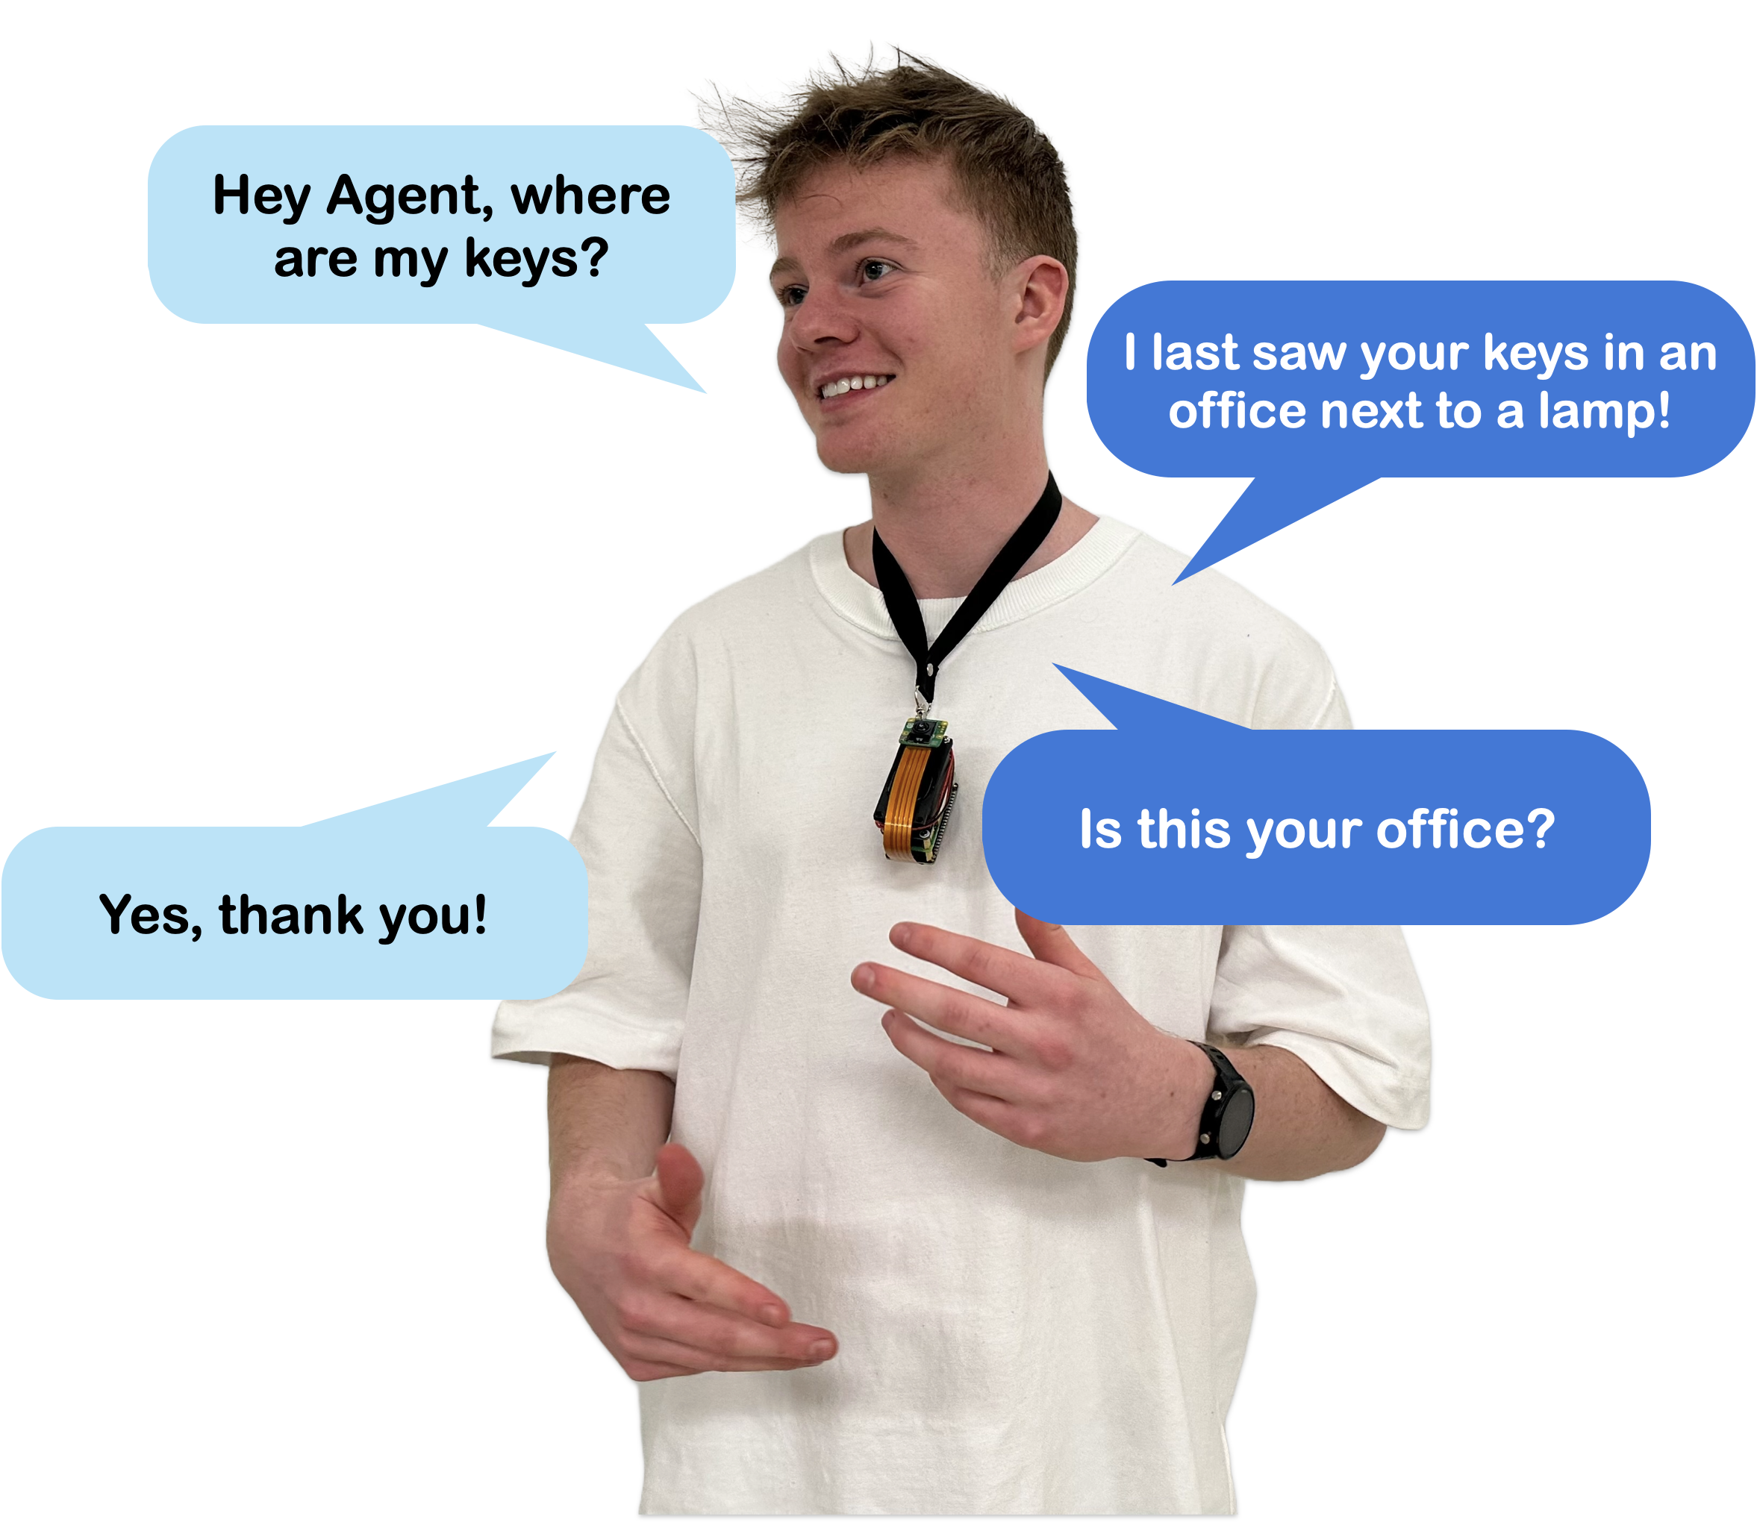

PAGE N + 14



Launch

Project Sponsors

Scott Campagna

Troy, Michigan

Anna Kowalak

Troy, Michigan

Jeff Meador

Troy, Michigan

Michigan State University

Team Members (left to right)

Anthony Oo

Novi, Michigan

Palina Skakun

Mogilev, Belarus

Gregory Lis

Lexington, Michigan

Swabhan Katkoori

Okemos, Michigan

Will Bray-Cotton

Troy, Michigan

Deirdre Eusebi

Bloomfield Hills, Michigan

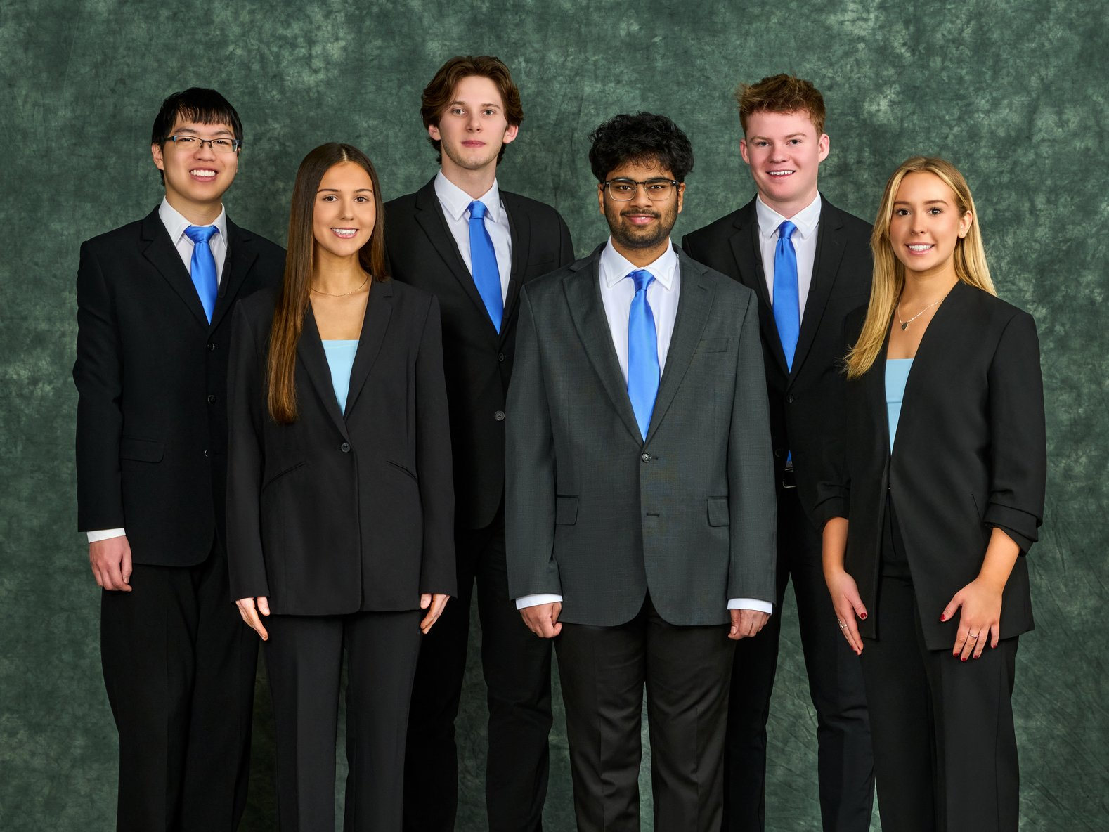

Launch, a subsidiary of NTT Data, accelerates product development by delivering innovative engineering solutions. With offices across the Americas, Launch partners with industry leaders like Jeep and Adidas to transform ideas into scalable technology.

People frequently misplace essential items like keys and wallets, leading to frustration and wasted time. Existing solutions, such as tracking tags, require manual setup, while voice assistants lack real-time object detection. A more intuitive, hands-free solution is needed to seamlessly integrate item tracking into daily life.

Our Everyday Agent is a wearable device powered by artificial intelligence that tackles this problem. Equipped with a compact camera, the device continuously scans the user’s surroundings to detect and log their items’ locations. Using this information, Everyday Agent provides the last known location of an item. If an object cannot be accurately located, the system analyzes past user habits and suggests the most likely location.

Users interact with Everyday Agent by saying, “Hey Agent,” followed by their query. When they request location services, the device responds with either a precise location or an estimate. It also functions as a voice assistant, answering general questions.

A companion mobile app provides users with a dashboard displaying their most frequently misplaced items. Each item is listed alongside a description, such as “on the kitchen counter,” and its last shown GPS-based coordinate, plotted on an interactive map.

Our Everyday Agent uses a Raspberry Pi Zero 2 W with a camera, speaker and microphone. The mobile app is written in Swift, and the product software is written in Python using multiple models. You Only Look Once, Places365, Roboflow and ORB-SLAM are used for image recognition. Microsoft Azure is used for speech, text and natural language processing as well as a virtual machine. PyTorch is used for the predictive location algorithm.

CSE498 | 8:00 a.m. – Noon Computer Science and Engineering, Third Floor | 3200/3300 Hallway

Launch by NTT DATA

Everyday Agent