Design Day Booklet Team Page

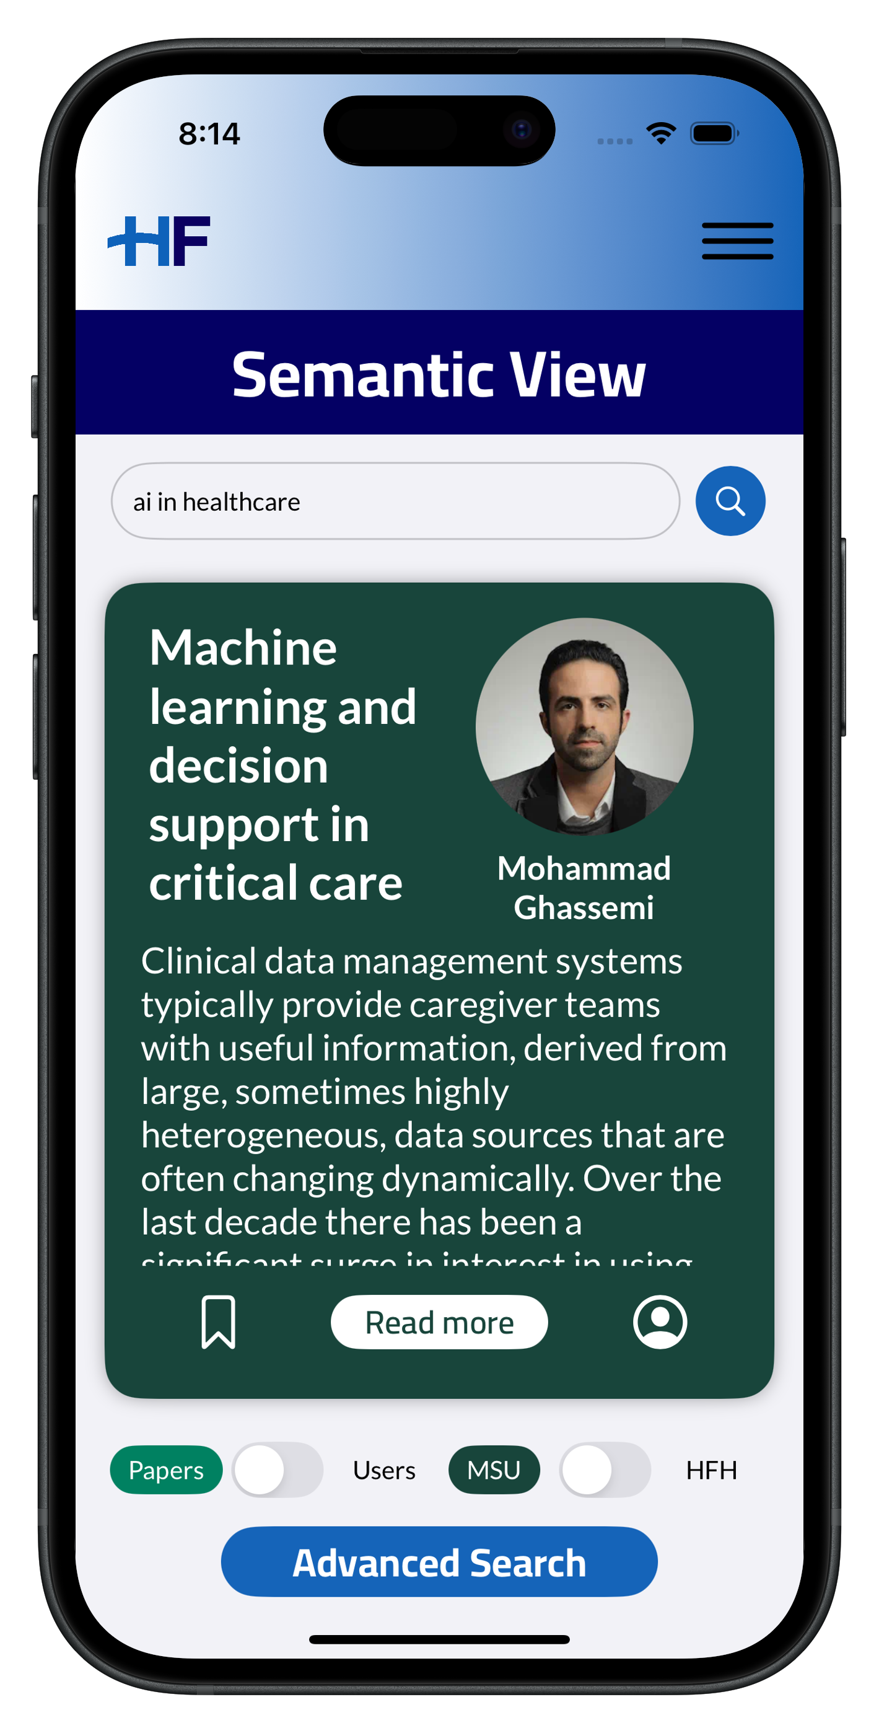

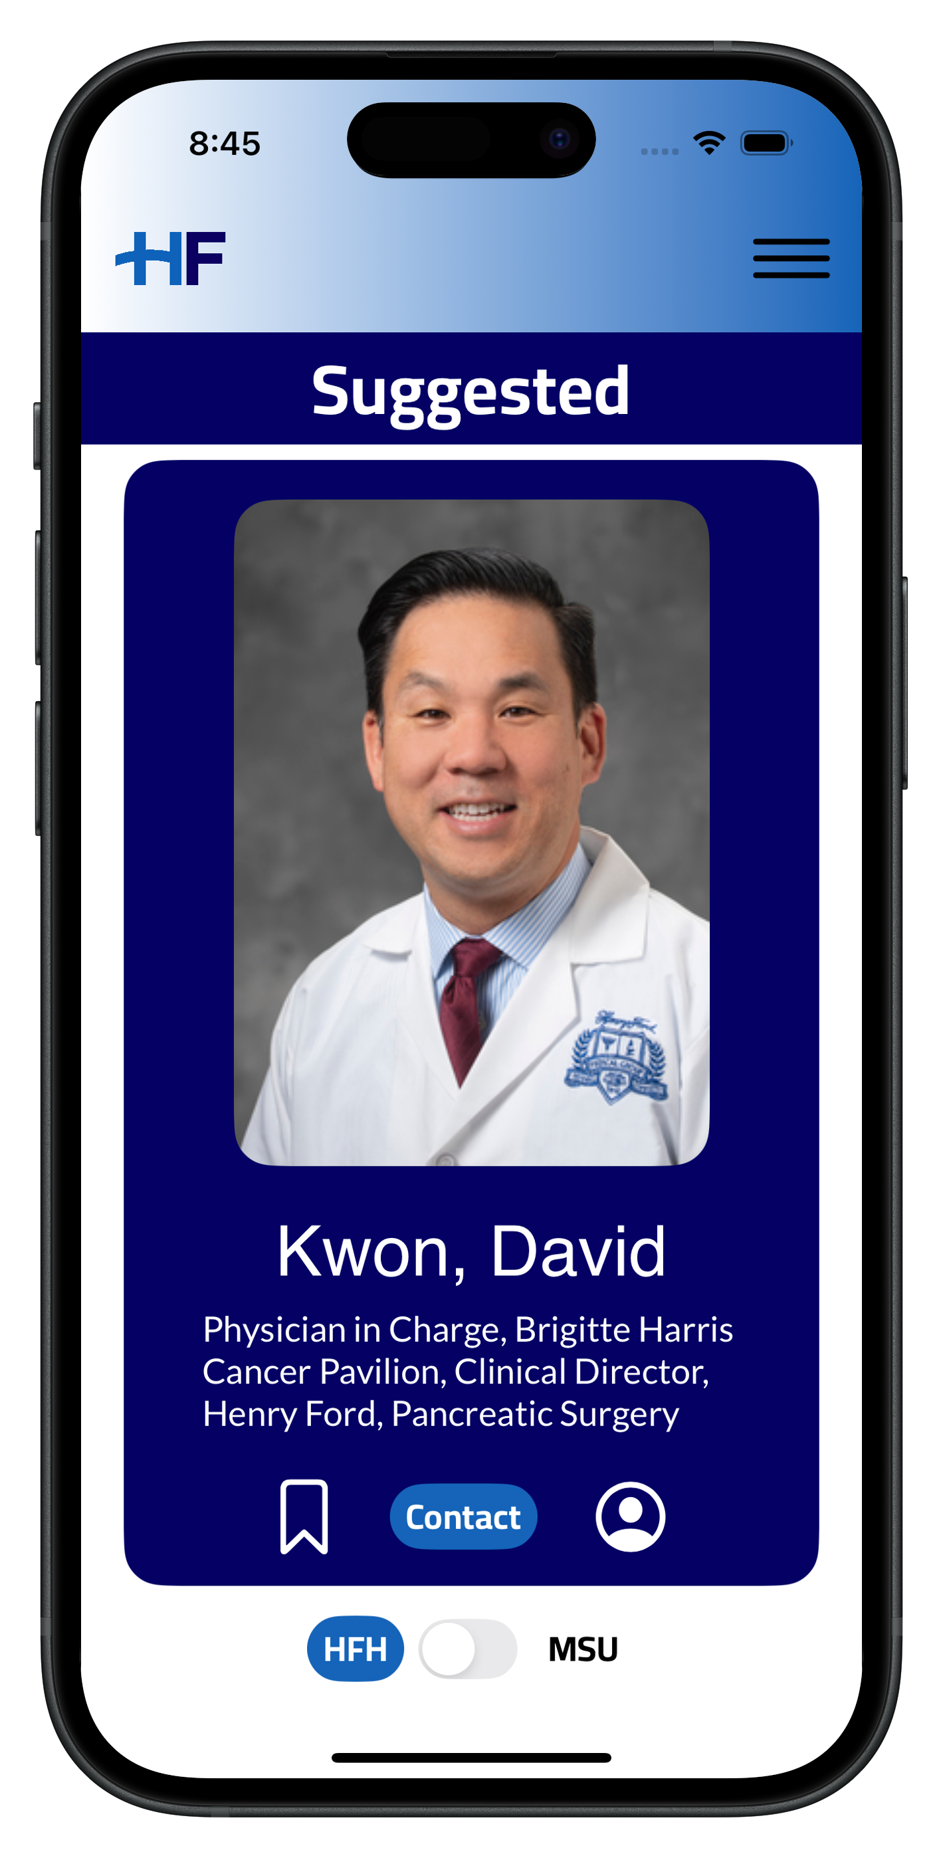

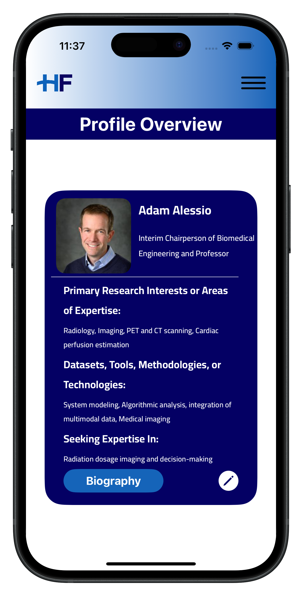

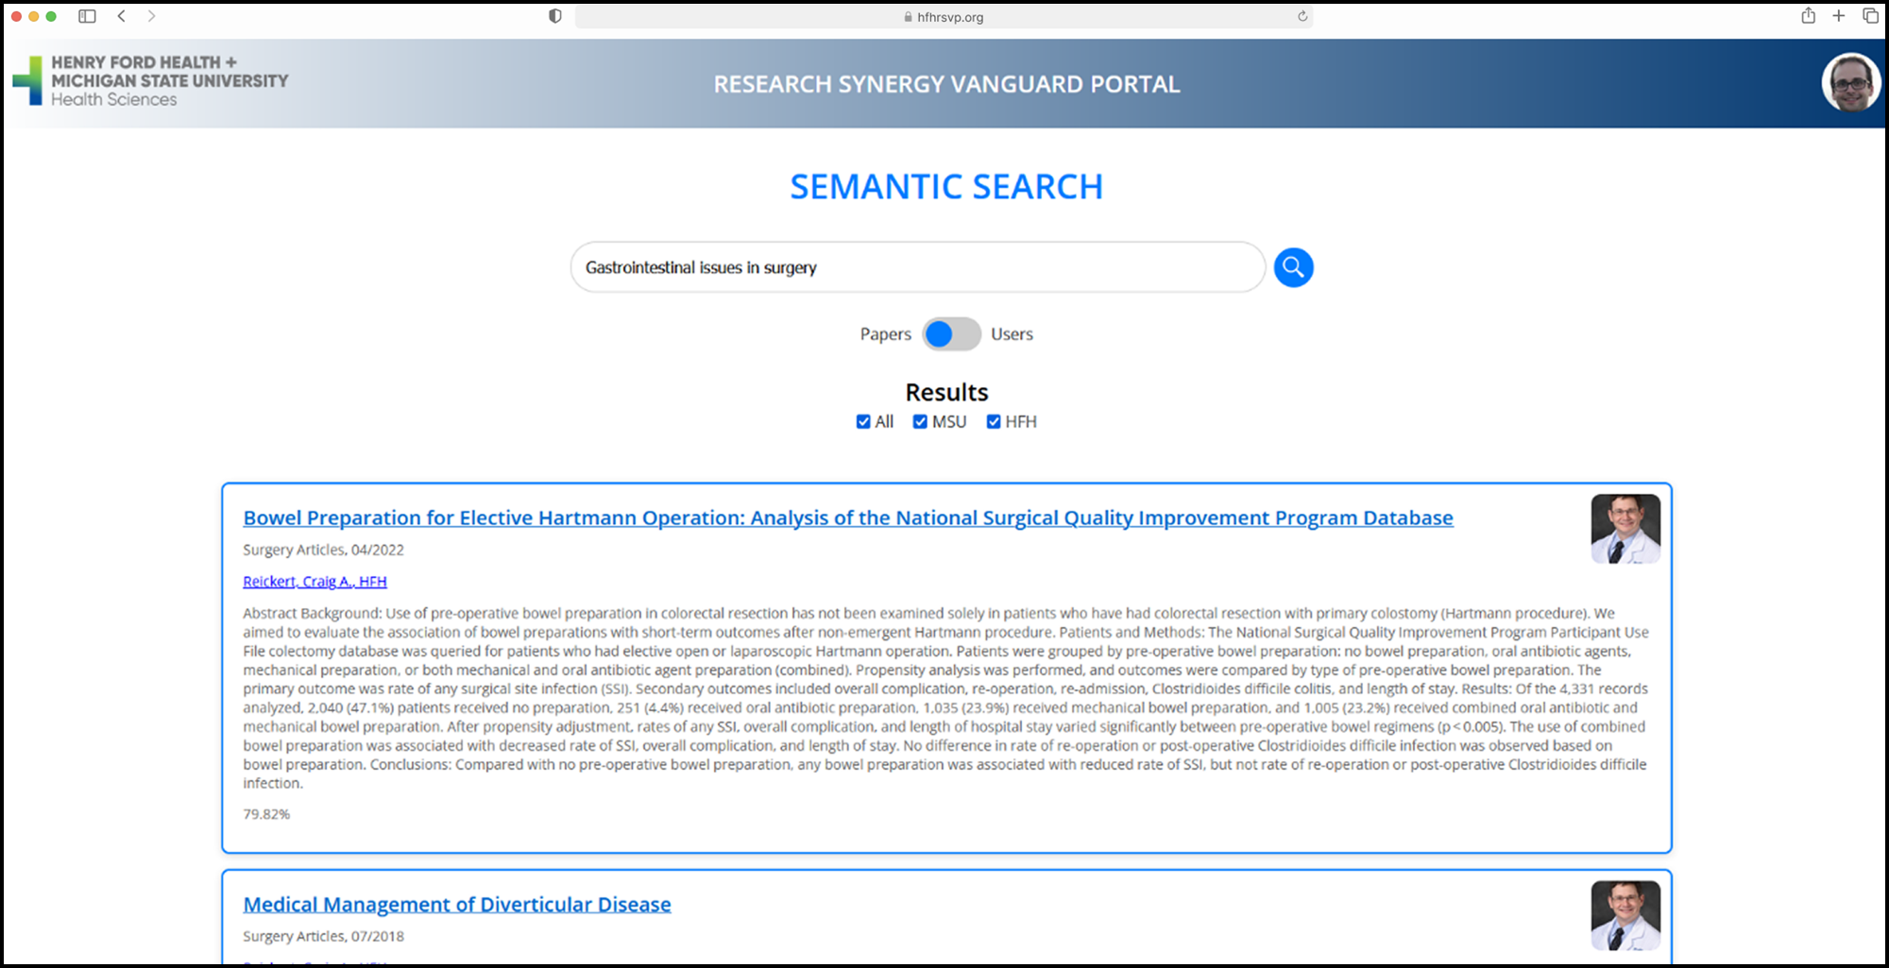

PAGE N + 13



Henry Ford Innovations RSVP

Project Sponsors

James Adams

Detroit, Michigan

Scott Dulchavsky

Detroit, Michigan

John Furcean

East Lansing, Michigan

Vikas Relan

Detroit, Michigan

David Willens

Detroit, Michigan

Michigan State University

Team Members (left to right)

Aaron Breese

Ann Arbor, Michigan

Felipe Marques Allevato

Rio de Janeiro, Rio de Janeiro, Brazil

Owen Nyenhuis

Holland, Michigan

Spandana Kodali

Novi, Michigan

Andriy Tryshnivskyy

Warren, Michigan

Nika Ghasemi Barmi

Tehran, Tehran, Iran

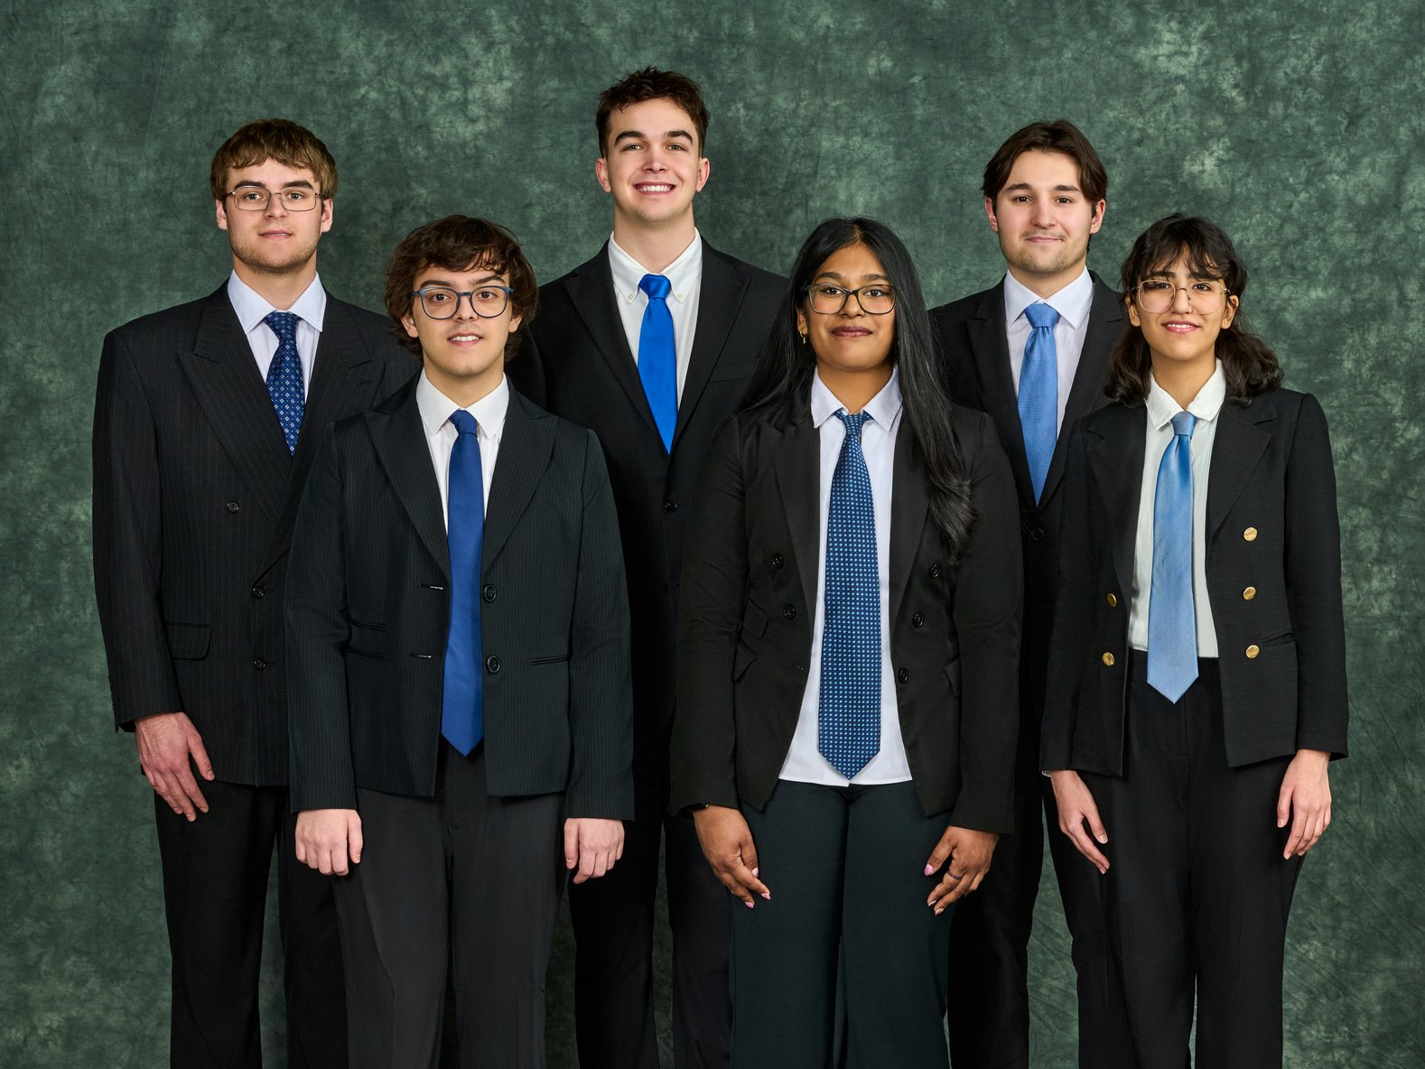

Henry Ford Health (HFH), based in Detroit, Michigan, is a leading healthcare system renowned for its commitment to innovation in medical research. In partnership with Michigan State University, HFH bridges the gap between clinical needs and academic expertise across both institutions.

Despite this partnership, clinicians at HFH and faculty at MSU face challenges in connecting across disciplines due to fragmented communication channels and a lack of centralized resources. This hinders the potential for interdisciplinary research and limits opportunities for collaboration among clinicians and experts such as engineers and scientists.

Our Research Synergy Vanguard Portal (RSVP) 2.0 addresses this challenge by providing both a web- and mobile-based platform that streamlines collaboration. The system helps users find research partners not only across institutions but also within their own organizations. The system intelligently analyzes user expertise and research interests to recommend ideal collaborators, creating a seamless and efficient networking experience.

Our mobile app introduces a swipe-to-match feature, enabling users to quickly browse and connect with potential collaborators. This new feature, along with automatic message suggestions, further encourages meaningful collaboration in a manner that fits the fast-paced schedule of many users.

With advanced semantic search capabilities, users refine their searches using multiple inputs, ensuring precise and relevant results in seconds.

Our portal is built using a ReactJS front end and a Flask back end for application logic. We utilize Bidirectional Encoder Representations from Transformers (BERT) for natural language processing to enhance search capabilities, and Elasticsearch for efficient search performance.

3200/3300 Hallway | Third Floor, Computer Science and Engineering 8:00 a.m. – Noon | CSE498

Henry Ford Innovations

MSU-HFH Research Synergy Vanguard Portal (RSVP) 2.0