Design Day Booklet Team Page

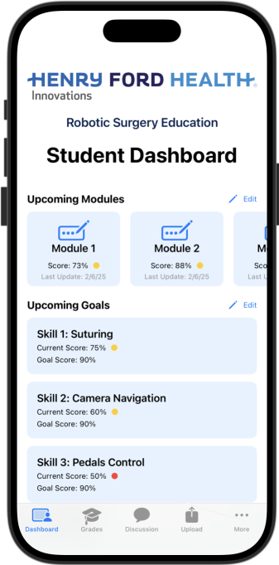

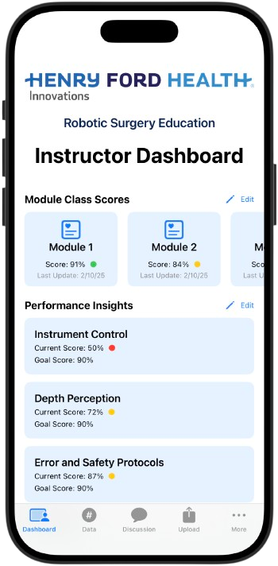

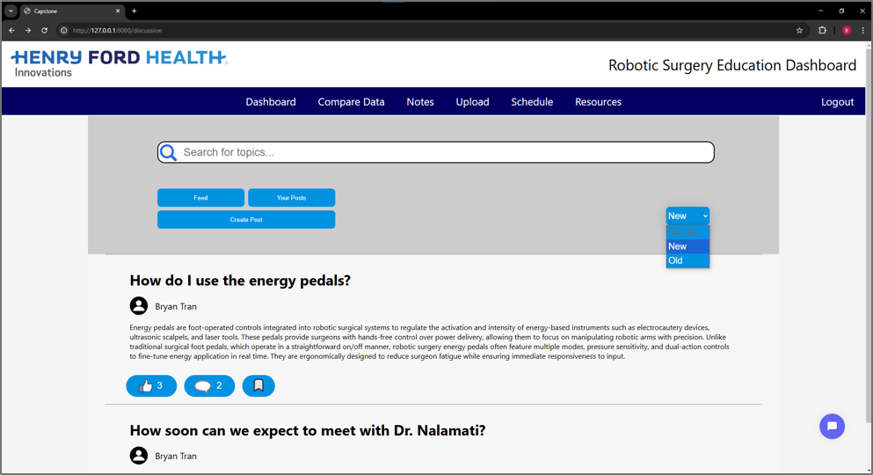

PAGE N + 12



Henry Ford Innovations RSE

Project Sponsors

James Adams

Detroit, Michigan

Dr. Surya Nalamati

Detroit, Michigan

Vikas Relan

Detroit, Michigan

Michigan State University

Team Members (left to right)

Caden Fisher

Grand Rapids, Michigan

Bryan Tran

Southfield, Michigan

Hayden Hiller

Grand Blanc, Michigan

Neha Kumar

Canton, Michigan

Dylan Troyer

Northville, Michigan

Miranda Gabbara

Washington, Michigan

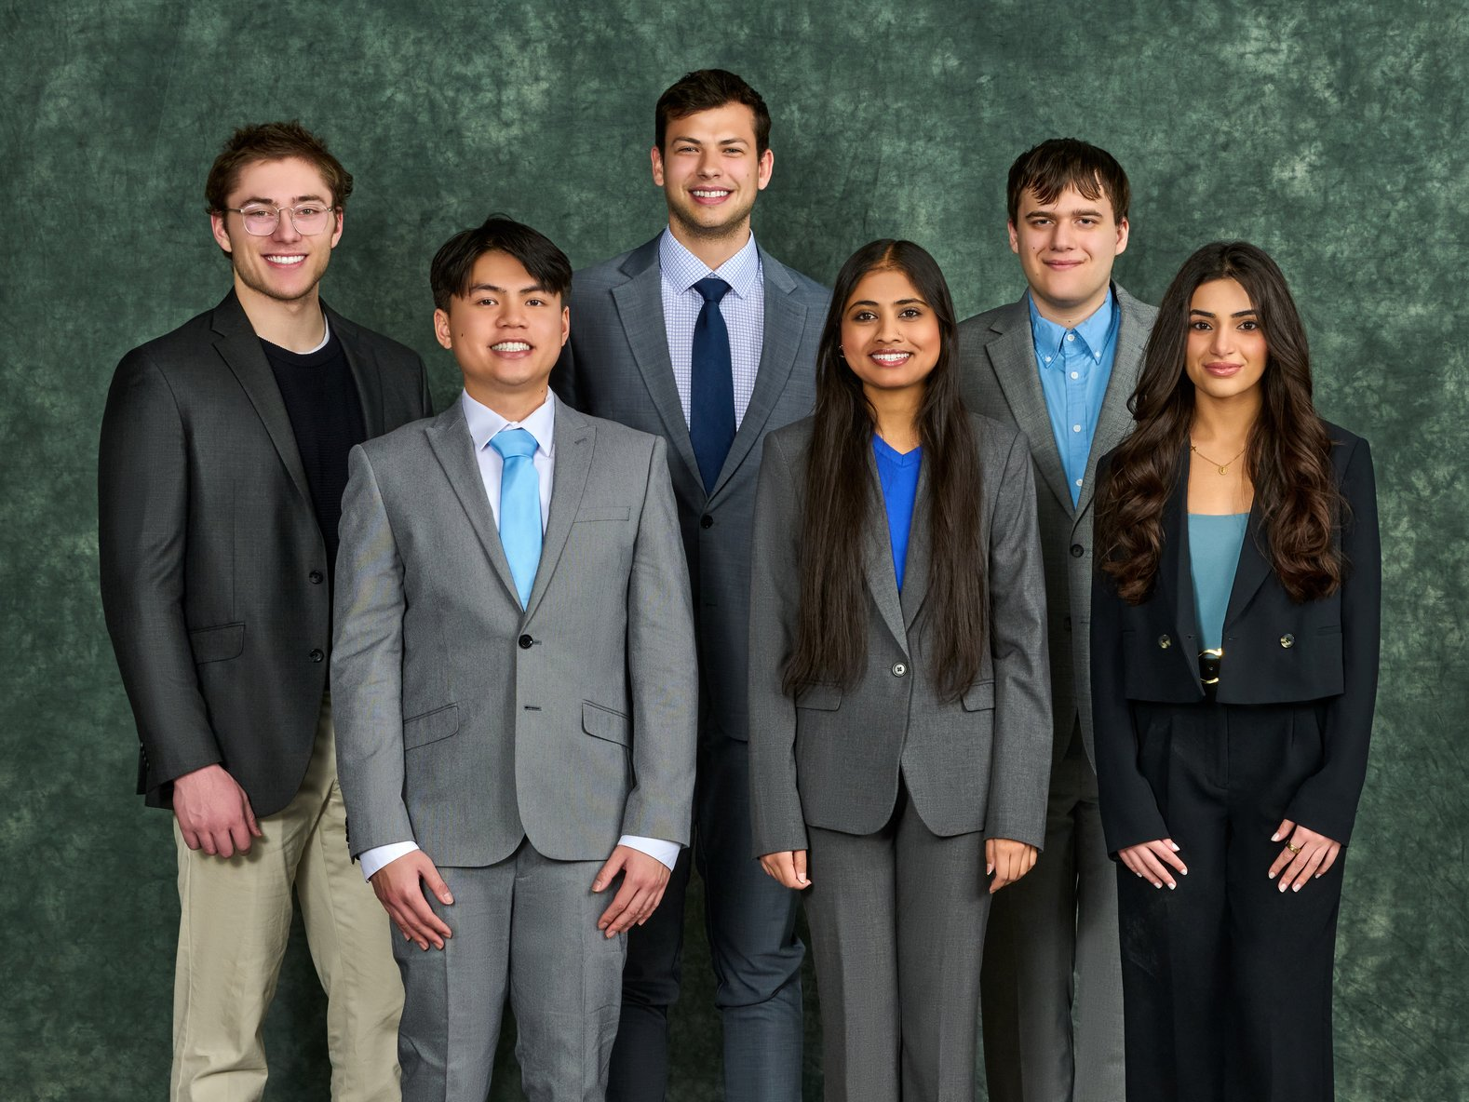

Henry Ford Health is a leading not-for-profit healthcare organization headquartered in Detroit, Michigan. Founded over 100 years ago, Henry Ford Health is recognized nationally due to its commitment to community care and breakthroughs in education, research, cancer treatment, and more.

As partners, Henry Ford Health and Michigan State University collaborate to innovate medical education and patient well-being.

Residents learning new surgical methods involving robotic equipment must first learn how to operate it effectively. There is a need for specialized software to adapt this education to newer generations of surgeons.

Our Modernizing Robotic Surgery Education 2.0 system improves the learning experience with new data analysis and discussion forums.

With our user-friendly focus, our updated software implements a personalized experience for both students and instructors. Employing a widget system, users enjoy a custom dashboard with valuable insights that streamlines the robotic surgery learning process.

Additionally, we have a mobile iOS application that connects to our web application. Data synchronizes between both applications, ensuring real-time updates.

Our software solution also features a discussion forum, where instructors and students collaborate, ask questions, and obtain feedback.

The platform links its data to a private and secure cloud server which stores data and settings, including login data. Users must undergo multifactor authentication to enhance security.

Our web-application uses Flask, PyTorch, Docker, JavaScript, Dash, HTML, and CSS to provide a seamless experience. We use Swift to extend the application to iOS platforms.

CSE498 | 8:00 a.m. – Noon Computer Science and Engineering, Third Floor | 3200/3300 Hallway

Henry Ford Innovations

Modernizing Robotic Surgery Education 2.0