Design Day Booklet Team Page

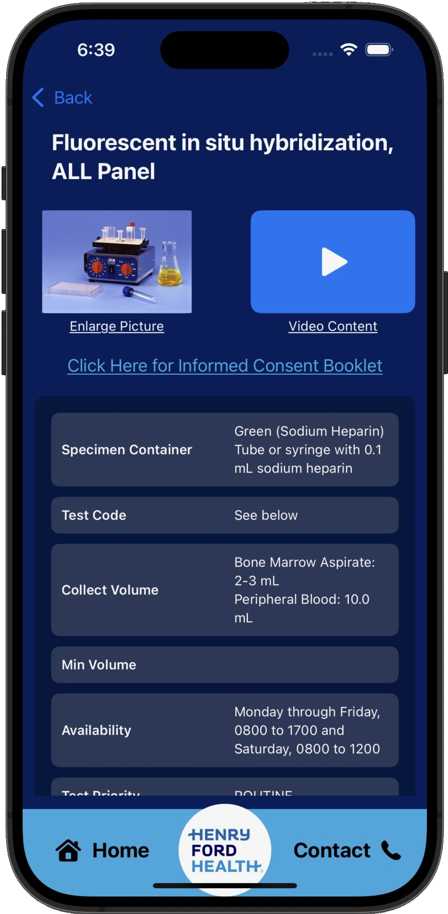

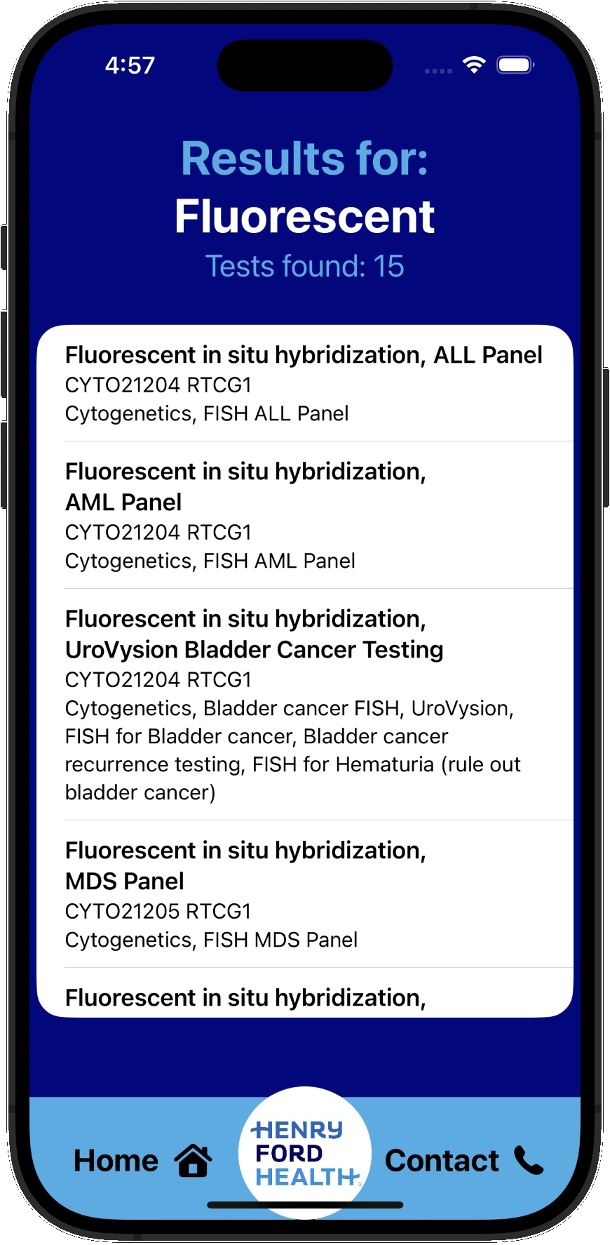

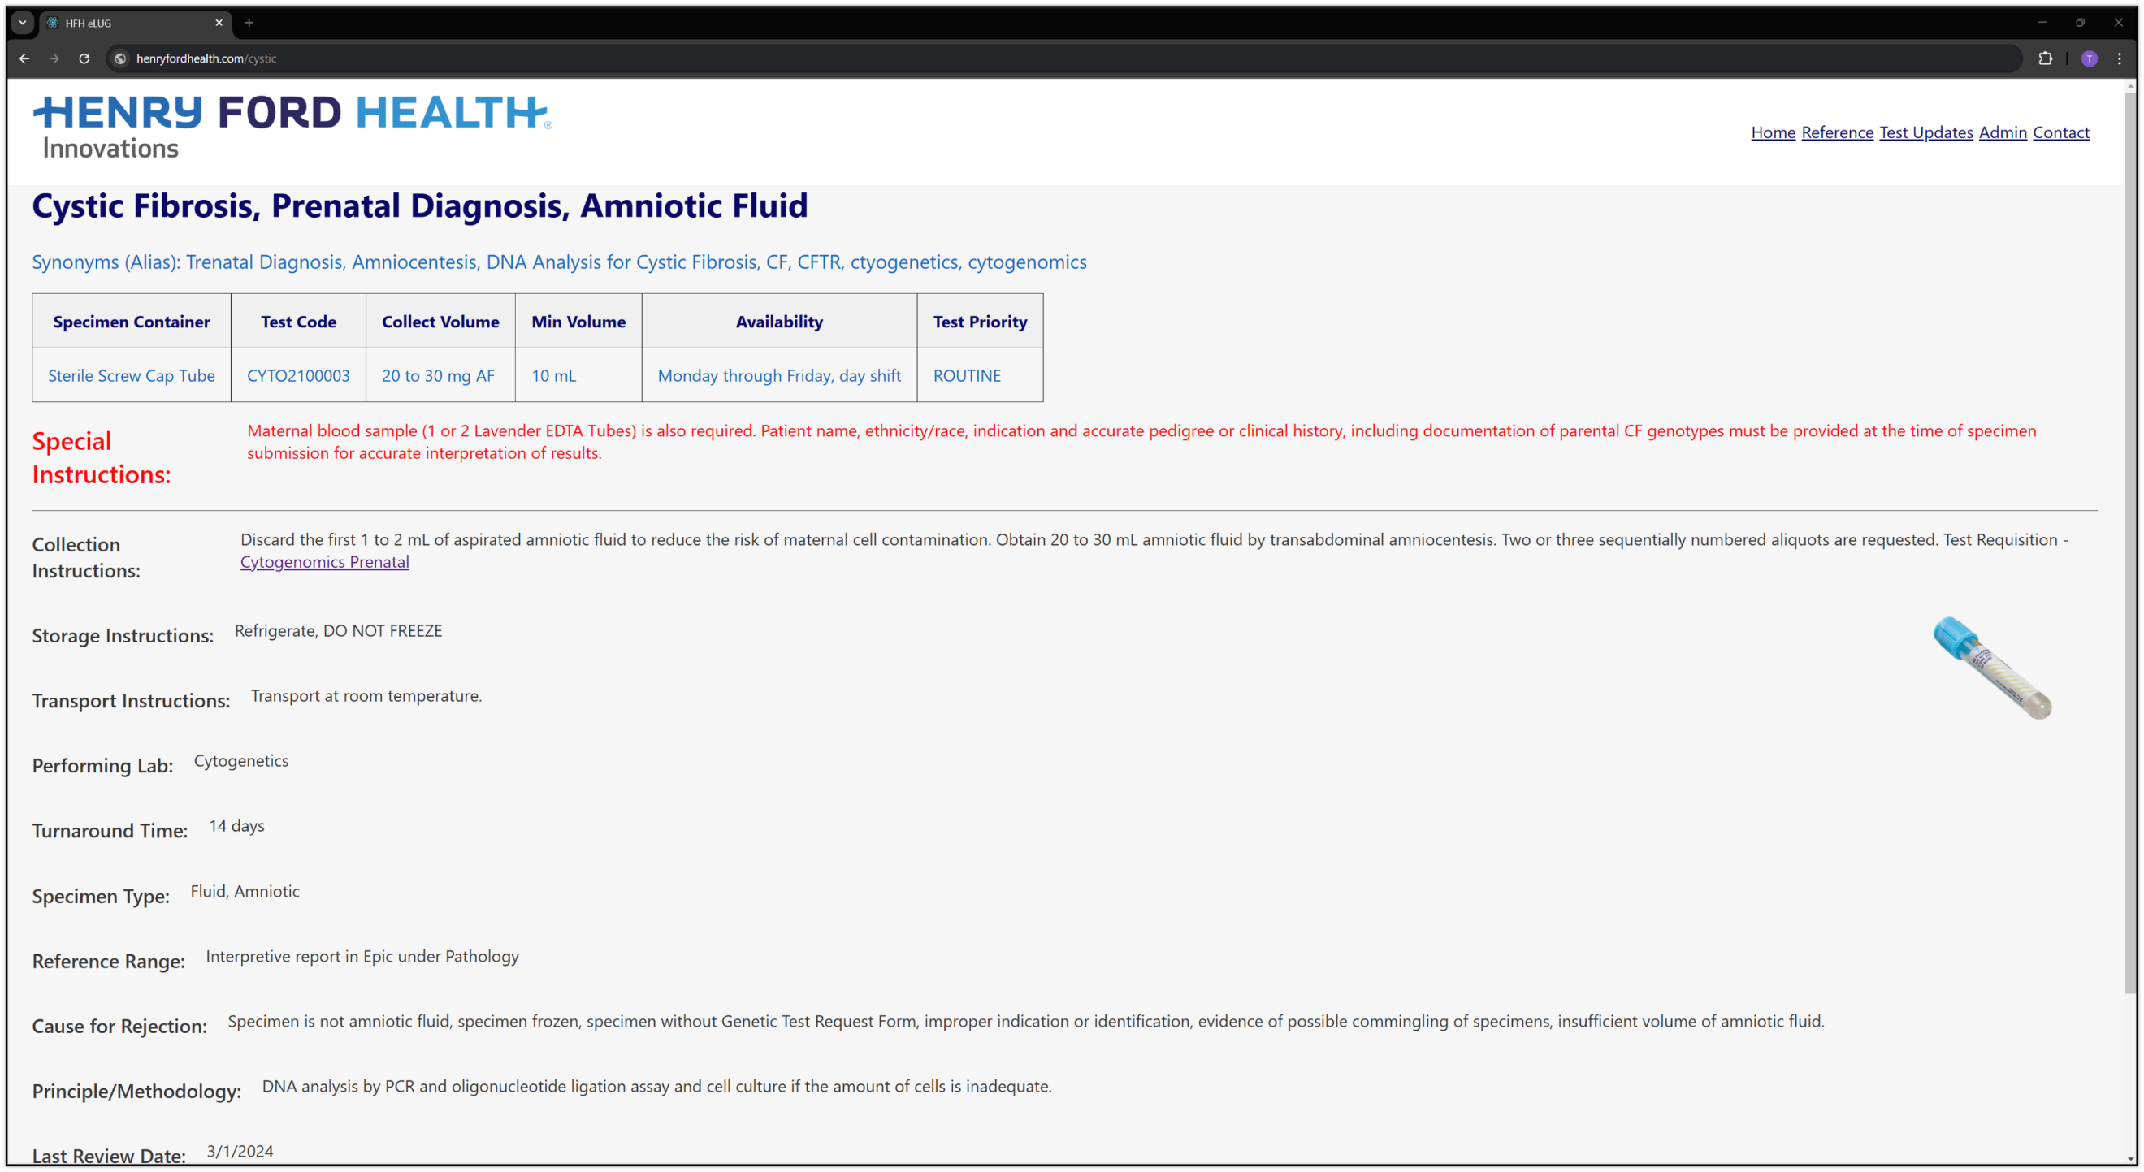

PAGE N + 11



Henry Ford Innovations eLUG

Project Sponsors

James Adams

Detroit, Michigan

Adam Baldwin

Detroit, Michigan

Bryce Crumrine

Detroit, Michigan

Vikas Relan

Detroit, Michigan

Michigan State University

Team Members (left to right)

Shreyas Sankar

Troy, Michigan

Shreya Rudagi

Troy, Michigan

Trevor Jacobs

Rockford, Michigan

Deenie Vichitpap

Troy, Michigan

Abhi Rao

Troy, Michigan

Anushka Basani

Novi, Michigan



Henry Ford Health is one of the nation’s leading healthcare providers based out of Detroit, Michigan. More than 6,000 medical professionals and researchers work towards ensuring that Henry Ford Health is at the forefront of modern medicine. Their engagement in over 2,000 research projects every year proves their dedication to medical innovation.

It is crucial that clinicians and medical professionals can properly collect and handle specimens from their patients for lab testing. This is why Henry Ford Health created the Electronic Laboratory User’s Guide (eLUG). The eLUG houses a lab testing catalog that provides guides on correct specimen collection methods.

eLUG was originally developed over 20 years ago, can be difficult to navigate, and many of its features are outdated.

Our improved eLUG features a modern, user-friendly, interface improving the experience for day-to-day users, both internal and external. Along with a web application, we offer a mobile application to increase the guide’s accessibility.

The improved search feature finds any guide within a few keystrokes. Additionally, shareability is a vital component of modern healthcare workflows. Our web application enables the simple sharing of test pages with unique links, while the mobile application provides direct access to corresponding web pages, ensuring smooth collaboration.

Security is a big concern in healthcare, and our application has three separate layers of secure access – a user, an admin, and a webmaster.

The eLUG web application is developed with HTML, CSS, JavaScript, and ReactJS, while the mobile application is developed with Xcode and Swift. Both are powered by a MySQL database, with the mobile application utilizing a RESTful API to fetch data.

3200/3300 Hallway | Third Floor, Computer Science and Engineering 8:00 a.m. – Noon | CSE498

Henry Ford Innovations

Electronic Laboratory User’s Guide (eLUG)