Design Day Booklet Team Page

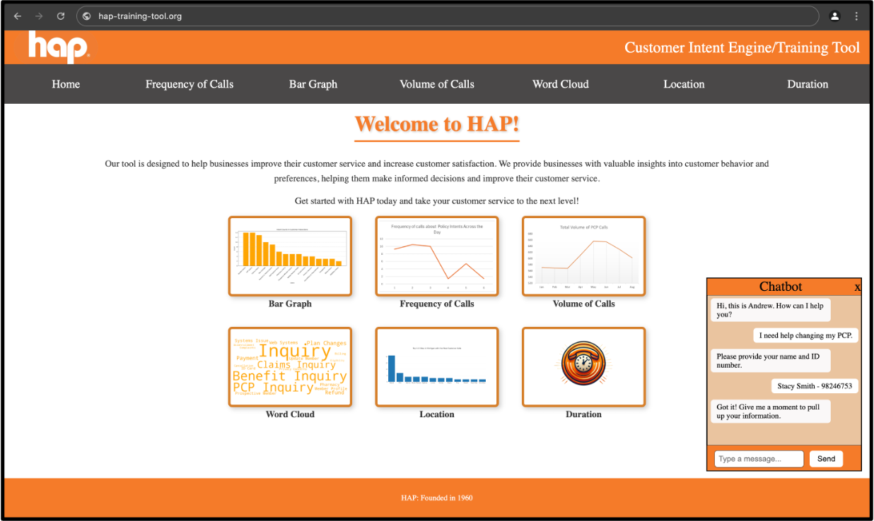

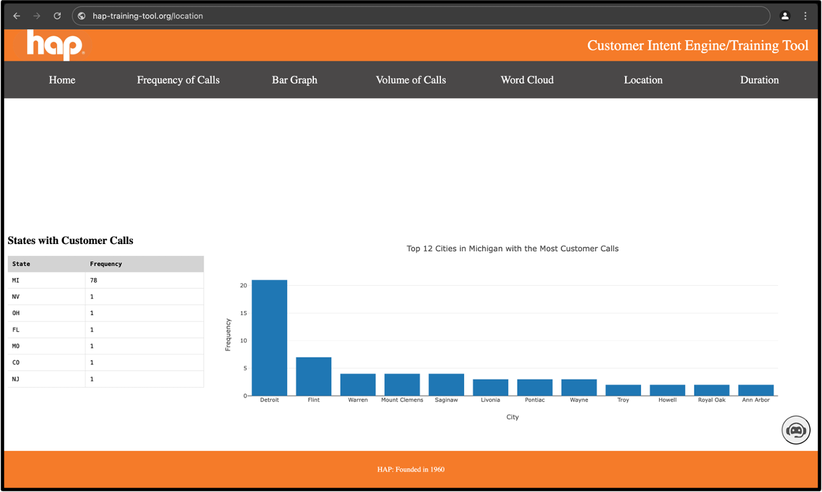

PAGE N + 10



HAP

Project Sponsors

Angela Endres

Detroit, Michigan

Rachel Mclean

Detroit, Michigan

Vinoth Mohan

Detroit, Michigan

Steve Neubecker

Detroit, Michigan

Michigan State University

Team Members (left to right)

Saarthak Sharma

Sterling Heights, Michigan

Praneetha Ankisettipalli

Troy, Michigan

Averey Davis

Whitmore Lake, Michigan

Abdulrahman Alanazi

Tabuk, Tabuk, Saudi Arabia

Bao Hoang

Hanoi, Hanoi, Vietnam

Karoline Yashin

Plymouth, Michigan



Health Alliance Plan (HAP), founded in 1969 and headquartered in Troy, Michigan, is an innovative and trusted health insurance provider with a mission “to enhance the health and well-being of the lives we touch.” HAP was one of the first 21 health plans in the United States to publicly report on the quality of care.

Every day, HAP receives numerous customer service inquiries in their call center that range across a variety of customer needs. With such diverse inquiries, there is a lot of information that a call center representative needs to be prepared to both receive and relay. Training representatives for all these different scenarios is a time-consuming and overwhelming process.

Our Customer Intent Engine and Training Tool enables representatives to enhance their customer service skills by providing valuable insights from historical customer calls. Our software analyzes transcripts from past calls, identifies the customers’ intents, and displays the information in numerous ways on our web application.

Our website offers interactive dashboards where users explore the details of past customer inquiries from various perspectives such as call frequency, commonly used words for specific topics, most frequently asked intents, and more. Users click on specific dashboard pages to gain further insight into a given topic. Our application also provides a smart chatbot to enable customer service staff to ask questions as they use the website for training.

Our front-end software is developed using HTML, CSS, and JavaScript, while the back end is implemented using Python Flask with PostgreSQL as the database. The software leverages Python for data analysis and generates interactive dashboards using the Python Dash library. The chatbot is trained and implemented using the Hugging Face library in Python.

CSE498 | 8:00 a.m. – Noon Computer Science and Engineering, Third Floor | 3200/3300 Hallway

HAP

Customer Intent Engine and Training Tool