Design Day Booklet Team Page

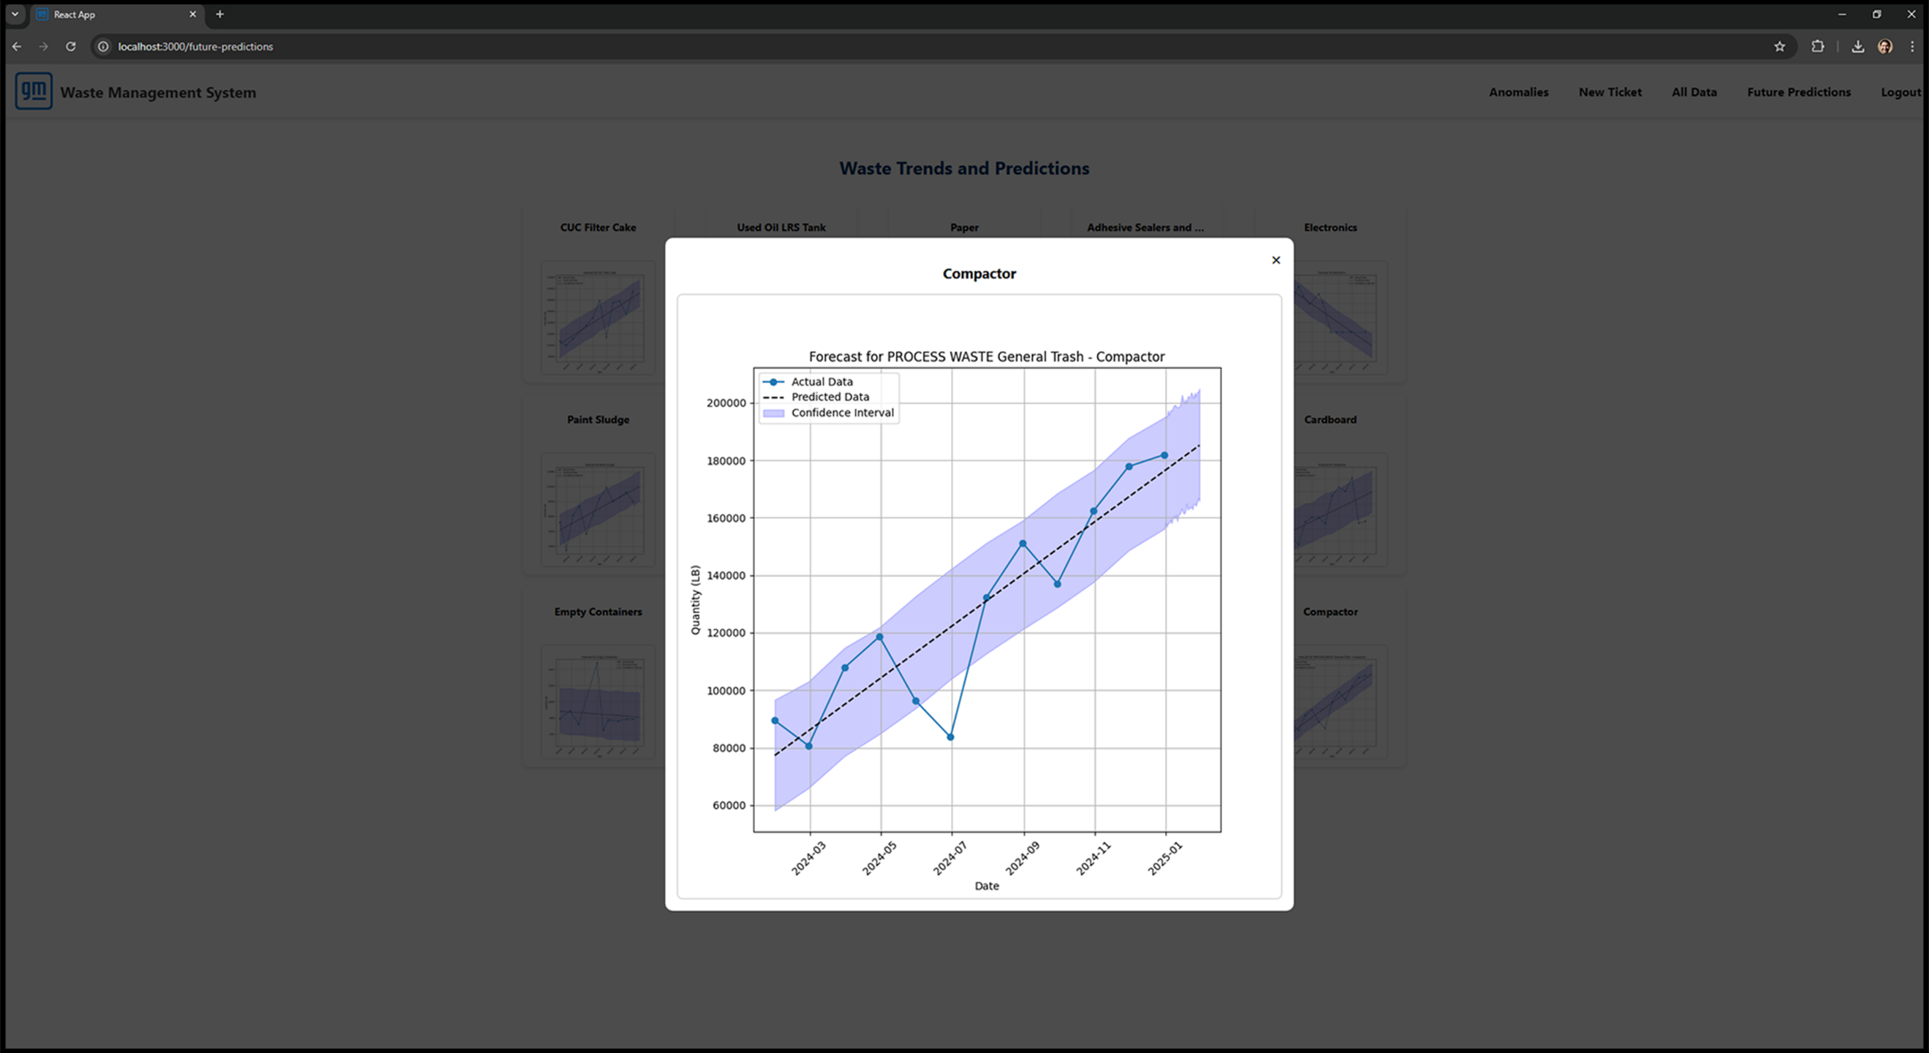

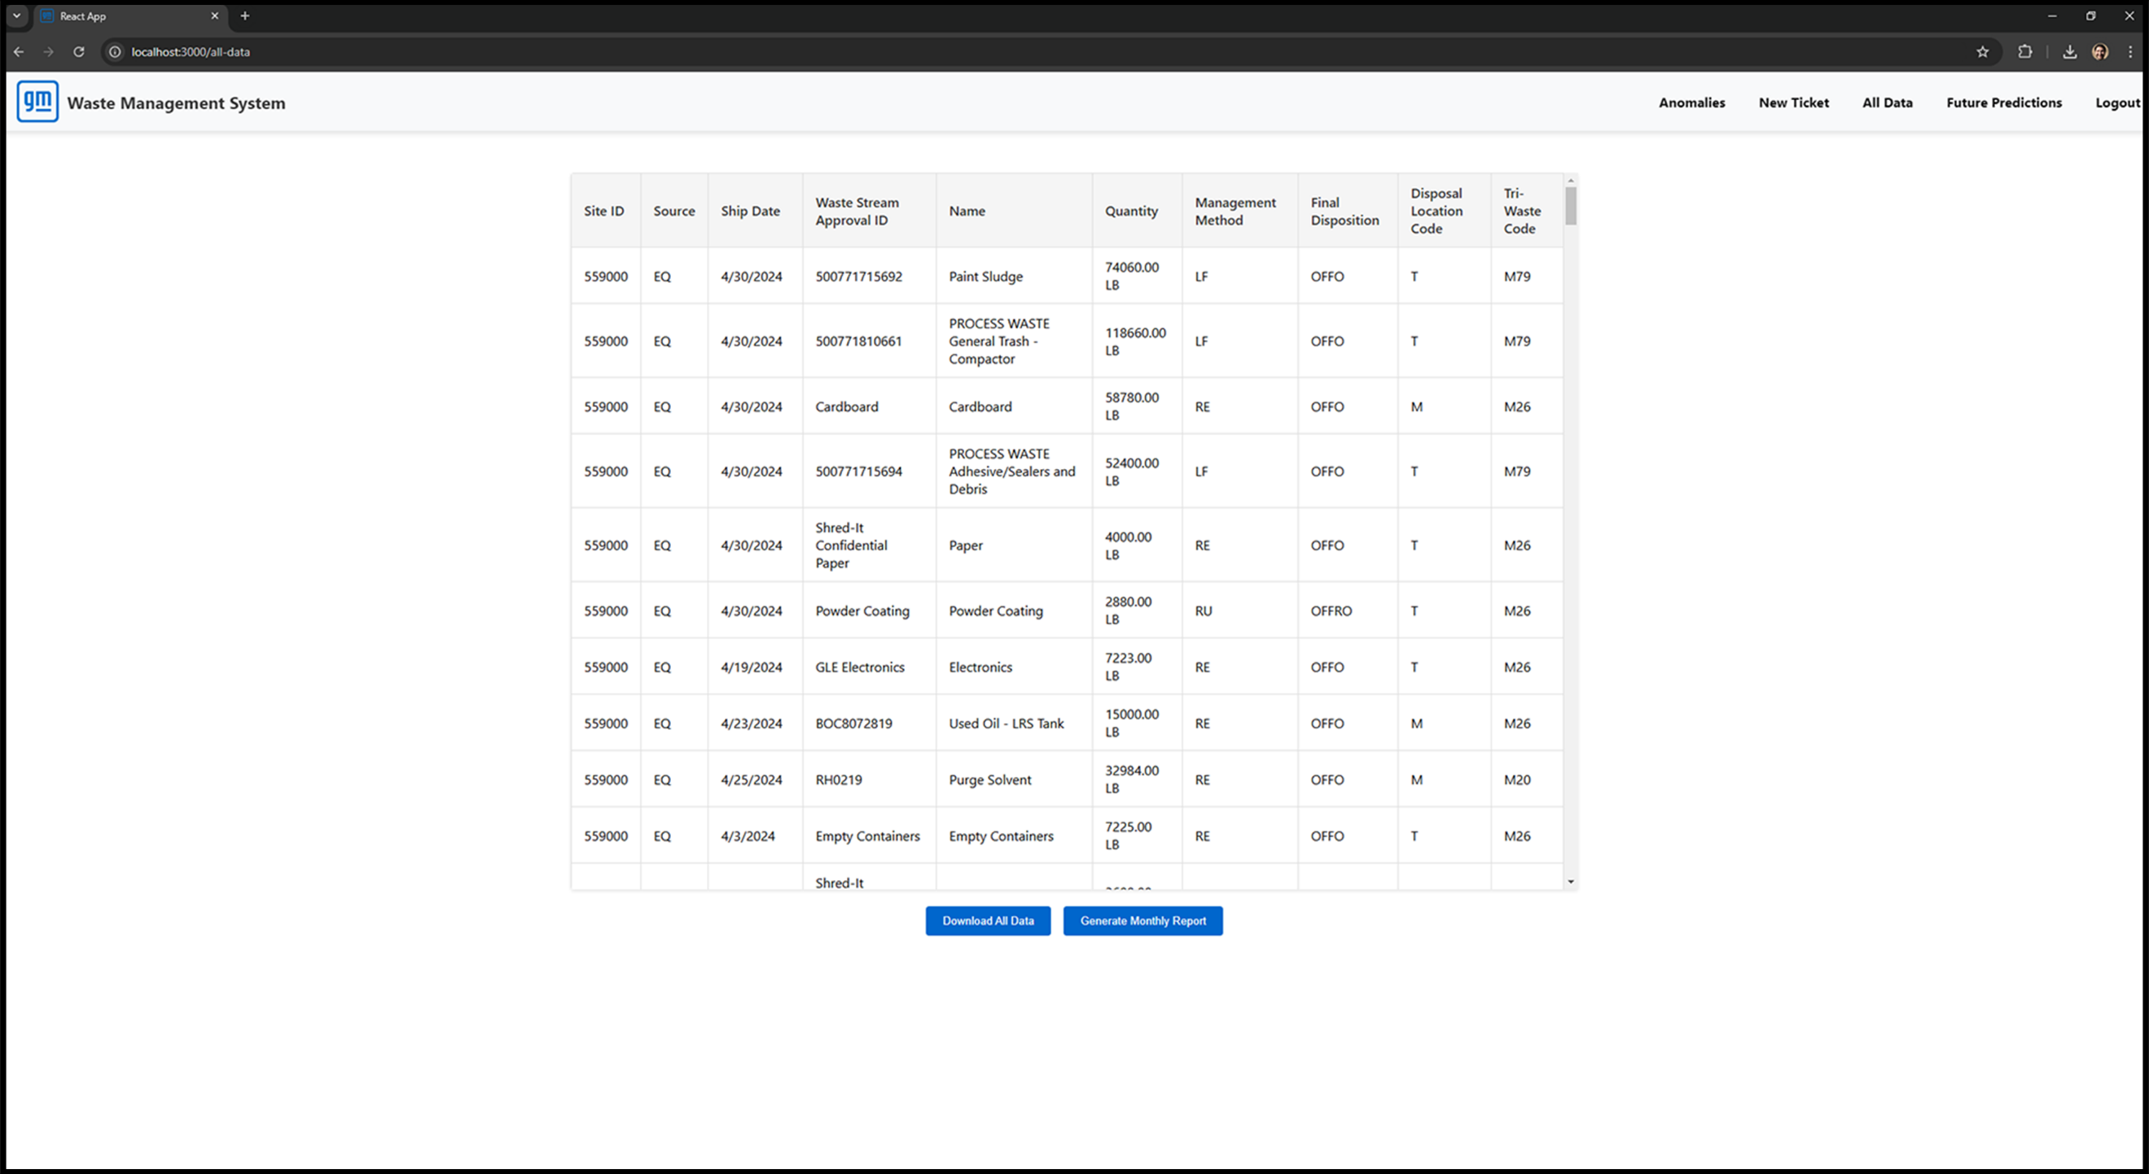

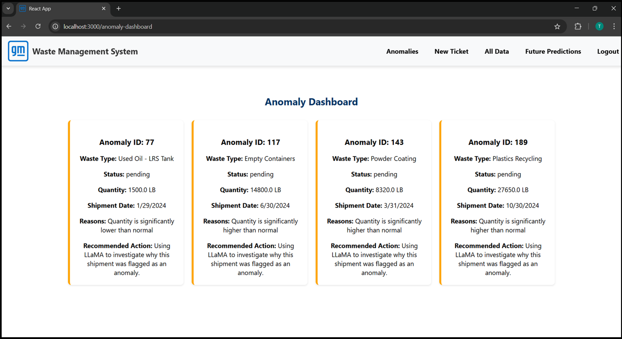

PAGE N + 9



GM

Project Sponsors

Michael Cherry

Warren, Michigan

James Currie

Warren, Michigan

Patrick Doyle

Warren, Michigan

Laura Evans

Warren, Michigan

Jeffrey Seibert

Warren, Michigan

Peter Wyatt

Warren, Michigan

Michigan State University

Team Members (left to right)

Hassan Maklai

Dubai, Dubai, UAE

Manh Tran

Hanoi, Hanoi, Vietnam

Ben Blanchard

Grand Rapids, Michigan

Joseph Khalaf

Troy, Michigan

Nathan Shammami

Walled Lake, Michigan



General Motors (GM) is a global automotive company that has proven through more than a century of automotive design and engineering to be a force of continuous innovation.

GM is focused on reaching zero waste and emissions by 2035 as they lead progress among automotive manufacturers.

However, compiling accurate waste data across a multinational corporation to inform sustainable operations is no easy feat, and converting waste data spanning years into useful information is challenging. Accurate data collection at GM relies on waste managers avoiding error during manual input, however mistakes are inevitable.

Our Global Waste Management System addresses these problems and promotes informed sustainability progress in GM operations through an intuitive web application.

Our web application supports robust data filtering and editing all while ensuring proper authorization. However, it has two truly outstanding features. Those are statistical error checking of data entries and predictive waste trend analysis.

Statistical error checking software prevents manual data entry errors by using a variety of metrics to identify anomalies. When a waste data entry error is made, the waste manager is prompted to resolve the issue or bypass it. Our software also includes capabilities for users to define what qualifies as an error.

With accurate data, it is possible to make informed sustainability decisions if the data can be visualized in a meaningful way. Our waste trend analysis predicts what the near future will look like in terms of waste production at GM using advanced data analysis. Predictions are displayed in multiple easy-to-read ways.

The front end of the Global Waste Management is built using React while the back end utilizes Flask, Python libraries, and MySQL.

3200/3300 Hallway | Third Floor, Computer Science and Engineering 8:00 a.m. – Noon | CSE498

General Motors

Global Waste Management System