Design Day Booklet Team Page

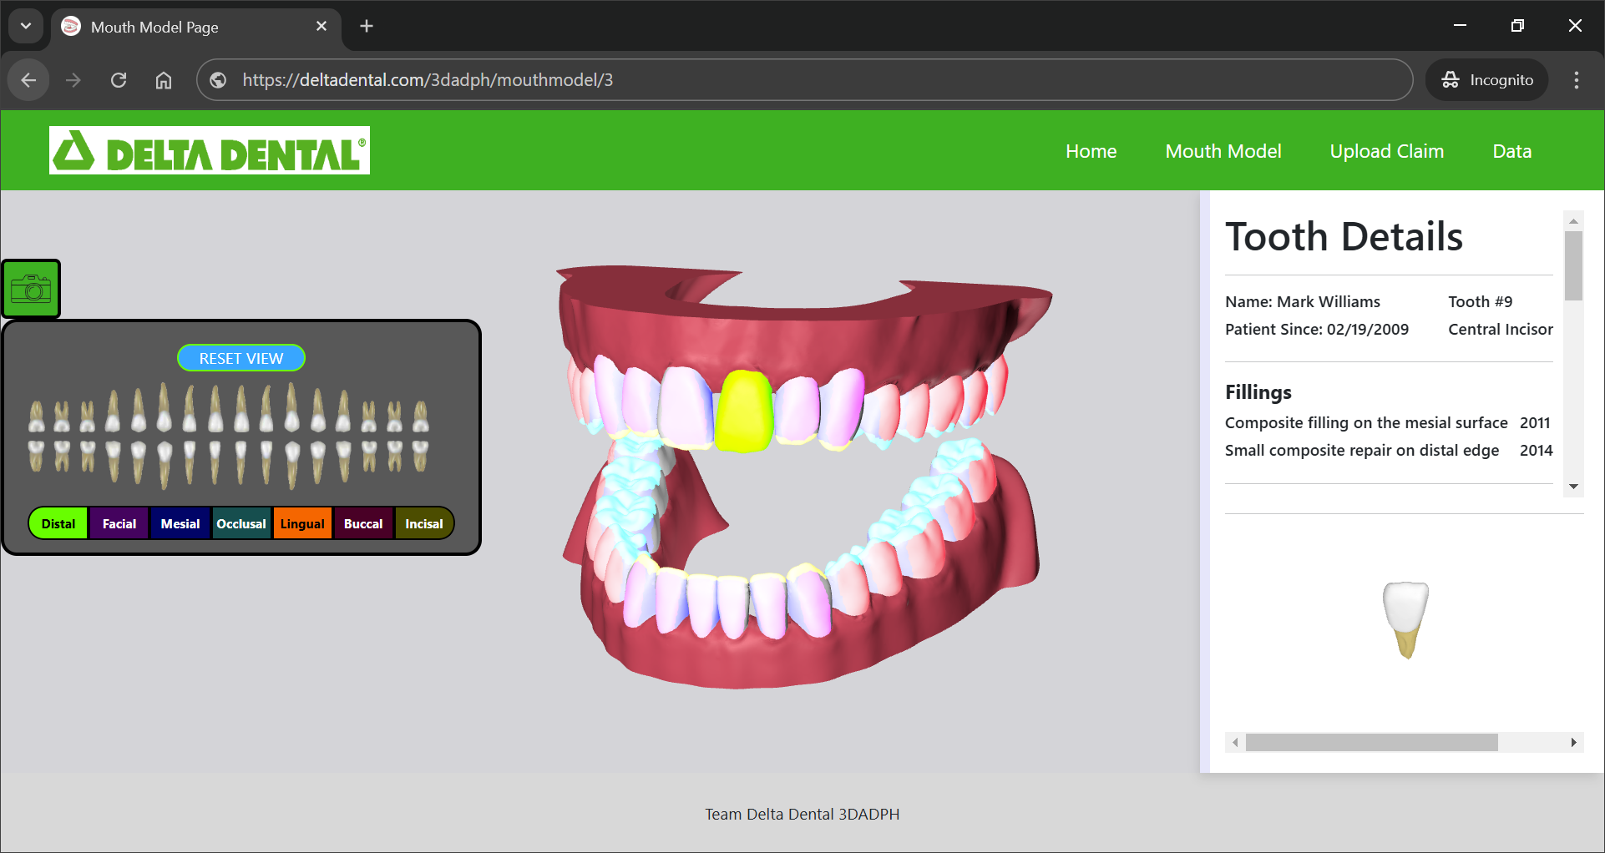

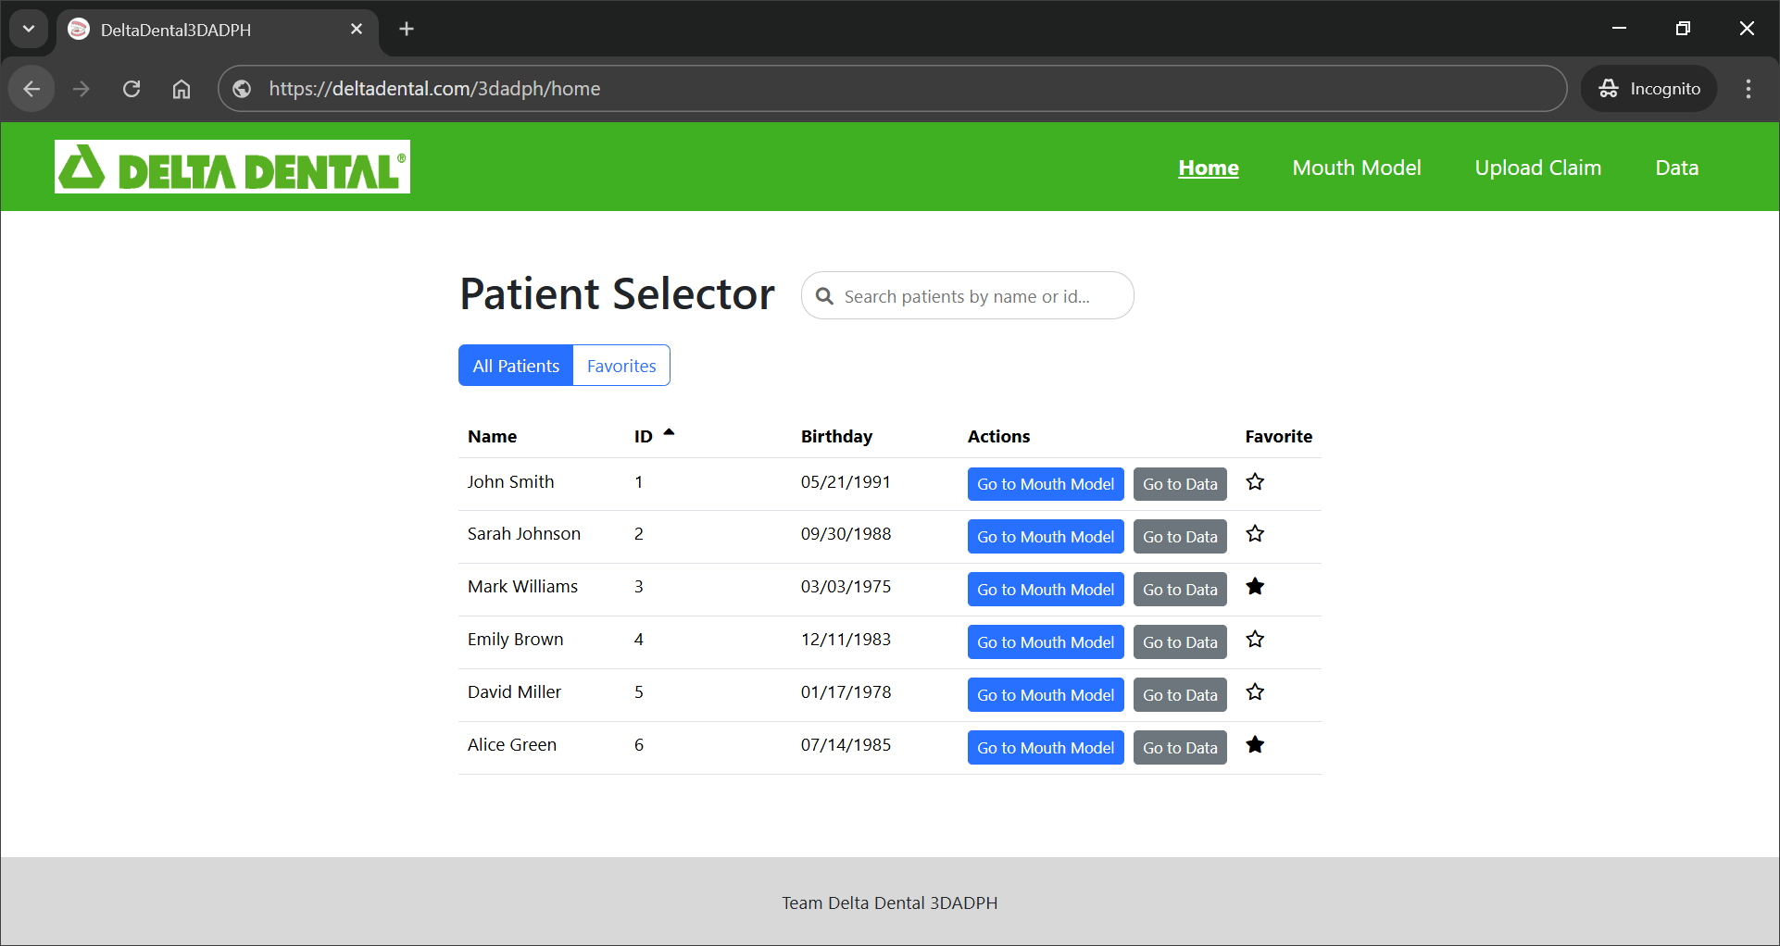

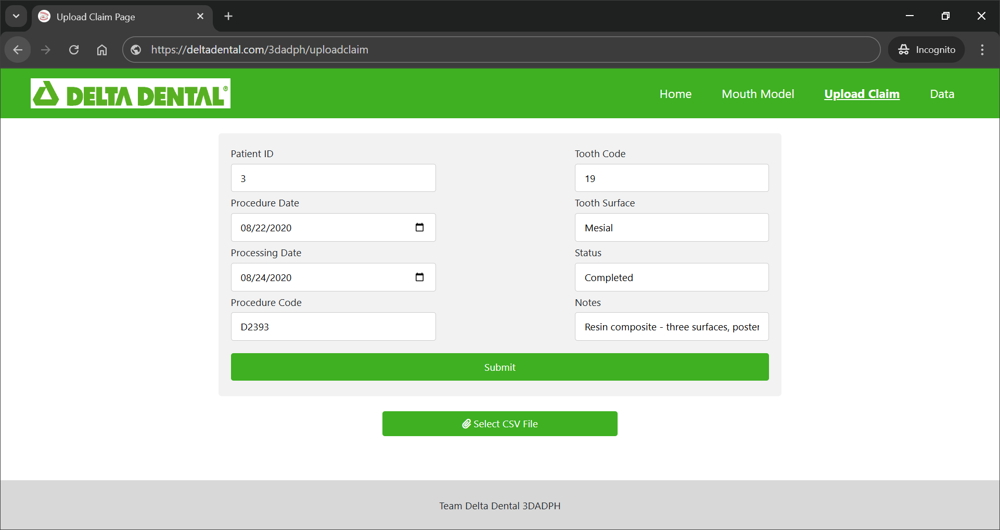

PAGE N + 7



Delta Dental 3DADPH

Project Sponsors

Mukundan Agaram

Okemos, Michigan

Michael Chen

Okemos, Michigan

Jacob Ernst

Okemos, Michigan

Toby Hall

Okemos, Michigan

Daniel Magaway

Okemos, Michigan

Michigan State University

Team Members (left to right)

Ben Crimmins

Beverly Hills, Michigan

Lance Stemple

Midland, Michigan

Jacob Robson

New Lenox, Illinois

Sanju Kona

Saint Joseph, Michigan

Jasen Van Acker

Rochester Hills, Michigan

Thomas Toaz

Ionia, Michigan

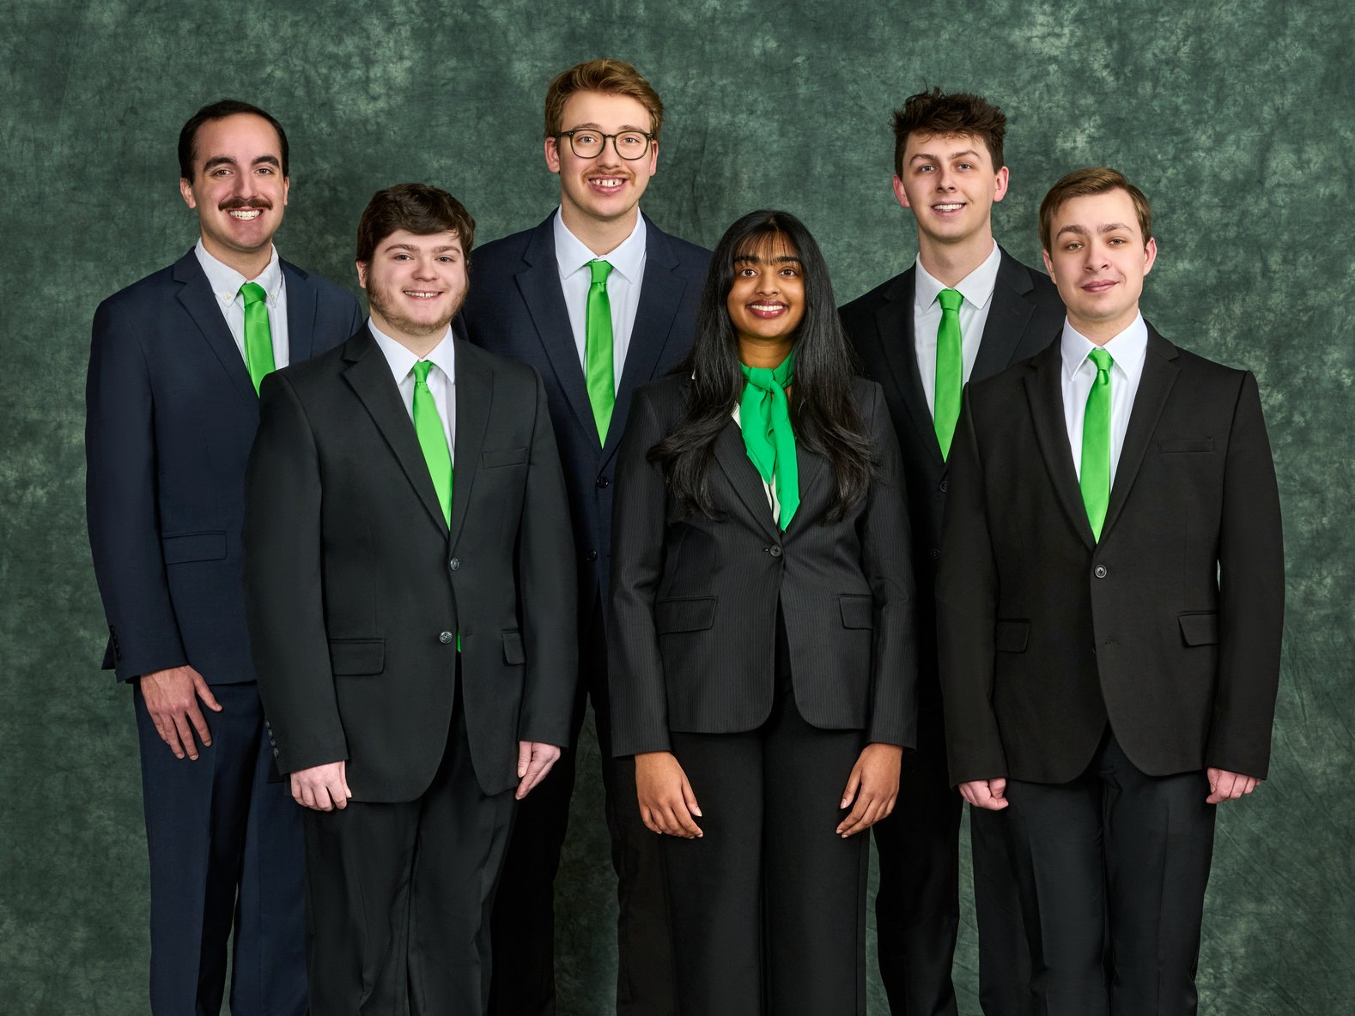

Delta Dental provides dental insurance coverage to more than 90 million Americans. They operate in all 50 states, making them one of the largest dental insurance providers in the United States.

Delta Dental processes millions of claims per year from their subscribers. When the claims go through their claims processing system, further human review by adjudicators may be required to correct malformed data or to review the validity of the claim.

Claims are reviewed through the context of the patient’s dental history, which Delta Dental has comprehensive access to. This includes any procedures or treatments performed on any patient, leading to a massive amount of data.

The 3D Analysis of Dental Patient History assists adjudicators by visualizing the dental patient history. Our web application features a 3D model that shows a patient’s entire dental history where the user rotates, zooms in, and selects specific teeth on the model. Selecting a tooth displays all information about its previous procedures and treatments as well as a more detailed individual tooth model.

In the web application, users edit existing data and upload new data. Inputting information can be done manually through a form or by uploading other records that are kept on file.

Once new data is uploaded, users view the patient’s information in the 3D model. With access to a patient’s complete dental history, past procedures and treatments are viewed in chronological order.

Our application streamlines claim reviews by enabling Delta Dental employees to quickly and accurately visualize patient history, saving valuable time and effort.

The front end of our web application is built with Angular. Three.js is used to display 3D models and Bootstrap provides formatting for the front end. Java Quarkus is used for connecting Angular to the PostgreSQL back end.

3200/3300 Hallway | Third Floor, Computer Science and Engineering 8:00 a.m. – Noon | CSE498

Delta Dental of Michigan, Ohio and Indiana

3D Analysis of Dental Patient History