Design Day Booklet Team Page

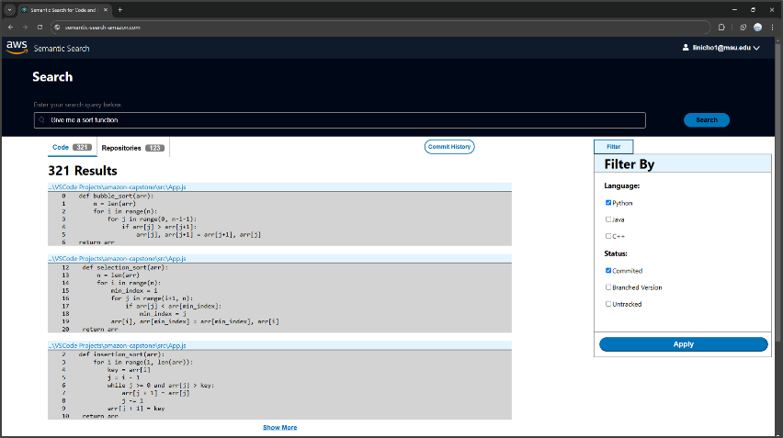

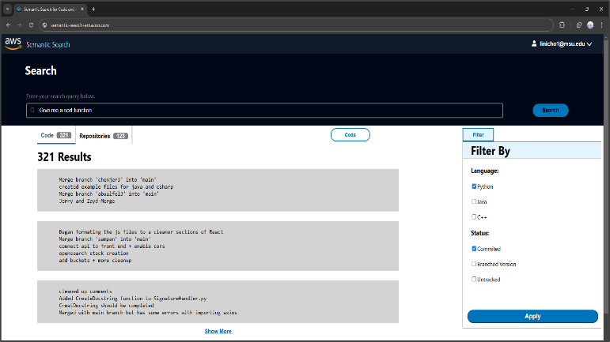

PAGE N + 3



Amazon

Project Sponsors

Steven Carpenter

Detroit, Michigan

Garret Gaw

Detroit, Michigan

Cole Riggle

Detroit, Michigan

Michigan State University

Team Members (left to right)

Nicholas Li

Troy, Michigan

Zayd Abualfellat

Grand Blanc, Michigan

Jerry Chen

Lincolnshire, Illinois

Atharva Kirkole

Pune, Maharashtra, India

Sampan Chaudhuri

Canton, Michigan



Amazon, located in Seattle, Washington, is a global leader in technology and a global e-commerce powerhouse. Originally founded by Jeff Bezos in 1994, Amazon has since expanded into a dominant force in cloud computing through Amazon Web Services (AWS) and is the parent company of over 100 subsidiaries.

Amazon software developers are responsible for creating Amazon’s popular online products. These developers often utilize reliable assets from previous projects and advice from subject matter experts (SMEs) to increase productivity. However, manually navigating through multiple codebases to find relevant assets and experts is inefficient.

Our Semantic Search for Code and Architecture Assets web application centralizes resources and improves productivity by reducing the time developers spend searching for code assets and SMEs. Amazon developers simply create a search request, and our application recommends optimal code snippets. This enables Amazon employees to spend less time searching and more time developing Amazon’s powerful services.

To use our web application, developers type a topic into the search bar, known as a query, and search. Upon entering a search query, our application utilizes artificial intelligence to locate and display optimal code assets. Developers filter by a variety of options to find the assets that best suit their needs.

Our web application mobilizes various codebases into a single platform for developers to access templated code, minimize workflow disruption, and contact the SMEs with ease.

Our web application utilizes a suite of technologies provided by AWS. The front end is built with React and hosted on AWS Amplify, while back-end operations are handled by Amazon API Gateway, AWS Lambda, and Amazon S3. Amazon OpenSearch is used to search for relevant code assets.

3200/3300 Hallway | Third Floor, Computer Science and Engineering 8:00 a.m. – Noon | CSE498

Amazon

Semantic Search for Code and Architecture Assets