Original Artwork


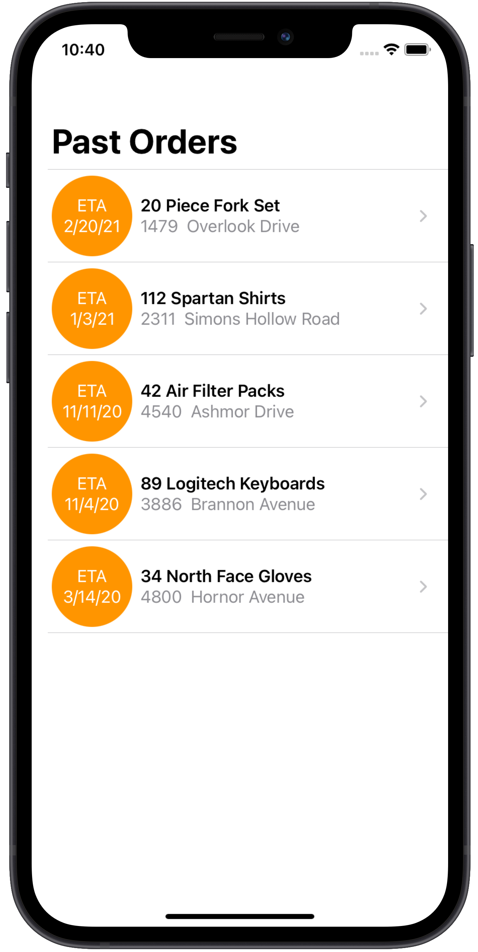

Artwork with No Whitespace.
Resize textbox.
Add black border to artwork.
Change textbox background to white.

Change textbox background to green.

Artwork with White Whitespace.

Resize textbox.
Change textbox background to white.
Add black border to artwork.
Change textbox background to green.
Resize textbox and note whitespace around artwork.

Cropping Artwork with White Whitespace in Word
Crop the artwork.
Change the picture.

Artwork with Transparent Whitespace.

Resize textbox.
Change textbox background to white.
Change textbox background to green.
Add black border to artwork.

Resize textbox and notice border around artwork

New Artwork With No, Some and Lots of Whitespace

Import New Artwork with No, Some and Lots of Whitespace

Import New Artwork With Whitespace

