Auto-Owners

Project Sponsors

Ross Hacker

Lansing, Michigan

Scott Lake

Lansing, Michigan

Jim Schumacher

Lansing, Michigan

Michigan State University

Team Members (left to right)

Alex Klingel

Marshall, Michigan

Connor Stabnick

Rochester, Michigan

Nabiha Biviji

Novi, Michigan

Michael Dickmann

Novi, Michigan

Auto-Owners Insurance is a Fortune 500 company that provides automotive, home, life and commercial insurance. Headquartered in Lansing, Michigan, Auto-Owners is represented by over 44,000 licensed insurance agents across 26 states, and provides insurance to nearly 3 million policyholders.

Every day, hundreds of insurance claims are filed with Auto-Owners through its independent agents. This process can be tedious for both policyholders and agents.

Our Jeffrey Virtual Insurance Claim Advisor system is a virtual claim assistant that automates the entire claim reporting process. Our mobile app, shown at the right, enables both agents and policyholders to file a claim easily and efficiently.

Jeffrey engages in a dialogue with policyholders and agents to gather information required to file their claim through natural conversation. If necessary, Jeffrey prompts users to take photos, record videos or attach documents relevant to a claim.

After completing a dialog with a user, Jeffrey automatically gathers the appropriate claim information and submits it to Auto-Owners.

Our companion web app enables agents and Auto-Owners associates to find and review claim information that is submitted through the mobile application.

Our Jeffrey Virtual Insurance Claim Advisor system features natural language processing, which is implemented using Google’s Dialogflow. A custom REST API, written in Kotlin, handles interactions between the applications and our MySQL database. Our web application is built using the React JavaScript framework.

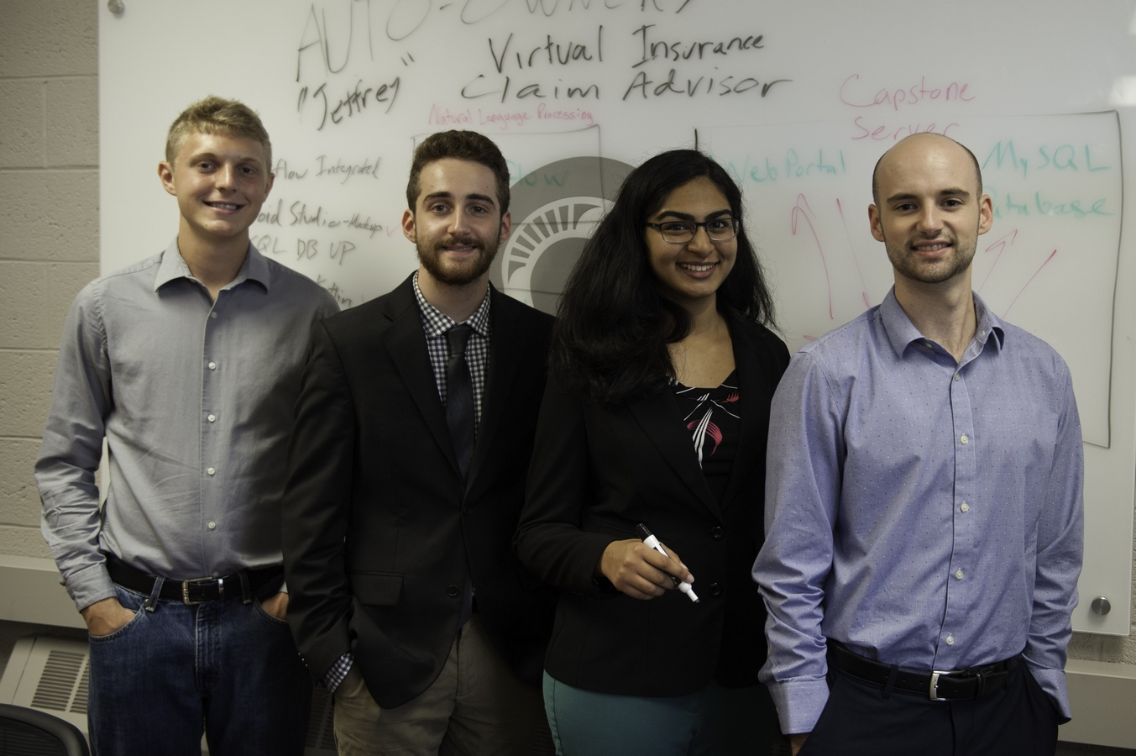

Auto-Owners Insurance

Jeffrey: Virtual Insurance Claim Advisor

