Headquartered in Benton Harbor, Michigan, Whirlpool is the world's leading global manufacturer of home appliances, employing over 100,000 people across 170 countries.

Whirlpool’s facilities include many buildings with hundreds of conference rooms and thousands of cubicles. So, finding a specific conference room or cubicle in an unfamiliar building can be quite a challenge. In addition, determining room availability for meetings is often difficult and time-consuming.

Our *Whirlpool Indoor Maps* (WIM) app provides interactive maps of Whirlpool buildings. Using our simple and intuitive design, employees can access and explore maps of any building at any Whirlpool location with their mobile phone.

WIM enhances the everyday work life of Whirlpool employees in a unique way by displaying up-to-the-minute Google Calendar information.

Our app combines Google Calendar with maps to provide a streamlined service so employees can find and book available meeting rooms and book them with visual map feedback.

To ensure simplicity, meetings for the day are readily available for viewing, editing and deleting.

Our mobile maps, combined with reservation and navigation functions, provide a comprehensive tool that increases the productivity of Whirlpool employees worldwide.

Our *Whirlpool Indoor Maps* app runs on both iPhones and Android phones. The iPhone app is written in Swift, while the Android app uses Java. Both utilize Google’s API services.

Whirlpool

Project Sponsors

Andrew Lewis

Benton Harbor, Michigan

Joshua Rawdin

Benton Harbor, Michigan

Dave Shunkwiler

Benton Harbor, Michigan

Lauren Stauder

Benton Harbor, Michigan

Jeffrey Stoller

Benton Harbor, Michigan

Carl Wendtland

Benton Harbor, Michigan

Michigan State University

Team Members (left to right)

Christian White

Midland, Michigan

Steph Brown

Warren, Michigan

Zoe Hayes

Howell, Michigan

Jallal Elhazzat

Taza, Morocco

Greg Richard

Novi, Michigan

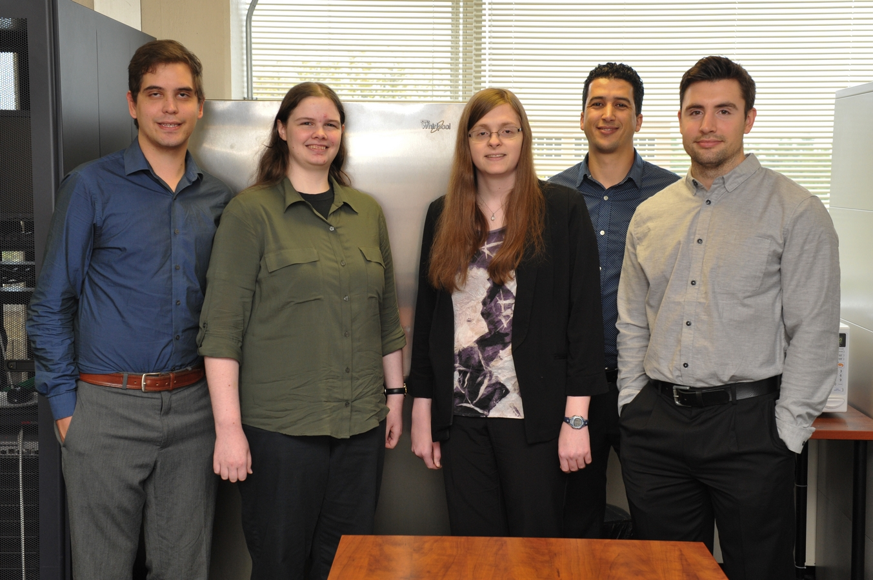

Whirlpool Corporation

Whirlpool Indoor Maps

