Urban Science is a business-solutions company focused on supporting the sales and marketing needs of automotive companies. They leverage a scientific methodology to help their client partners sell more vehicles, improve profitability, and increase customer loyalty.

At each client partner, marketing managers track customer loyalty through a variety of metrics. By looking at “repurchase loyalty scores,” managers determine the amount of customers repurchasing the same vehicle brands. Low scores prompt consideration of new marketing schemes.

Our *Visualizing Brand Loyalty* app consolidates loyalty data in expressive visualizations that enable loyalty managers at client partners to quickly assess market performance.

Using a multi-diagram interface, loyalty managers select a market of interest for a specific manufacturer’s brand or model. Markets are colored red or green depending on the loyalty of customers, which allows loyalty managers to identify which markets are struggling and what former customers are buying instead of their vehicles.

Loyalty trends over time illustrate new customer (conquest) data and former customer (defection) data. Monthly push notifications alert loyalty managers of newly acquired market data.

*Visualizing Brand Loyalty* is an application written for Apple and Android tablets. It is built on the Ionic framework using AngularJS and the D3 visualization library. PHP connects the application to a Microsoft SQL Server database.

Michigan State University

Team Members (left to right)

Meghan Huynh

Holt, Michigan

Jeff Baum

Caledonia, Michigan

Nick Durak

Canton, Michigan

Richard Brush

Brownstown Township, Michigan

Asha Patel

Canton, Michigan

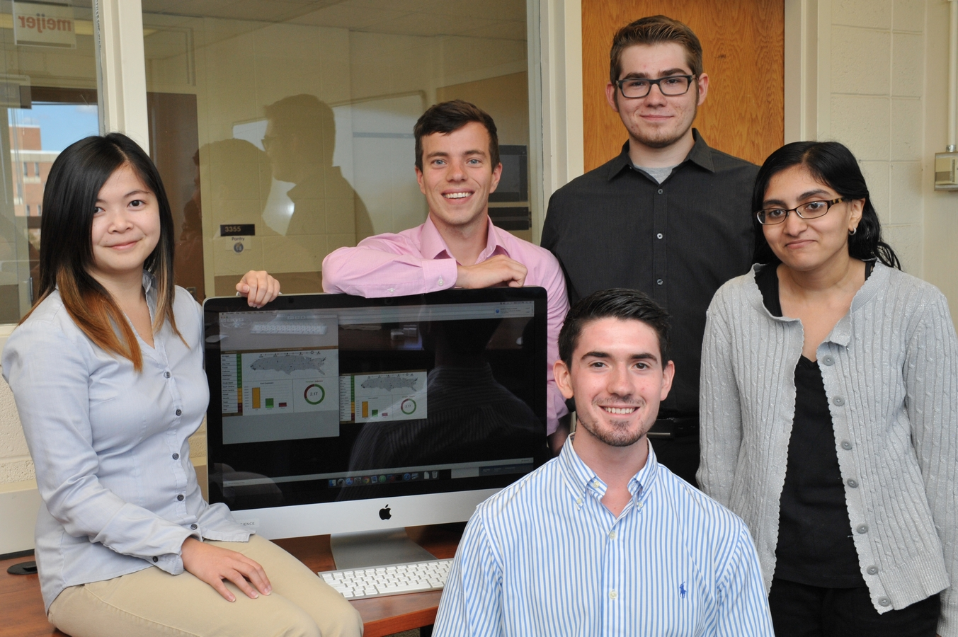

Urban Science

Visualizing Brand Loyalty

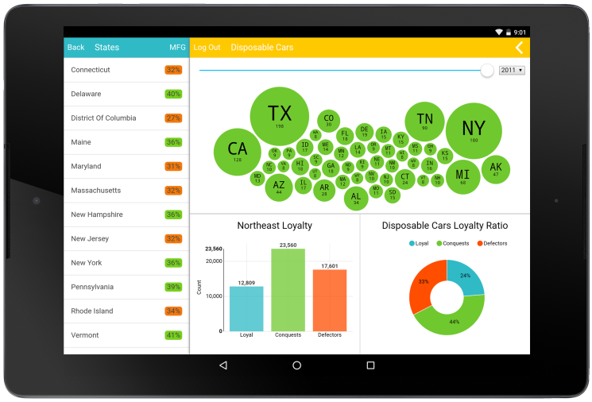



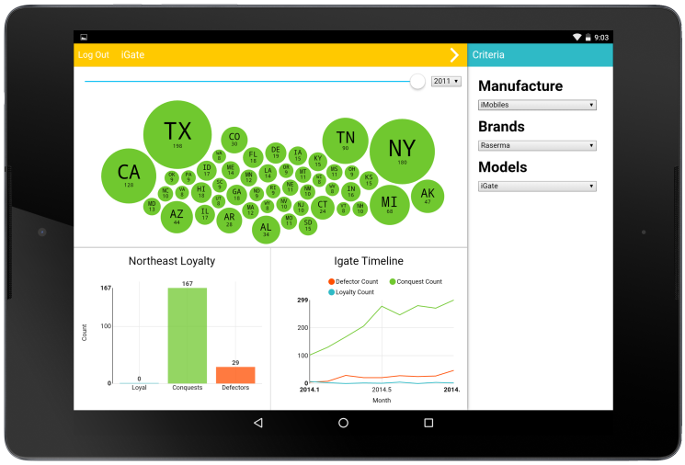

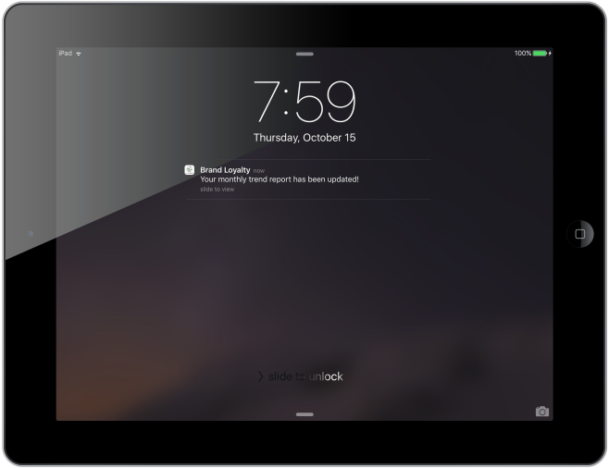

Urban Science

Project Sponsors

Matt Bejin

Detroit, Michigan

Sam Bryfczynski

Detroit, Michigan

Mike DeRiso

Detroit, Michigan

Elizabeth Klee

Detroit, Michigan

Kathy Krauskopf

Detroit, Michigan

Michael Nelson

Detroit, Michigan

Mitch Phillips

Detroit, Michigan

Christian Welch

Detroit, Michigan