TechSmith

Project Sponsors

Michael Bell

Okemos, Michigan

Dean Craven

Okemos, Michigan

Austin Gregory

Okemos, Michigan

Dave McCollom

Okemos, Michigan

Michigan State University

Team Members (left to right)

Jordyn Castor

Grand Rapids, Michigan

Debayan Deb

Kanpur, Uttar Pradesh, India

Whitney Mitchell

Alto, Michigan

Max Miller

Pittsburgh, Pennsylvania

Cody Pearson

Hudsonville, Michigan

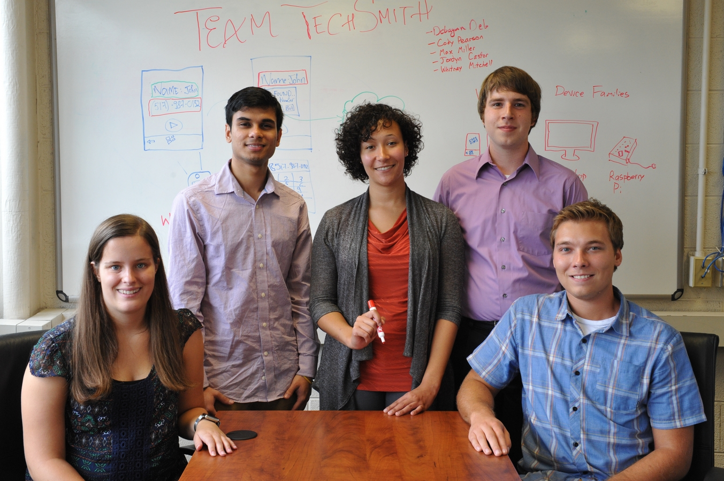

TechSmith

Intelligent Real World Text Recognition

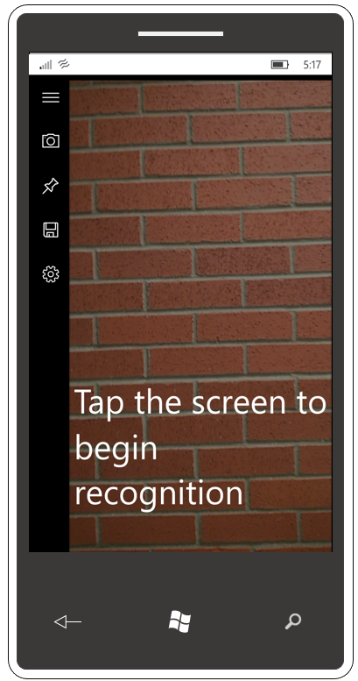

TechSmith is a leading developer of screen capture, video capture, and editing software including the very popular Snagit, Camtasia, TechSmith Relay and Morae, which are used by companies and educational institutions around the world.

Our *Intelligent Real-World Text Recognition* app uses a device’s camera to find text in the real world, recognize what it is, and then perform a task depending on the format of the text.

For example, if our app recognizes text as a phone number, it offers to call it or save it. If it sees an email address, it can send an email. If our app recognizes a street address, it gives the address to an app like Apple Maps or Google Maps.

A useful feature of our app is its ability to read text out loud for the visually impaired or someone learning to read.

Our app is a Universal Windows 10 application, which means that it runs on any Windows 10 platform including phones, tablets, laptops and Raspberry Pi devices.

Users can save recognized text to the cloud and access it from any Windows 10 device.

Our app meets accessibility standards so that it is usable by those with disabilities. It enhances productivity for all users.

Our *Intelligent Real-World Text Recognition* app is written in C# and XAML. Microsoft Azure cloud services and an SQL database store the recognized text. Microsoft’s Optical Character Recognition Engine converts camera frames to text, which is then recognized using regular expressions.

