Quicken Loans

Project Sponsors

Pat Hartford

Detroit, Michigan

Linglong He

Detroit, Michigan

Ted Williamson

Detroit, Michigan

Michigan State University

Team Members (left to right)

Brian Chivers

Antioch, Illinois

Chase Grove

Clare, Michigan

Emily Klopfer

Troy, Michigan

Eric Nartker

Midland, Michigan

Ben Toth

Midland, Michigan



Quicken Loans

Enterprise Roadmap Tool



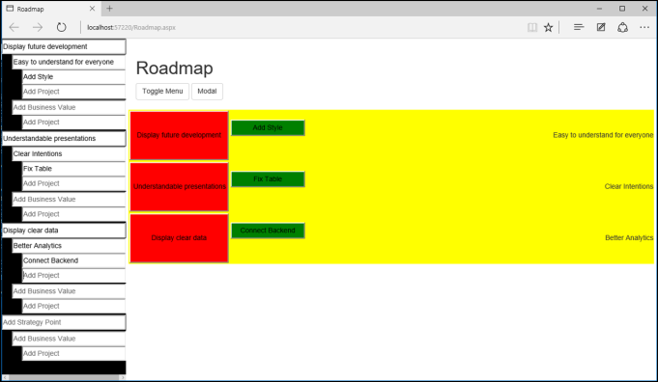

Quicken Loans, based in Detroit, is the largest online mortgage lender in the US. With almost 30 years of experience, their customers include over 2 million families.

Quicken Loans designs and develops its own enterprise software systems, which often requires significant amounts of time and money. In order for senior level executives to make sound business decisions about investing in the development of these new systems, executives must understand what’s being proposed and why.

Our *Enterprise Roadmap Tool* provides visualizations of Quicken Loans’ enterprise software systems including projects being proposed and developed. Executives view an intuitive project roadmap rather than reading a complex document.

Enterprise architects use our system to build project roadmaps and their main components: the strategic purpose, the business value, and the tasks that need to be accomplished to achieve the purpose and business value.

A roadmap presents a high-level overall view of a project, color-coding tasks and business values to show dependencies. As executives drill down into the details, popups provide more information such as a task’s description, its dependencies on other tasks, risks involved, and links to outside relevant information.

Our *Enterprise Roadmap Tool* is written in JavaScript and C# using the .NET framework. The database is implemented using Microsoft SQL Server 2012.

