Meijer is one of the country’s largest supercenter chains, providing high quality food and merchandise in six states across the Midwest. With their headquarters located in Grand Rapids, Michigan, Meijer has over 200 stores, 60,000 team members and serves millions of customers each year.

Our *In-Store Price Compare* mobile app gives Meijer customers an easy way to compare prices as well as giving Meijer insight into the marketplace.

Customers scan an item’s barcode using their iPhone, iPad or Android device. Our app shows the Meijer price along with the prices of Meijer’s competitors. If the Meijer price is not the lowest, a special one-time coupon may be offered to encourage the customer to make the purchase at Meijer.

Every time a Meijer customer scans a product for pricing, relevant data about the product and prices are uploaded into a Meijer database. Our companion web app visualizes this data with charts and graphs.

Meijer sourcing managers use the web app to analyze the strengths and weaknesses of their in-store pricing as well as consumer buying patterns. As a result, Meijer customers get the best products at the lowest prices.

Our *In-Store Price Compare* iOS and Android apps are written in C# using cross platform interfaces created with Xamarin.Forms. The web platform runs on the ASP.NET framework and is written using HTML5, D3.js and Bootstrap. Both the SQL database and web platform are hosted on Microsoft Azure.

Meijer

Project Sponsors

Jim Becher

Grand Rapids, Michigan

Chris Laske

Grand Rapids, Michigan

Terry Ledbetter

Grand Rapids, Michigan

Jim Poll

Grand Rapids, Michigan

Murali Rajagopalan

Grand Rapids, Michigan

Michigan State University

Team Members (left to right)

Brian Wyss

Albuquerque, New Mexico

Brandon Bielicki

Livonia, Michigan

Anthony Laurain

Pinckney, Michigan

Zandra Russell

Clarkston, Michigan

Spencer Ottarson

Williamston, Michigan

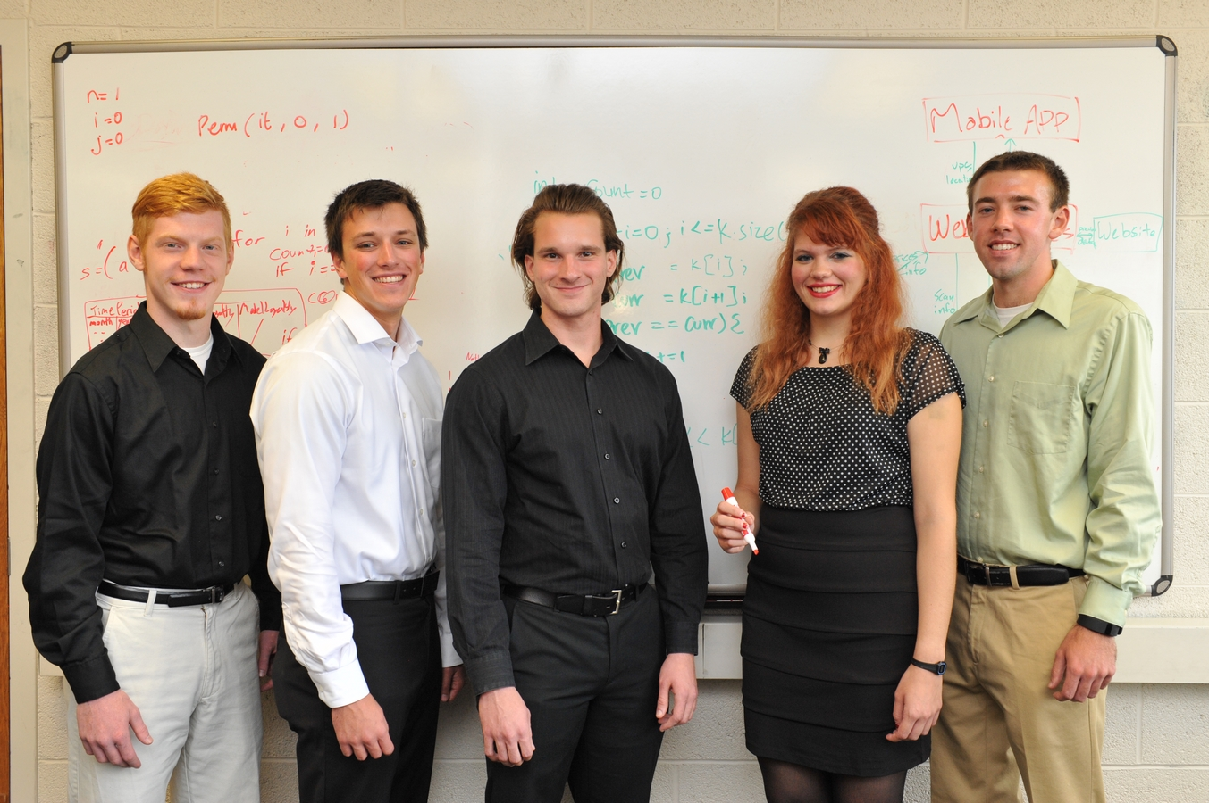

Meijer

In-Store Price Compare

