Michigan State University

Team Members (left to right)

Brian Hart

Sterling Heights, Michigan

Michael Palmer

Grand Rapids, Michigan

Corbin Rangler

Jackson, Michigan

Evan Hlavaty

Howell, Michigan

Sean Rabaut

Pontiac, Michigan

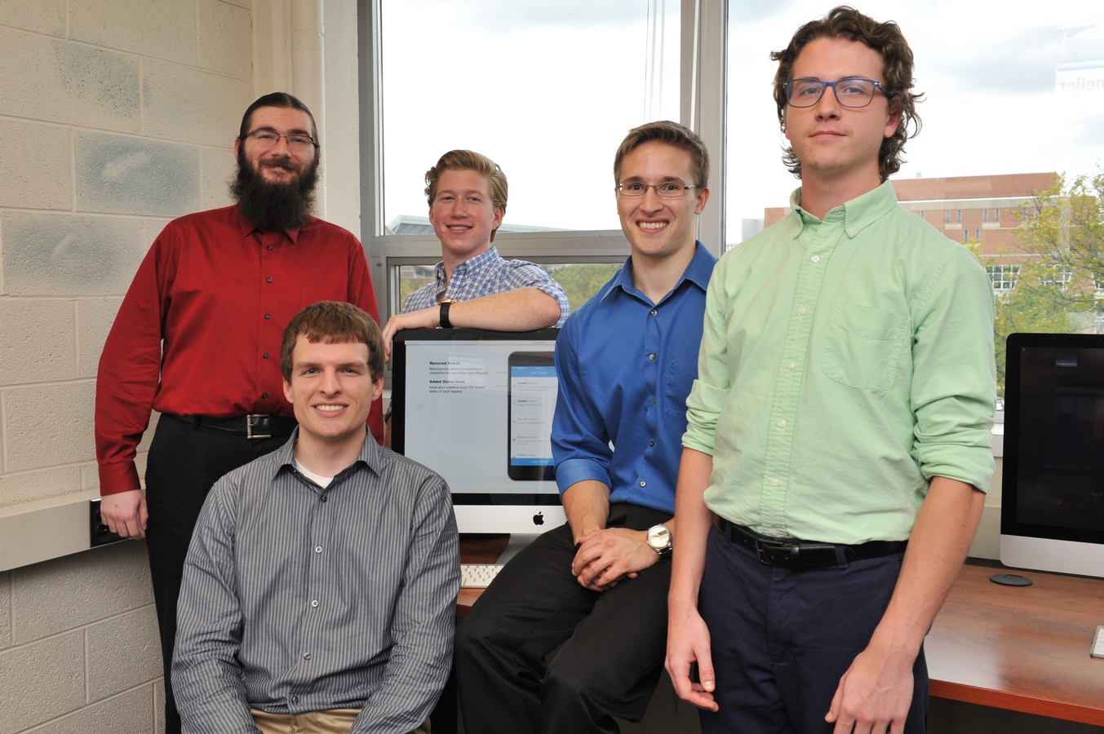

General Motors

Global Service Desk Mobile App

General Motors is one of the world’s foremost designers and manufacturers of cars and trucks sold in more than 120 countries. Headquartered in Detroit, Michigan, GM’s 218,000-plus employees work in 396 facilities spanning six continents.

GM’s Global Service Desk (GSD) helps GM employees solve their information technology (IT) problems. Our *Global Service Desk (GSD) Mobile App* provides GM employees with access to the GSD from anywhere at any time.

When needing IT assistance, GM employees use GSD Mobile. After describing their problem, users are presented with possible fixes so they can solve their problem immediately themselves, without calling the GSD. If not resolved, users submit a help ticket, which they can track easily.

A GSD agent determines the best time to call an employee needing IT help by looking at the employee’s calendar, which our team integrated into GM’s IT Service Manager system.

As an agent makes changes to a help ticket, push notifications are sent to the *GSD Mobile App* to keep the GM employee up to date. Agents may also send preset messages requesting more information about an employee’s problem.

Using our system, GSD agents process help tickets faster and more efficiently, alleviating phone congestion for other GM employees with more serious IT issues.

Our *GSD Mobile App* and web front end are written in Swift 2 and JavaScript, respectively. Both interface with an Apache2 web server that synchronizes with a MySQL database via PHP.

GM

Project Sponsors

Mike Adelson

Warren, Michigan

Treva Beckius

Warren, Michigan

Joseph Goree

Warren, Michigan

Fred Killeen

Warren, Michigan

Trevor Lift

Warren, Michigan

Shane McCutchen

Warren, Michigan

Dan Rudman

Warren, Michigan

Christian Stier

Warren, Michigan



