**Urban Science**

***Corporate Sponsors***

Matt Bejin

Detroit, Michigan

Randy Berlin

Detroit, Michigan

Mark Colosimo

Detroit, Michigan

Suzanne Dubois

Detroit, Michigan



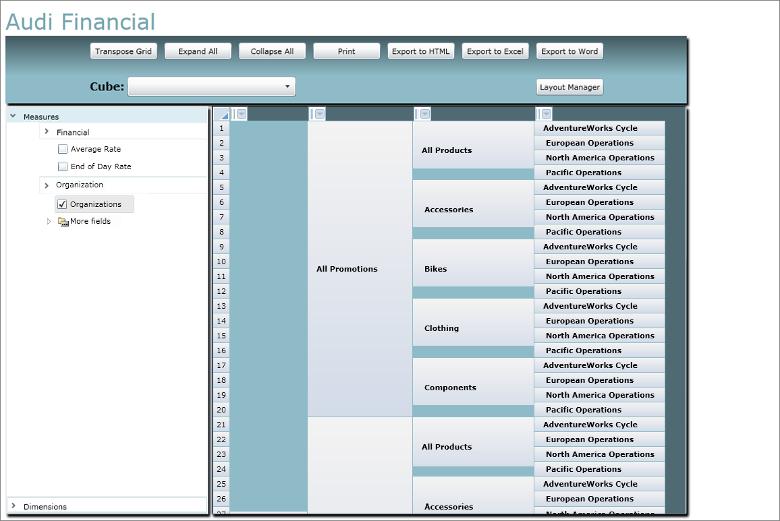

As one of the most trusted sources of analytical data in the industry, Urban Science helps their automotive and retail clients plan effectively, define and measure performance, and develop sales and marketing programs that deliver results.

In order to produce these results, very large amounts of data need to be analyzed very quickly and efficiently. A special kind of database structure—OLAP (OnLine Analytical Processing) cube—is used as a querying tool with a user-friendly interface.

The figure at the right shows our OLAP cube dashboard interface and functionality.

Our dashboard is accessible from the internet, while the database is stored at a remote location off-site. Customers need not install any additional software, thus giving our program a zero-footprint for our end-users.

Users can manipulate the various dimensions available to them based on a given set of data, and view it in a grid. The data can be sorted, transposed, graphed, or saved for later use. Microsoft Silverlight lightens the actual programming load due the presence of multiple built-in libraries.

A widely requested functionality for this program is the ability to export data to Excel, which is provided by a one-click link.

The program uses Silverlight and XAML for the interface, ASP.NET and C# for the processing, and Microsoft SQL Server and MDX for database manipulation.

**Michigan State University**

***Team Members*** (left to right)

Nathan Goodrich

Haslett, Michigan

Dinesh Banda

Troy, Michigan

Ryan Kelly

Farmington Hills, Michigan

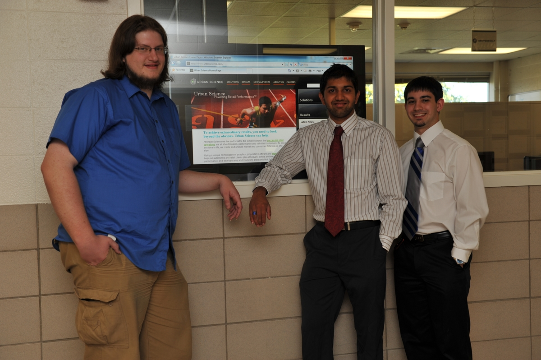

**Urban Science**

**Modern Online Analytical Processing Cube**