GE Aviation
Flight Management System Voice Interface
GE Aviation
Corporate Sponsors

Don Moore
Grand Rapids, Michigan
Greg Sykes
Grand Rapids, Michigan
Robert Taylor
Grand Rapids, Michigan
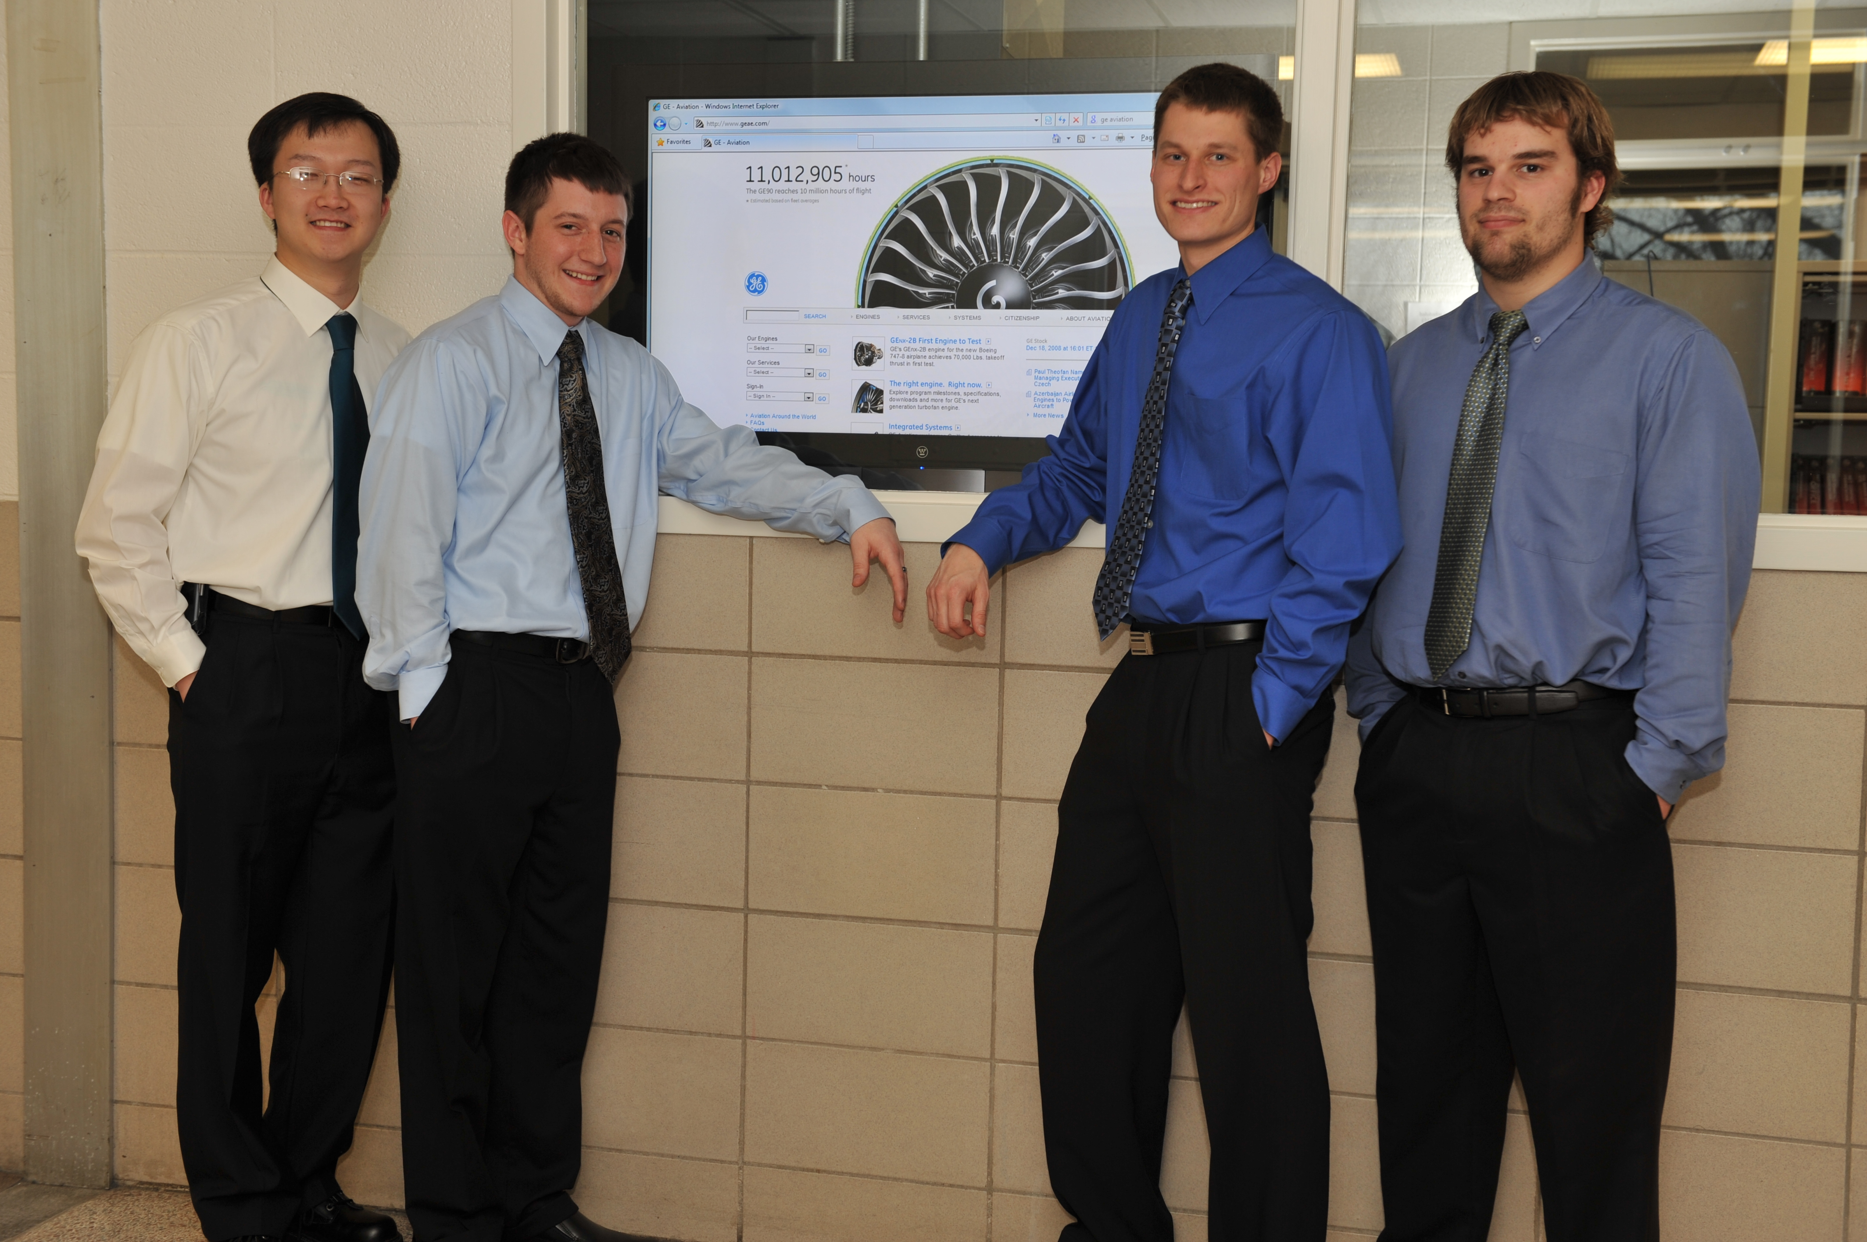
Air Traffic Control / Pilot communication has remained largely unchanged since the 1950’s. But recently, text based communication between Air Traffic Controllers and Pilots is being used with increased frequency.
GE’s current system provides direct data link communication between air traffic controllers and pilots. It provides the flight crew with the ability to send and receive messages similar to today's email or text messages. Communication supported by this system provides position reporting, pilot request, and air traffic control clearances. This technology reduces air traffic controller workload.
Their software allows controllers to input text using a computer keyboard. Our software extended this functionality by allowing the controller to speak the message he/she wishes to send into a microphone. Our software automatically translates the controller’s voice message into a formatted text message and is sent to the desired aircraft.
As an example scenario, an Air Traffic Controller would speak a command into the microphone such as “descend to 13,000 feet”. This message is then displayed in our software to allow the controller to verify the message before sending it to the aircraft. The aircraft crew would then receive the message and make the appropriate course corrections.
Our development was done with C# and C++ languages. The speech recognition was done using SAPI 5.1.
Michigan State University
Team Members
(Left to Right)
Xulu Zhang
Ann Arbor, Michigan
David Schwanky
Brighton, Michigan
Eric Partlo
Brighton, Michigan
William Rogers-Snodgrass
Holt, Michigan



