TechSmith
Mobile Smart Video Player
TechSmith
Project Sponsors
Randall Brown
Okemos, Michigan
Dean Craven
Okemos, Michigan
Ryan Eash
Okemos, Michigan
Bill Hamilton
Okemos, Michigan
Dave McCollom
Okemos, Michigan
Matt Mercieca
Okemos, Michigan
Mike Simons
Okemos, MIchigan
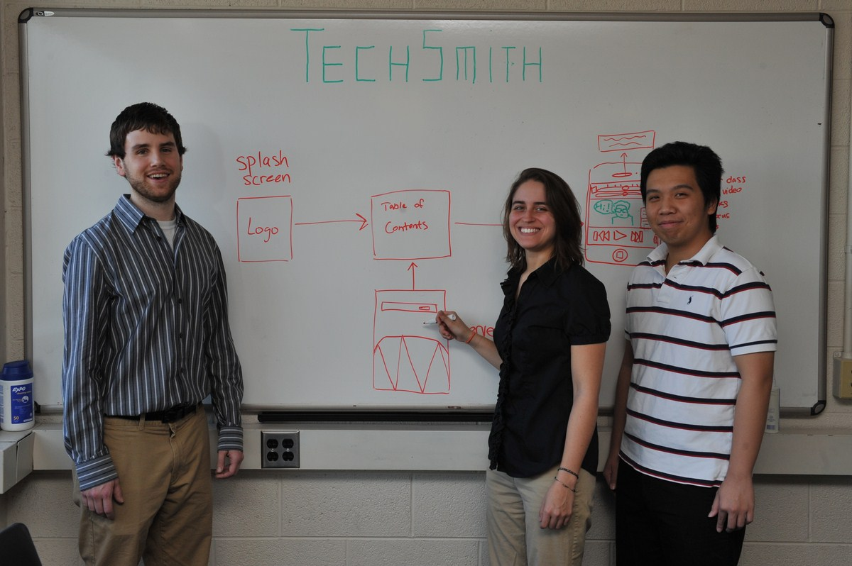
TechSmith is the world leader in screen recording software with millions of users creating informational and educational content. Their content creation products generate valuable metadata that can enhance the viewing experience.
Our Mobile Smart Video Player is an iPhone/iPad application that makes use of this metadata, extending the functionality of TechSmith’s Camtasia Studio screen-capture editing software to a mobile environment. It learns what video content is most relevant by sampling each user’s tags and by displaying the optimal content to all users.
While watching a screen-capture movie using the Mobile Smart Video Player, a user can gesture to add a bookmark, an on-screen comment about the content, or a SmartFocus zooming or panning point.
Every user-generated tag is added to a database to which tags from users worldwide are constantly being added. The most commonly-placed tags are pulled from this crowd-sourced collection onto all users’ iPhones and iPads. Each individual user has the option of viewing their own data alone or the most popular crowd-sourced data from around the world.
Our Mobile Smart Video Player is written in Objective-C. Video content comes from Camtasia Studio. The XML metadata is parsed using Google libraries and is stored in a Microsoft SQL Server database. Our player communicates with the server via the RESTful Open Data Protocol.
Michigan State University
Team Members (left to right)
Scott Klum
Grand Rapids, Michigan
Meryl Dara Mabin
Rockford, Michigan
Yue Lu
Chaozhou, Guangdong, China

