Spectrum Health Systems
Web Applications for Healthier Communities
Spectrum Health
Project Sponsors
Adam Baker
Grand Rapids, Michigan
Hollie Blagg
Grand Rapids, Michigan
Jason Joseph
Grand Rapids, Michigan
Ed Koller
Grand Rapids, Michigan
Jeremy Meller
Grand Rapids, Michigan
Patrick O’Hare
Grand Rapids, Michigan
Sergey Stoma
Grand Rapids, Michigan
Seth Wentland
Grand Rapids, Michigan
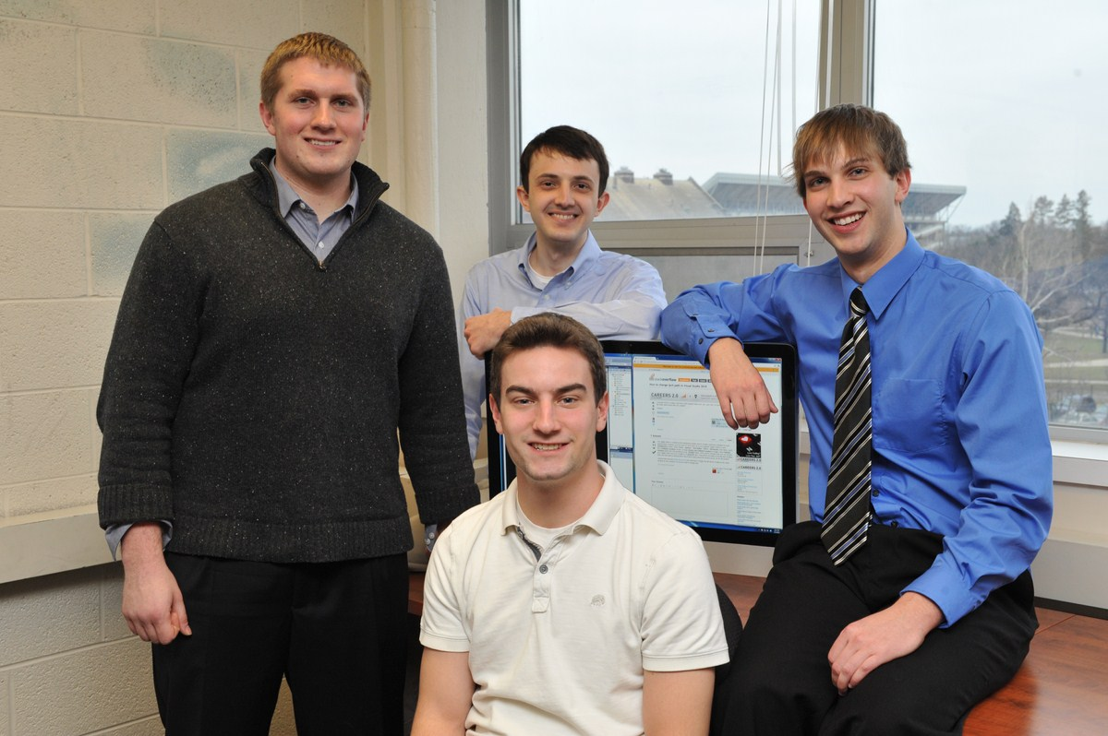
Healthier Communities is a volunteer health services program sponsored by Spectrum Health, the largest health care provider in Western Michigan. Healthier Communities provides medical outreach to the underserved populations.
In 2010, Community Health Workers made 2,599 home visits to 477 participants to collect health data to ensure that they are getting better and staying healthy. Currently, the process of collecting this health data involves the completion of a 23-page paper form, which subsequently must be entered in a computer.
Working with leaders of Healthier Communities and the technical department of Spectrum Health, we are making the entire process digital. Our Web Applications for Healthier Communities system replaces the 23-page paper form with a user friendly iPad web application connected to a database at Spectrum Health.
After logging in, the user simply presses a button to select a participant, open up their file, and start collecting information. They can save, load, and manage participant information with the touch of a finger, without the stack of paper.
One of our applications most appealing features is its look and feel. Even though it is web application, it appears to the user as a native iPad application.
Our Web Applications for Healthier Communities system is written in C# with JavaScript and is supported by a backend SQL database.
Michigan State University
Team Members (left to right)
Brian Duncan
New Baltimore, Michigan
Charlie Andrews
Shelby Township, Michigan
Alper Can
Ankara, Turkey
Bret Myers
Newberry, Michigan
