Raytheon
Android Secure VoIP Communications System
Raytheon
Project Sponsors
Jay Blevins
Fort Wayne, Indiana
David Emery
Fort Wayne, Indiana
David Holbrook
Fort Wayne, Indiana
Jason Hoover
Fort Wayne, Indiana
David Peter
Fort Wayne, Indiana
Barry Peterson
Fort Wayne, Indiana
Daniel Sheline
Fort Wayne, Indiana
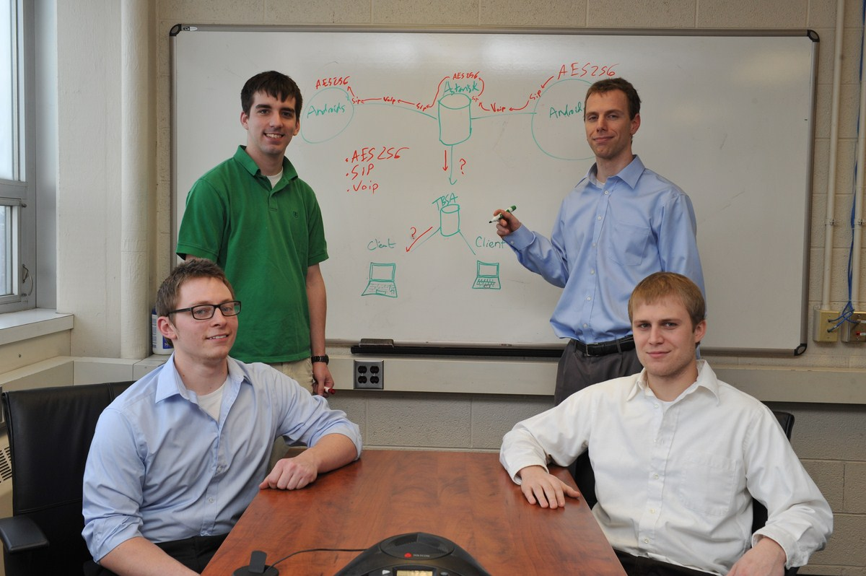
Secure voice communication is an essential feature for command and control (C2) applications used in emergency management situations or combat settings. The Android Secure VoIP Communications System enables mobile C2 users to transmit confidential information over encrypted channels and thereby exchange information securely.
Our system provides both one-to-one communication and group collaboration. The latter enables tactical operations centers to provide groups of personnel with situational awareness data quickly. In addition to beginning and ending calls, our system also allows one user to invite another user onto an existing call. A separate desktop application enables users at operation centers to participate in calls, and to listen to previously recorded conversations.
In an effort to simplify radio configuration in a C2 setting, the system also allows radios to be configured in a hands-free manner. Nearby radios can be configured with appropriate voice commands. A confirmation message is sent back to the Android phone for the user to verify the current state of a reconfigured radio.
The Android Secure VoIP Communications System is developed with the Android SDK. Calls are managed with the Session Initiation Protocol (SIP) standard. An Asterisk server handles the routing of calls. Conversations are encrypted with AES 256. The entire system is integrated into Raytheon’s existing C2 application.
Michigan State University
Team Members (left to right)
Forrest Yockey
Dewitt, Michigan
Kyle Bartush
Ludington, Michigan
Benjamin Katt
Concord, California
Calvin Griggs
Nunica, Michigan
