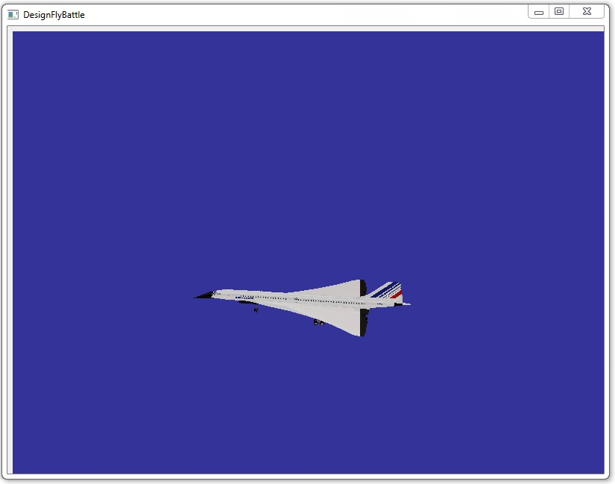
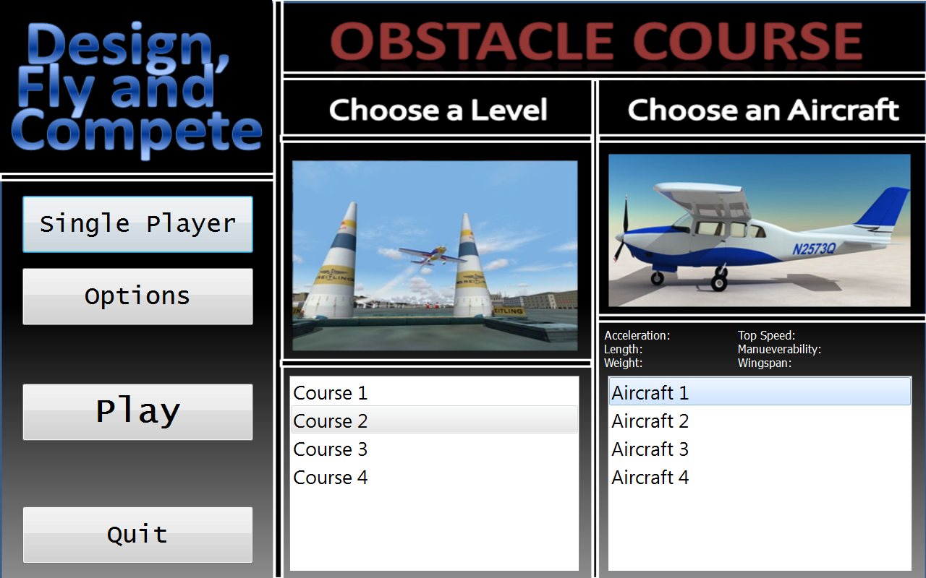
The Boeing Company
Design, Fly and Compete Flight Simulator
Boeing
Project Sponsors
Pete Clive
Saint Louis, Missouri
Matt Daniels
Saint Louis, Missouri
Jayson T. Vincent
Saint Louis, Missouri
Steve Yallaly
Saint Louis, Missouri
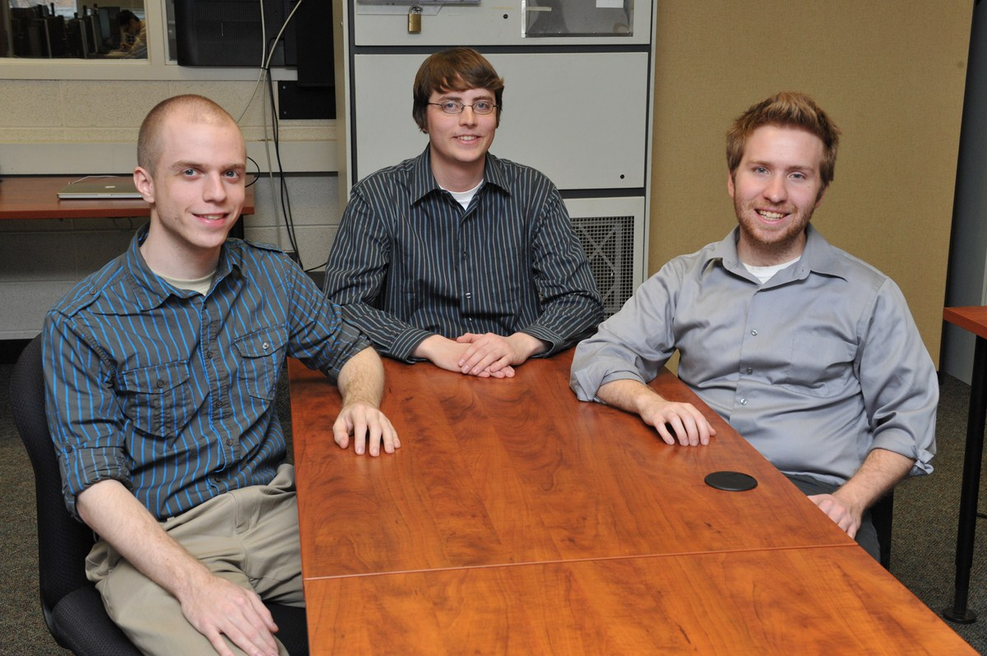
The Boeing Company is a world leader in commercial and military aircraft. They utilize complex simulation software to design and develop their products to explore how changes in design affect performance.
In order for simulations to give accurate predictions of performance, they must be a very accurate representation of actual flying conditions. Our Design, Fly and Compete Flight Simulator provides a plane flight simulator with a strong flight model, using six degrees of freedom for motion.
Our flight simulator features a progression system in which the user completes a series of obstacle courses, challenging their flight skills in order to unlock additional courses as well as improve their completion times.
The user starts the program and enters their user name, which is used to track their progression, as well as scores on courses.
The user can choose from any of the courses available to them and see their previous best result. They can choose to run through a course in the simulator to improve their result or complete it for the first time, thereby furthering their progression through the course system.
The obstacle courses consist of a series of floating rings that must be flown through in the correct order. The rings are arranged to present various challenging maneuvers.
The program uses the Qt framework for Windows. The 3D environment is rendered by OpenSceneGraph.
Michigan State University
Team Members (left to right)
Brandon Overall
Walled Lake, Michigan
Jon Moore
Fort Wayne, Indiana
David Cornelius
Blue Springs, Missouri


