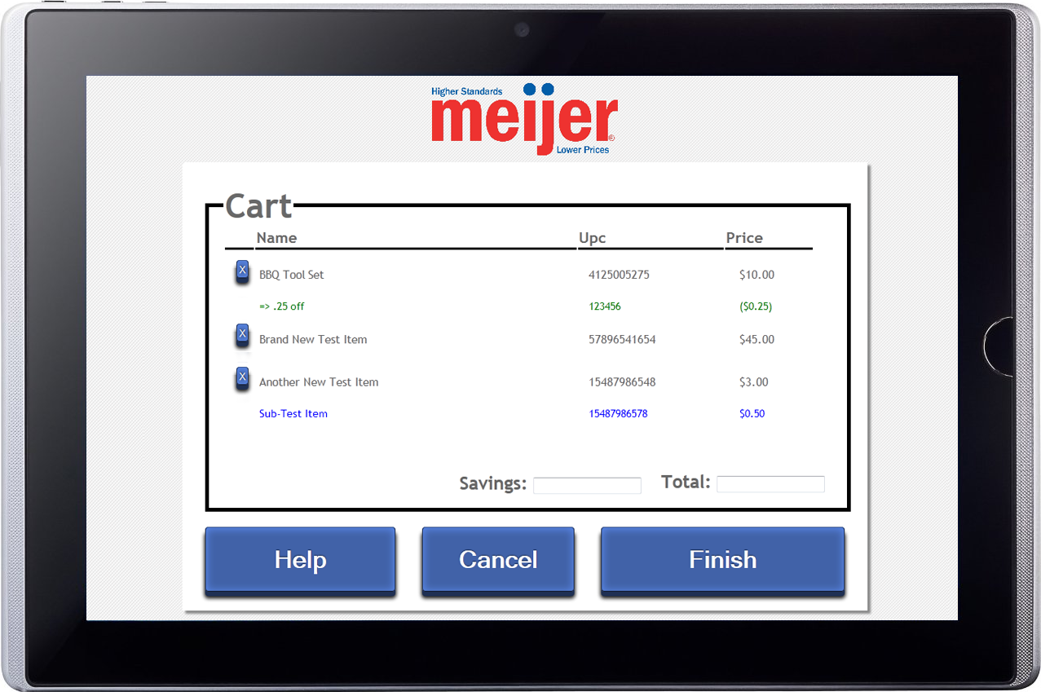
Meijer
Tablet-Based Point-of-Sale System
Meijer
Corporate Sponsors
Randy Brower
Grand Rapids, Michigan
Scott Pallas
Grand Rapids, Michigan
Jim Poll
Grand Rapids, Michigan
Murali Rajagopalan
Grand Rapids, Michigan
Dave Rodgers
Grand Rapids, Michigan
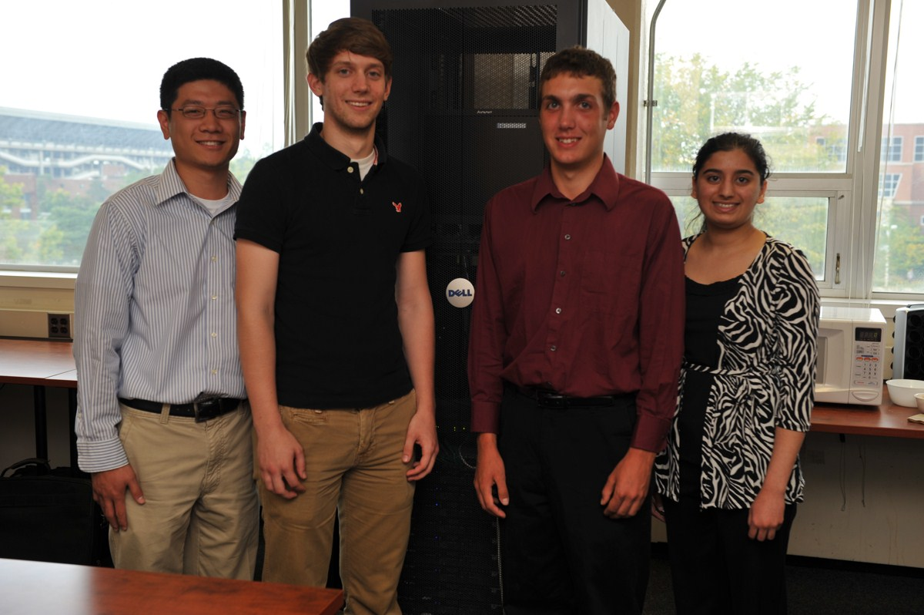
With over 200 stores, Meijer continues to grow steadily because they truly value their customers. To better enhance the shopping experience, Meijer is experimenting with innovative ways to use mobile devices in the checkout process.
Our Tablet-Based Point-of-Sale System is a creative new interface, which provides Meijer customers with a “next generation” checkout experience.
Our tablet-based system uses barcode scanners to identify each item to be purchased. It then sends a unique product identifier to Meijer’s Point-of-Sale system, which responds with the specific information about the item.
Shoppers interact with two tablets at the checkout station. The tablets display information about the scanned items such as their name, description, and price. Our system handles a variety of exceptions such as price or age verification.
The goal of our tablet-based system is to replace the bulky touchscreen devices that are currently in use. One important advantage is that the tablet itself is small, self-contained, and relatively inexpensive. In the event that a tablet breaks, thereby shutting down a self-checkout station, the broken tablet can easily be replaced with a working one.
Our application runs in web browsers on the two tablets. The software is written in C# with ASP.Net MVC. Data is stored in Microsoft SQL Server 2008. The UI for our system is written in HTML 5, CSS, and JavaScript.

Michigan State University
Team Members (left to right)
Mark Sun
Canton, Michigan
Andrew Rockwell
St. Johns, Michigan
Peter Rifel
Huntington Woods, Michigan
Riti Adhi
Okemos, Michigan


