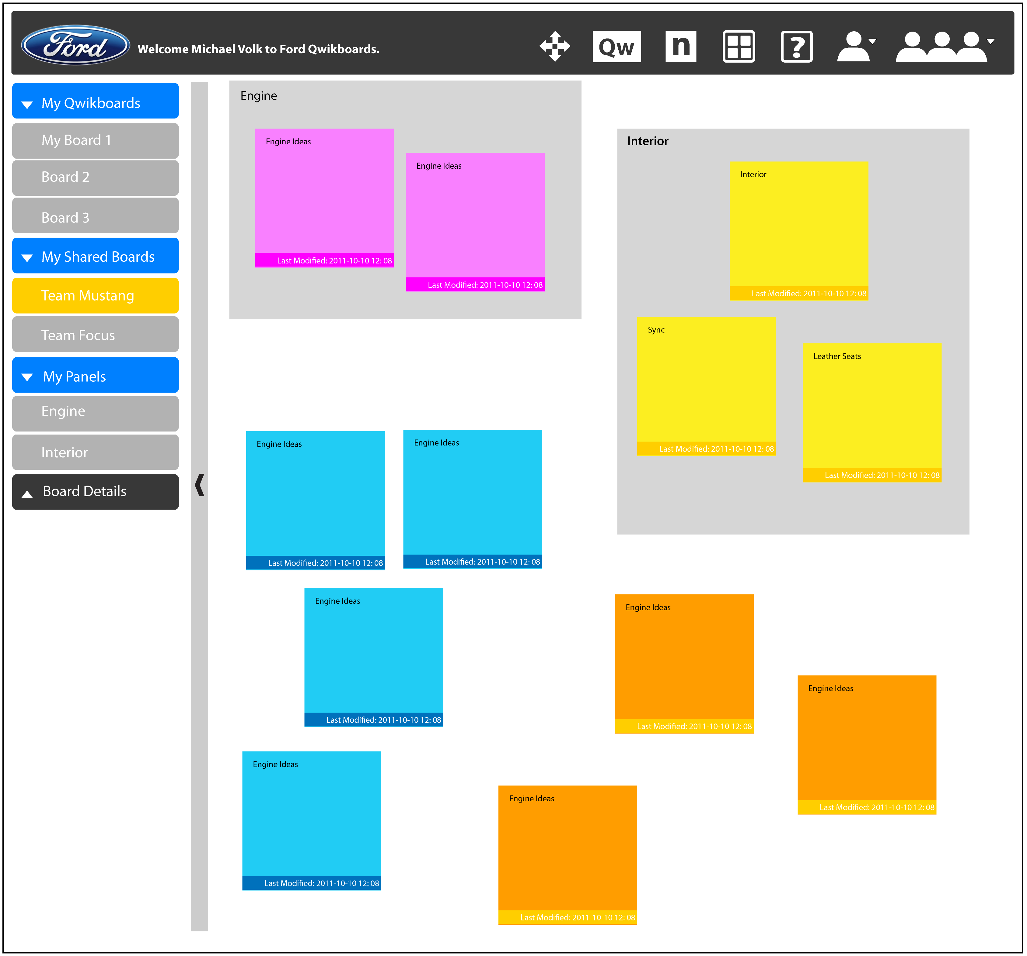
The Ford Motor Company
Ford Qwikboard
Ford
Corporate Sponsors
Nat Girish
Dearborn, Michigan
Adam Haas
Dearborn, Michigan
Gopal Kamat
Dearborn, Michigan
Michael Seneski
Dearborn, Michigan
Laura Terbrack
Dearborn, Michigan
Michael Volk
Dearborn, Michigan
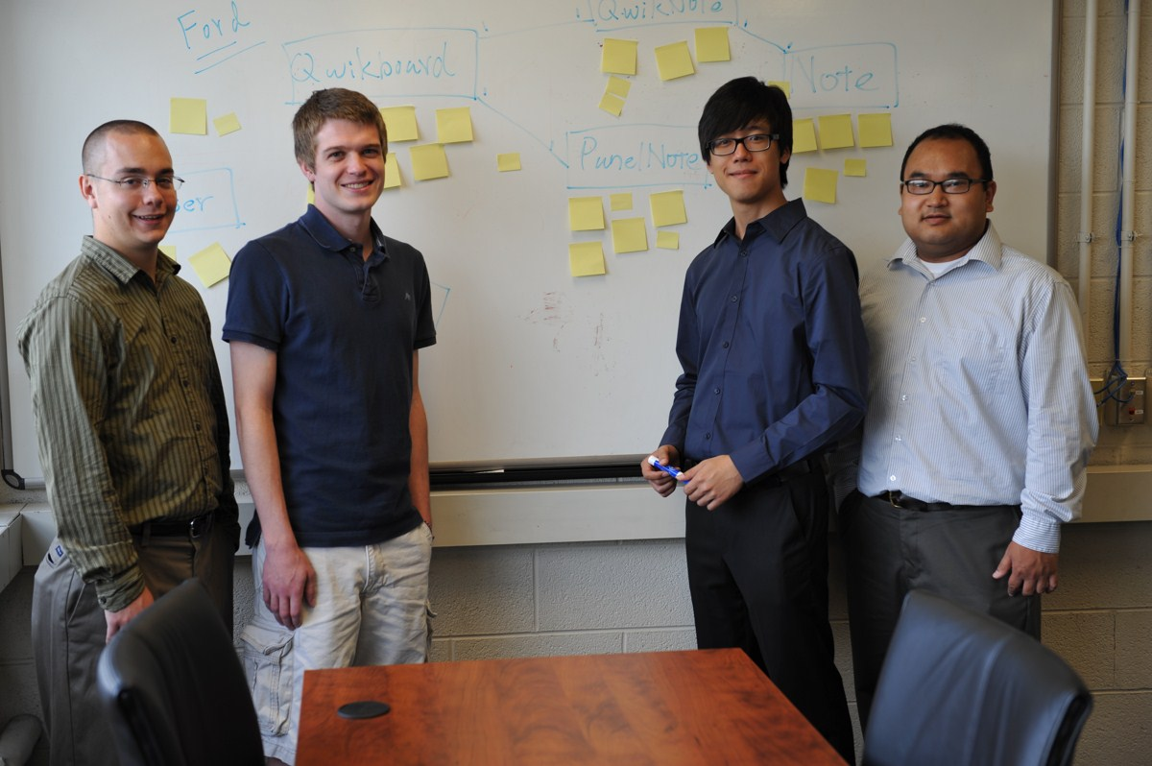
Ford is a global company that has many geographically dispersed teams. In order for these teams to be able to communicate more effectively and efficiently we have designed and written Ford Qwikboard.
Ford Qwikboard is a “sticky note” web application that allows teams to share key ideas through text, audio, video and various office attachments. For easy organization a Qwikboard is able to be broken into different sections called panels.
When a user logs in they see their current Qwikboards, can create a new Qwikboard, and they can add users with whom they will be able to collaborate with. The Qwikboard is one big open space to share thoughts and ideas freely with peers.
The Qwikboard is updated in real time, which allows for instant communication and feedback. This eliminates confined conference rooms and cluttered whiteboards.
The Ford Qwikboard is a very user friendly web application that captures the natural look and feel of using 'sticky notes' on a whiteboard. Everything is ideally located with large buttons. Our application replaces cluttered war room processes and whiteboard brain storming with a clean and efficient virtual one accessible at any time.
Ford Qwikboard is written in HTML5 with Java, JavaScript, jQuery and multiple open source frameworks. It runs on any modern web browser or mobile device.
Michigan State University
Team Members (left to right)
William S. White Jr.
Ferndale, Michigan
Luke Davis
Mason, Michigan
Jin Hou
Guang Dong, China
Danh Tran
Warren, Michigan
