The Boeing Company
BAPS 2: Battle Aircraft Position Share 2
Boeing
Corporate Sponsors
Pete Clive
Saint Louis, Missouri
Matt Daniels
Saint Louis, Missouri
Bob Feldmann
Seattle, Washington
Jayson T. Vincent
Saint Louis, Missouri
Steve Yallaly
Saint Louis, Missouri
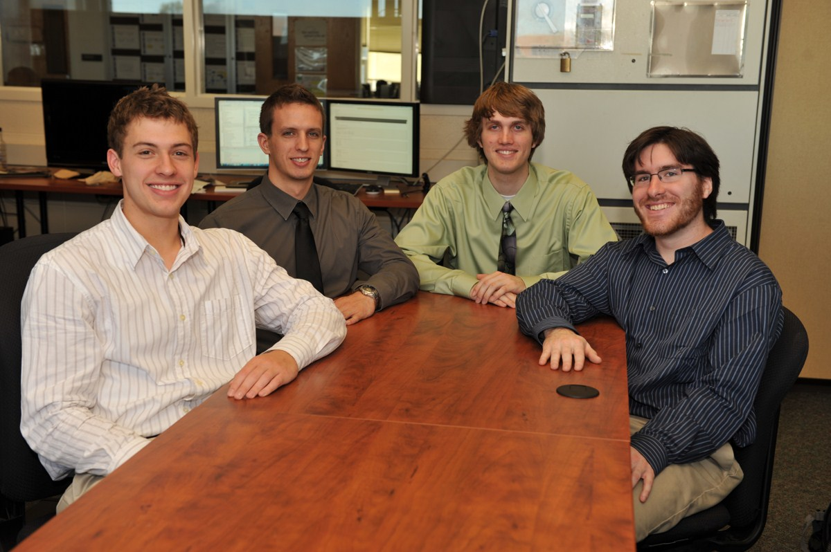
Battle Aircraft Position Share 2, or BAPS 2, is a game in which two players compete in a 3D arena to destroy their enemy’s targets, which include technology centers and planes. Players must protect their own targets by intercepting enemy communications and reacting accordingly. The game occurs in real time, with each player working to command their entire fleet through both offensive and evasive maneuvers.
Continuous and strategic command of technology centers is essential to mounting a strong defense. In addition, each player selects a cyber-defense plan, which offers certain advantages and disadvantages, depending on whether or not the player is playing offensively or defensively.
Players must deal with information overload and respond to feedback resulting from game events. Players who react both quickly and effectively will have an advantage in the game.
Since BAPS 2 is a web app, it can be played on many devices from different locations. The web app connects to a central game server, which keeps the game synchronized across all devices. This server also ensures that network latency does not have significant influence on the game. Communication between the web app and the game server is encrypted.
BAPS 2 is compatible with Windows XP/Vista/7, Mac OS X, Linux, Android, and iOS. The visuals are rendered in WebGL. Network connections between the game web app and the game server are made through WebSockets.
Michigan State University
Team Members (left to right)
Devin Rosen
Lansing, Michigan
Nicholas Palm
Ypsilanti, Michigan
Christopher Heuser
Brighton, Michigan
Joshua J. Theisen
Saginaw, Michigan

