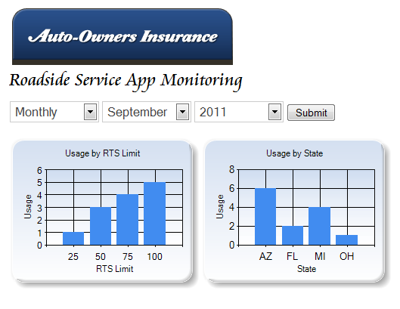
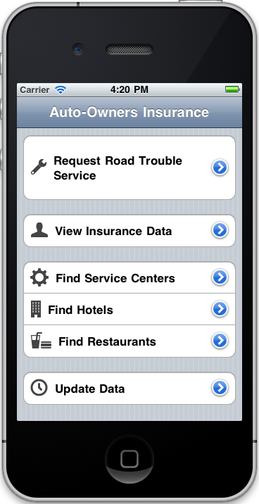
Auto-Owners Insurance
24-Hour Road Service Mobile Apps
Auto-Owners
Corporate Sponsors
Bob Buchanan
Lansing, Michigan
Corey Burns
Lansing, Michigan
Tony Dean
Lansing, Michigan
Priscilla Facundo
Lansing, Michigan
Scott Lake
Lansing, Michigan
Jim Schumacher
Lansing, Michigan
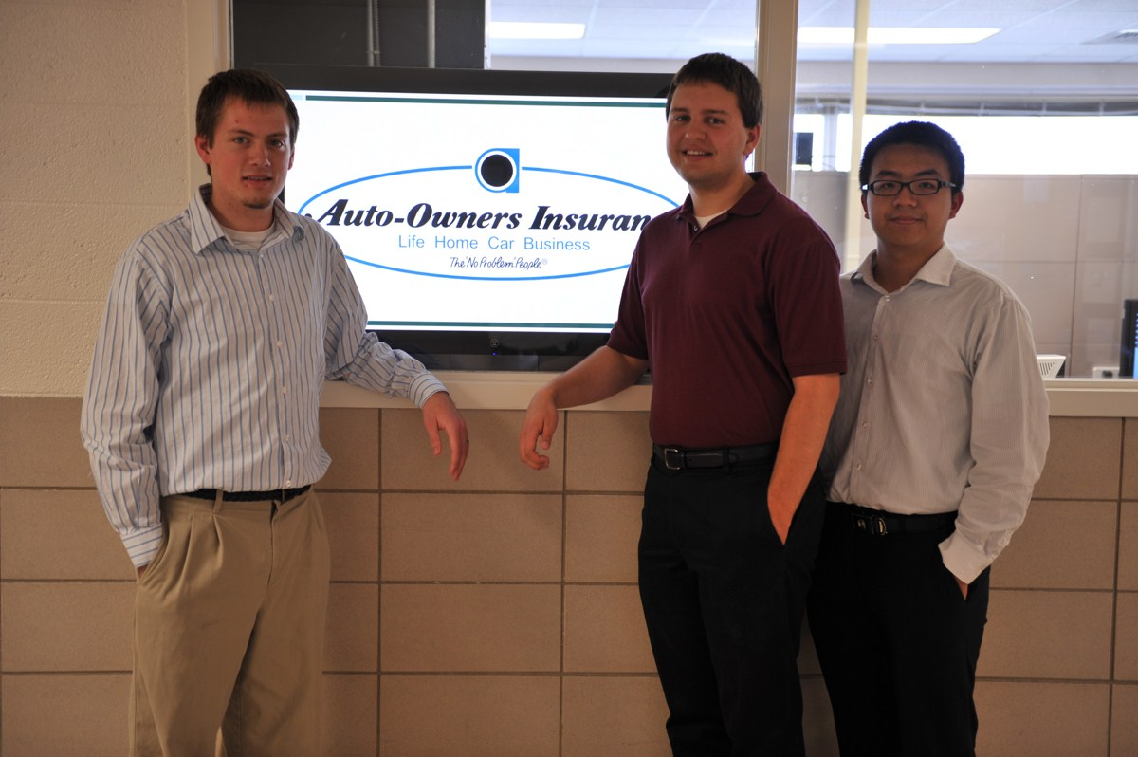
When going on a vacation or simply driving home from work, flat tires or other car problems can ruin one’s day. Auto-Owners Insurance provides 24-hour road service to their customers, aiding in the acquisition of help.
Unfortunately, when problems occur, customers often do not know their account information or their exact location.
With this in mind, we have developed iPhone and Android mobile apps that store a customer’s Auto-Owners account information and have the ability to determine a customer’s exact location using the phone’s GPS in the event of trouble.
When in need of roadside assistance, a customer sends a help request to Auto-Owners with a few button presses, after which our app places a phone call on the customer’s phone to verify that a tow truck is indeed on the way.
In addition to being able to view their own account information, Auto-Owners customers can search for maps to nearby restaurants, hotels, and service centers.
As a companion to our mobile apps, we have developed a website for use by Auto-Owners Insurance associates to monitor and track the utilization of our mobile apps. Auto-Owners associates can view app usage by service coverage limit, state, and a variety of other parameters.
The applications are developed with Objective-C and Java. The website is built with C# using MVC3. Both use a restful web service to communicate with MySQL databases.
Michigan State University
Team Members (left to right)
Justin Hammack
Howell, Michigan
Paul Fritschen
Novi, Michigan
Lingyong Wang
Jinan, Shan Dong, China


