Auto-Owners Insurance
Enterprise Learning Management System
Auto-Owners
Project Sponsors
Bob Buchanan
Lansing, Michigan
Tom Beaudoin
Lansing, Michigan
John Kirk
Lansing, Michigan
Scott Lake
Lansing, Michigan
Jana Peeples
Lansing, Michigan
Jim Schumacher
Lansing, Michigan
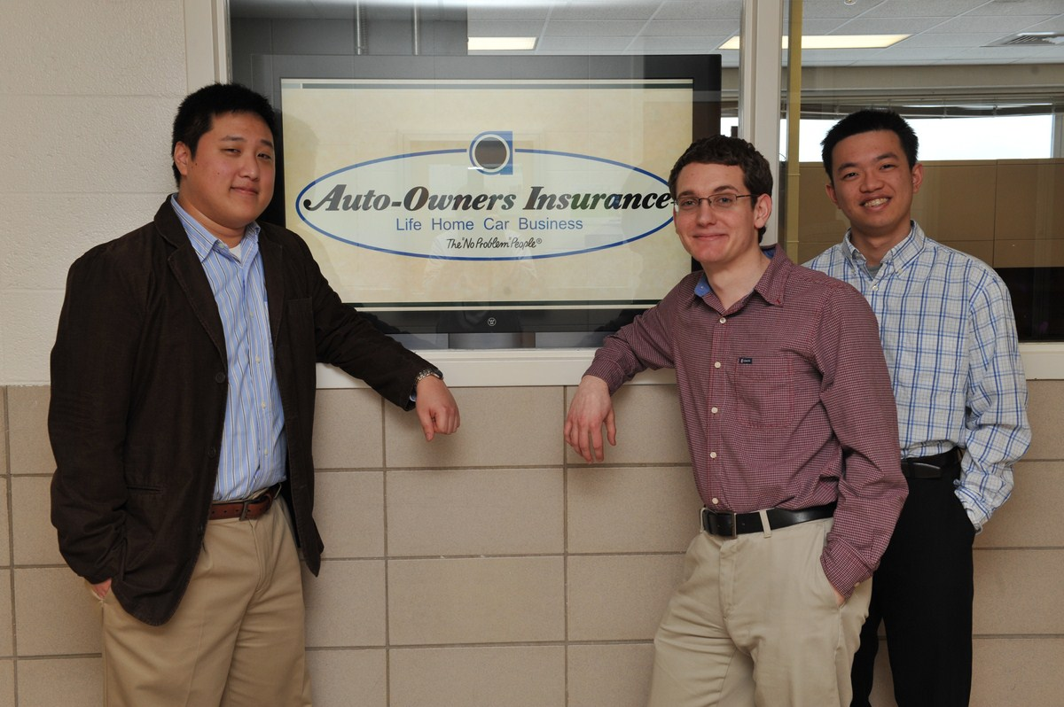
Auto-Owners Insurance provides its associates many opportunities for professional development, which include courses and certifications from a variety of vendors. Our Enterprise Learning Management System (ELMS) is a web-based application designed to manage the entire professional development program of Auto-Owners.
Based on a system called Moodle, our ELMS is tailored specifically to the needs of Auto-Owners. Extensions to Moodle provide functionalities and features customized for associates, managers, and instructors, all through a web browser. Courses from many organizations such as Institute of Internal Auditors and the Life Office Management Association are integrated seamlessly providing one-stop shopping.
Our ELMS enables Auto-Owners associates to manage their own professional development. They enroll themselves in courses, view class materials, take tests, view test results, and track their progress towards each designation or certification, all within a single, user friendly web application.
Managers and instructors monitor the progress of associates, making recommendations and generating reports.
Our extensions to Moodle are easy-to-install plug-ins, making the customization of Moodle simple and easy for Auto-Owners Insurance to maintain.
Moodle is an open-source software package. Our custom extensions are written in PHP 5 and JavaScript.
Michigan State University
Team Members (left to right)
Christopher Marsh
Royal Oak, Michigan
Preston Skupinski
South Lyon, Michigan
Fai Hui Wu
Warren, Michigan
