Microsoft

Project Sponsors

Scott Sawyer

Boston, Massachusetts

Kurt Seippel

Boston, Massachusetts

Scott Wadsworth

Redmond, Washington

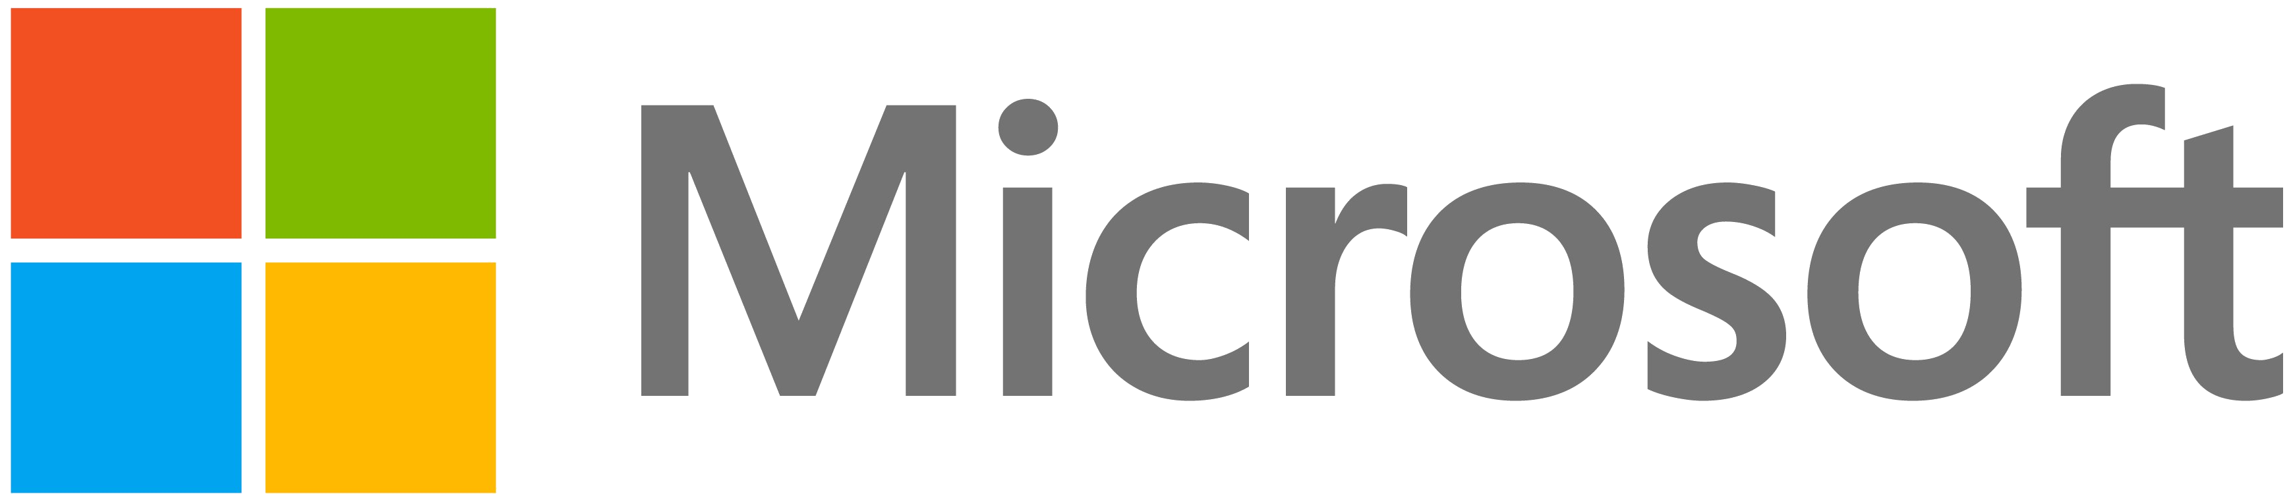

Headquartered in Redmond, Washington, Microsoft is a long-time technology leader and innovator. For decades, they have provided enterprises with a comprehensive body of technological solutions created to drive productivity.

More and more, people are using their personal mobile devices to do work that was once done only in the office. This not only enhances work flexibility and productivity, but it also lowers company hardware costs. However, accessing sensitive company data on a personal device poses a potential significant security risk.

Our Enhanced Company Portal with Graph is an Android app that enables employees to access company resources safely and securely using their personal mobile devices.

Our app uses Microsoft Graph to provide users with a single endpoint for information and resources across all Microsoft programs, applications and platforms within their organization.

After using our app to enroll their personal devices, employees can access valuable company resources, data and applications directly on their personal devices. In addition, users can contact their company’s IT department directly from within our app to open and resolve service tickets quickly and efficiently.

To provide for safety and security, once a user’s mobile devices are enrolled, their enterprise IT team can ensure that employee devices are compliant with the company’s security policies.

Our application is written in Java using Android Studio.

Michigan State University

Team Members (left to right)

Jordan Green

Holt, Michigan

Junda Yin

Guangzhou, China

Matthew Pasco

Clarkston, Michigan

Mike Xiao

Wuhan, Hubei, China

Yumo Wang

Qingdao, Shandong, China

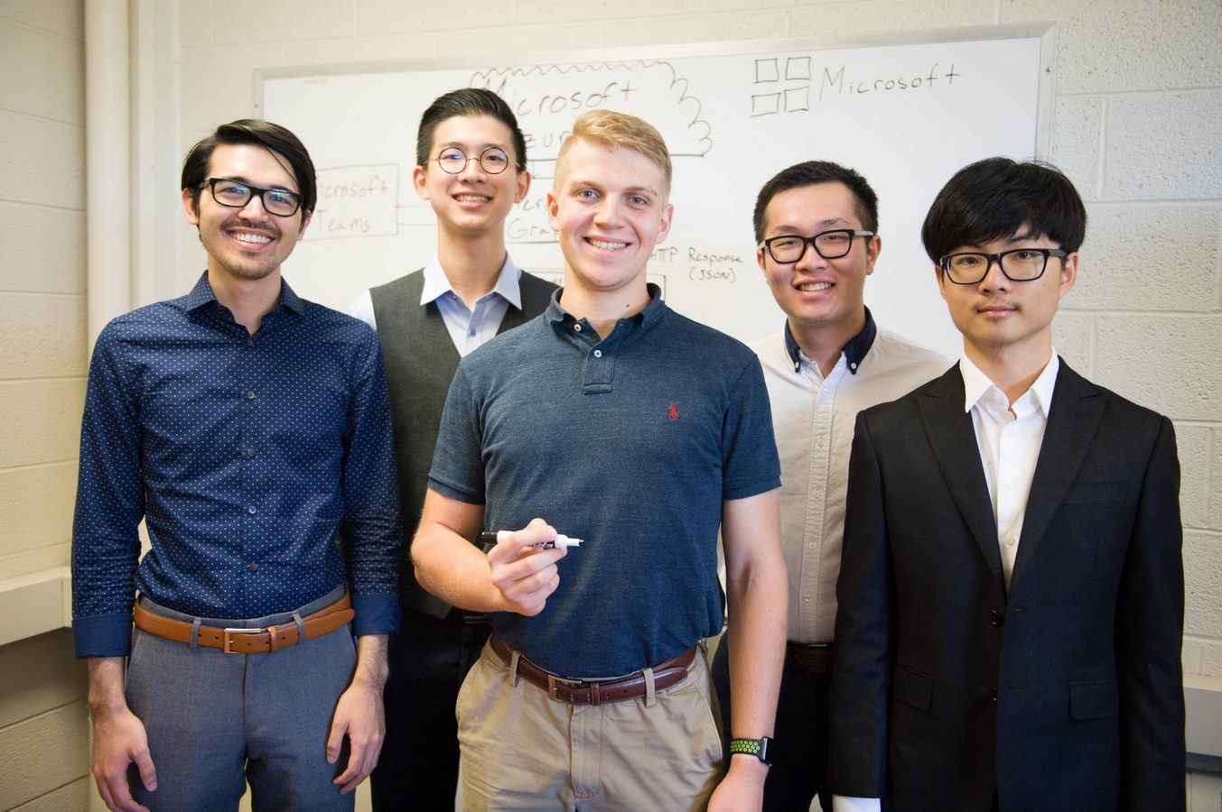

Microsoft

Enhanced Company Portal with Graph





