TechSmith
Mobile Web Reporter
TechSmith
Corporate Sponsors
Chris Bowron
Okemos, Michigan
Dean Craven
Okemos, Michigan
Bill Hamilton
Okemos, Michigan
Jeffrey Morgan
Okemos, Michigan
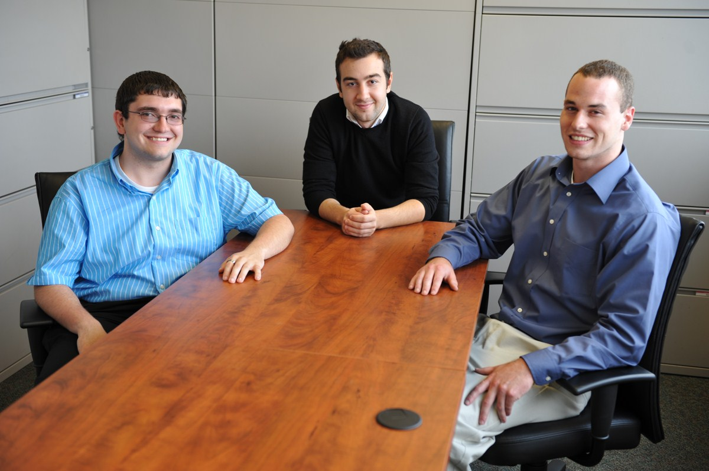
The Mobile Web Reporter enables users to make journalist style videos from their mobile devices. The app has a web browser embedded so that the user can search for relevant information in the background as well as record their audio commentary and video of their environment.
For example, let’s say that you go out to eat at a restaurant with your family and, in the middle of dinner, your friends at home ask you what you think of the place. Instead of trying to explain it to them, with the Mobile Web Reporter you are simply able to take your phone, pull up online ratings, and make a video of your experience all in real time.
Once you are satisfied with your report you can save the video to your phone and continue eating, or you can upload the video to the web right away. You have the option of uploading your video to websites like YouTube, Facebook, or Twitter. In a matter of seconds your friends at home are able to see and hear what you are experiencing.
The major design challenges for the Mobile Web Reporter are recording a video that captures both the screen and camera, creating an easy to use workflow, and achieving good performance on mobile devices.
The Mobile Web Reporter is a mobile app designed for iPhone and iPad (iOS), using Objective C, and for Android, using java and C/C++. For the iPhone and iPad, videos are created in MPEG-4 format using the AV Foundation. In the Android app videos are created in WebM format using a native encoder.

Michigan State University
Team Members (left to right)
Jacob Anderson
Grand Ledge, Michigan
Mehmet Barutcuoglu
Istanbul, Turkey
Joshua Berger
Brighton, Michigan

