Spectrum Health Systems
Log Monitoring Compliance
Spectrum Health
Corporate Sponsors
Mary Delrue
Grand Rapids, Michigan
Brett Hoffman
Grand Rapids, Michigan
Gary Lacher
Grand Rapids, Michigan
Jeremy Meller
Grand Rapids, Michigan
Patrick O’Hare
Grand Rapids, Michigan
Tammy Rhoades
Grand Rapids, Michigan
Sergey Stoma
Grand Rapids, Michigan
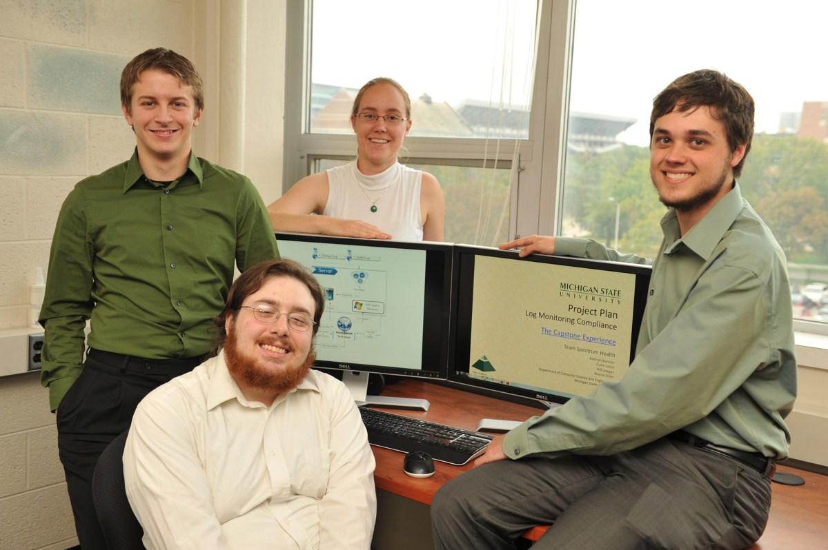
Spectrum Health Systems is a not-for-profit healthcare system in Western Michigan. Healthcare systems manage large quantities of extremely sensitive data. Monitoring access to this information is extremely important since it keeps medical information safe and helps Spectrum Health Systems stay in compliance with federal regulations.
Working with Spectrum Health Technology Information Solutions, we have developed Log Monitoring Compliance, a system that monitors and reviews information and configuration accesses.
After an employee accesses sensitive information, that information access is logged. This log record is then stored by our system and marked if it requires manual review. Designated reviewers can access records requiring manual review using our system.
Within the application, a user can keep up to date information about each review they are overseeing. Managers can see the compliance of their employees and track progress.
The Log Monitoring Compliance system also provides high-level summary reports of the total compliance of Spectrum Health Systems’ Technology and Information Solutions division, which allows executives to quickly see and assess the company’s adherence to audit objectives.
Our application runs in standard web browsers. The application is written in C# with the MVC Razor Engine framework and the underlying database is SQL.
Michigan State University
Team Members (left to right)
William D. Seeger
Bath, Michigan
Wayne Stiles
Sterling Heights, Michigan
Kathryn Bonnen
Austin, Texas
Collin Lotus
East Lansing, Michigan

