GE Aviation
NextGen Aircraft Taxi Assistance
GE Aviation
Corporate Sponsors
Serge Badiane
Grand Rapids, Michigan
Steve Carlson
Grand Rapids, Michigan
Brian Loyal
Grand Rapids, Michigan
Dashiell Kolbe
Grand Rapids, Michigan
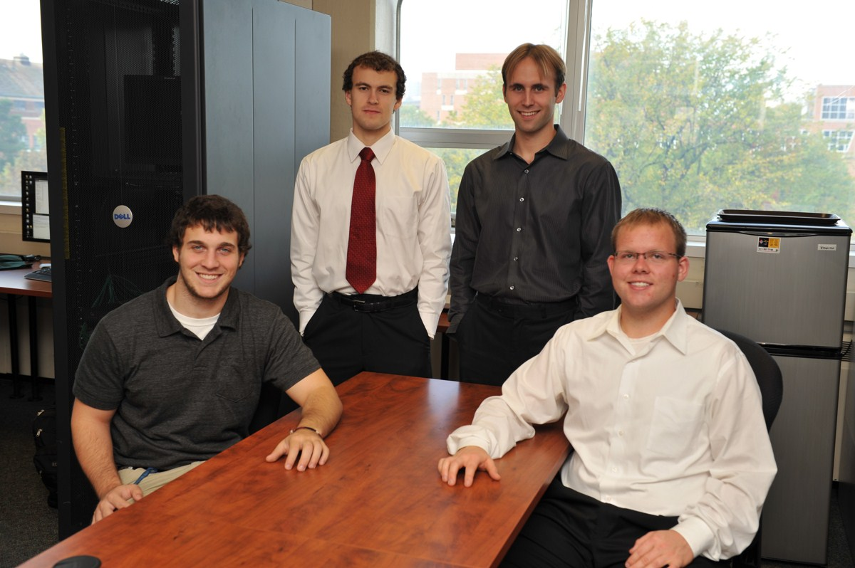
Runway and taxiway collisions account for the majority of commercial airliner accidents. In fact, the deadliest accident in aviation history occurred when two Boeing 747 jumbo jets collided in dense fog on a runway in the Canary Islands.
While on the ground, pilots are often challenged by a variety of competing factors including bad weather, tight schedules, and high-traffic volume. Breakdowns in communication along with limited visibility due to fog can lead to dangerous situations resulting in disastrous collisions.
Our NextGen Aircraft Taxi Assistance provides pilots with an intuitive user interface that enables them to plan their ground routes, to navigate easily complicated airports, and to avoid other aircraft while taxiing to their destination. With our system, runway and taxiway collisions will be greatly reduced and possibly eliminated completely.
NextGen Aircraft Taxi Assistance is the latest addition to the MSU Next Generation Flight Deck, which is the culmination of five Capstone team projects. While nothing can replace the skills and ingenuity of an experienced flight crew, our next generation flight deck design equips pilots to operate aircraft safely and reliably better than ever even in the direst of situations.
Our NextGen Aircraft Taxi Assistance is built with C++ and OpenGL. We have integrated our system with the X-Plane flight simulator to simulate aircraft taxiing and test the use of our system.
Michigan State University
Team Members (left to right)
Mitchell Thelen
Fowler, Michigan
Jacob Walker
Lake in the Hills, Illinois
Jason Cepela
Canton, Michigan
Johnathan Richter
Dewitt, Michigan

